# NOTES TO Self

1. Check the text of the MolCel2013 paper against the DVD backup. The main text is from the MolCel website, as are the main figures. Supplemental text and figures need to be reconciled with your DVD backup.
   1. Add the piRNA references to this document
      1. This will take awhile.
2. Phrases to FIND and Replace for symbols ETC.
   1. 5prime and 3prime = I want the symbols!

# COVER PAGE

# TITLE PAGE

Possible titles:

* Investigation of long RNAs using a novel ligation-based approach
* Investigation of long RNAs using RNA templated DNA ligation
* Long RNAs: biology, technology, and perspective
* Examination of dynamic long RNAs

A Dissertation Presented

By

Christian Knauf Roy

Submitted to the Faculty of the

University of Massachusetts Graduate School of Biomedical Sciences, Worcester

in partial fulfillment of the requirements for the degree of

DOCTOR OF PHILOSPHY

(MONTH, DAY, YEAR)

BIOCHEMISTRY

# SIGNATURE PAGE

A Dissertation Presented

By

Christian Knauf Roy

The signatures of the Dissertation Defense Committee signify completion and approval as to style and content of the Dissertation

The signatures of the Dissertation Defense Committee signify completion and approval as to style and content of the Dissertation

(Signature) (Name Typed),

Melissa J. Moore (Signature) (Name Typed),

(Signature) (Name Typed),

Phillip D. Zamore (Signature) (Name Typed),

Scot Wolfe

(Signature) (Name Typed),

Job Dekker

(Signature) (Name Typed),

Brenton R. Graveley

(Signature) (Name Typed),

Dissertation Committee

Zhiping Weng

(Signature) (Name Typed),

The signature of the Chair of the Committee signifies that the written dissertation meets the requirements of the

Chair of Committee

The signature of the Dean of the Graduate School of Biomedical Sciences signifies that the student has met all graduation requirements of the school. (Signature)

Anthony Carruthers, Ph.D., Dean of the Graduate School of Biomedical Sciences Program (Typed)

Month, Day and Year (Typed)

# Front Matter

## Dedication

*I would like to dedicate this Doctoral dissertation to my grandfather, George Knauf. My grandfather passed away on September 23rd, 2011, just one week shy of his 82nd birthday. I find it difficult to articulate how much I miss him. He spoke carefully, and never without purpose or conviction. While I hear from others that he was proud of me, he rarely, if ever, betrayed that type of emotion to me directly. It is my goal to build a solid life like he did. His life was founded on hard work, playing the long game, assuming responsibility, and maintaining friendships throughout his life. These are just a few of the personality traits that I observed and try to emulate. The fact that he passed while I was in graduate school, and before he could meet our son Owen, is one of my biggest regrets. Of all the possessions he left behind, it is the memory of our time together that I will cherish the most. Rest in peace, Grump. I did it.*

## Acknowledgements

First I would like to acknowledge and thank Laura Geagan and Rebecca Sendak at Genzyme. They were supervisors while I was a research associate there, and encouraged, and assisted my transition to graduate school. Without the confidence they instilled in my abilities as a young scientist in biochemistry, I doubt I would have ever signed up for more school.

Next I’d like to thank Melissa. It was during my 1st year retreat at Wood’s Hole that I first learned what a fantastic communicator of interesting and important science Melissa is. When she brought out her rope representing the unspliced pre-mRNA of *dystrophin*—a rope that reach to the back of a rather large auditorium—and then dramatically help of a pencil representing the final mRNA product, both to scale, I knew I needed to rotate in her lab. I have never once doubted the decision to join Melissa’s lab, and have learned so much from the broad and interconnected approach she takes to important scientific questions. Thank you so much for teaching me to always consider the big picture, go for the answer, and to just ask when I need help.

Soon after joining Melissa’s lab, and with the project I was working on going well, it was proposed to me that I be a joint student between Melissa and Phil. It was not difficult to not jump at the opportunity to be adviser by *two* Howard Hughes investigators, and I also haven’t regretted the decision since. Over the past few years, I have been continually amazed at the depth of Phil’s knowledge, both scientifically and in broader topics. He is a careful, meticulous, quantitative, and calculating mentor. While I feel that I clicked ‘on the level’ with Melissa, interacting with Phil forced me to think and act outside my comfort zone, something I always tell myself is a critical aspect of change—and growth. Thank you Phil for everything I’ve learned.

My committee has also been very supportive throughput my PhD. I hardly believed the ease with which I passed my qualifying exam, and took it as a big confidence boost. The following years of TRAC meetings confirmed that I was not thinking way off-base. The one-on-one meetings just prior to my QE were especially helpful. Thanks to Scot, Job, and especially Zhiping for all the guidance.

Lab Members

Aaron

Alper

Amrit

Eric and Erin

Collaborators

Dave Weaver

Muro

Graveley

Heinrich

Anna

Ogo

Family

Table of Contents

1) NOTES TO Self i

2) COVER PAGE ii

2) ii

3) TITLE PAGE 1

4) SIGNATURE PAGE 2

5) Front Matter 4

Dedication 5

Acknowledgements 6

Abstract 10

List of Tables 11

List of Figures 13

List of Symbols, Abbreviations or Nomenclature (optional) 15

Preface 17

1) Introduction 18

2) CHAPTER I: SeqZip methodology 31

3) CHAPTER II:HIV and piRNA precursors 34

4) CHAPTER III : MolCel2013 41

5) Perspective 76

1) Back Matter 77

Appendices 78

Biblography 79

## Abstract

## List of Tables

Table 2‑1, A set of 10 genes investigated for splicing coordination using SeqZip 30

Table 3‑1, Just 9 clusters from 5 promoters generate >50% of 14.5 dpp (pachytene) piRNAs 33

## List of Figures

Figure 1‑1, Limitations of Sequencing technologies for the study of splicing coordination 22

Figure 1‑2, Mouse piRNA dynamics across developmental time 25

Figure 2‑1 - SeqZip quantification of fragmented in vitro transcribed RNAs 29

Figure 2‑2, Quantificaiton of trans-transcript effect for different [RNA] 30

Figure 3‑1, Unstranded RNA-Seq suggests poly(a)+ piRNA precusor transcripts 32

Figure 3‑2, piRNAs that don't map to genome do map to spliced precursor transcripts 33

Figure 3‑3, RT-PCR can not be used to demonstrate continuous precursor transcripts 33

Figure 3‑4, Precursor transcripts are only seen in testes RNA-Seq samples 34

Figure 4‑1 piRNA Precursors are RNA Pol II Transcripts 40

Figure‑4‑2. The Major piRNA-Producing Genes of the Post-Partum Mouse Testis 41

Figure 4‑3 Three Classes of piRNA-Generating Loci 44

Figure 4‑4 Pre-pachytene piRNAs Persist in Pachytene Spermatocytes 45

Figure 4‑5 Examples of Pachytene piRNA Genes 47

Figure 4‑6 Examples of Pre-Pachytene piRNA Genes 47

Figure 4‑7. A-MYB Binds the Promoters of Pachytene piRNA Genes 49

Figure 4‑8 ChIP-qPCR Confirms ChIP-seq Data 50

Figure 4‑9 Change in piRNA Expression in A-Myb, *Spo11*, *Mili, Tdrd6*, and *Tdrd9* Mutants 52

Figure 4‑10 Examples of the Effect of the A-Myb Mutant on piRNA Expression 53

Figure 4‑11 Pachytene piRNA Precursor Abundance in *A-Myb*, *Miwi*, and *Trip13* mutants 54

Figure 4‑12 A-MYB Regulates Expression of mRNAs Encoding piRNA Pathway Proteins 56

Figure 4‑13. A-Myb mutants, but Not Miwi Mutants, Change the Expression of RNA Silencing Pathway Genes 57

Figure 4‑14 Feed-Forward Regulation of piRNA Biogenesis by A-MYB is Conserved in Rooster 61

Figure 4‑15. Genomic Locations of piRNA Clusters in the Rooster (*Gallus gallus)* Testis. 62

## List of Symbols, Abbreviations or Nomenclature (optional)

### Abbreviations

|  |  |
| --- | --- |
| AS | Alternative Splicing |
| DNA | Deoxyribonucleic acid |
| RNA | Ribonucleic acid |
| ChIP-Seq | Chromatin Immunoprecipitation followed by sequencing |
| HTS | High-throughput sequencing (see also *NGS*) |
| NGS | Next-generation sequencing |
| nt | A nucleotide of either DNA or RNA |
| bp | A base pair of DNA |
| SRE | Splicing Regulatory Element |
|  |  |

### Symbols

|  |  |
| --- | --- |
| 5´ | The 5 prime end of a DNA or RNA molecule |
| 3´ | The 3 prime end of a DNA or RNA molecule |
| μ | Micro. A value of 1x10-6 standard units |
| $ | Reference |
| % | Needed definition |
| # | Figure or Table |

### Definitions

|  |  |
| --- | --- |
| RNA-Seq | A technology wherein RNA is fragmented, converted to DNA, and analyzed on a high-throughput sequencing instrument |
| A ‘Read’ | The sequence of nucleotides produced from each spot on a high-throughput sequencing machine |
| Insert | The RNA molecule captured between two cloning sequences in a high-throughput sequencing library preparation workflow |
| Read length | The number of nucleotides for each given 'read' |
| Read depth | The number of reads obtained from each high-throughput sequencing analysis |
| Coverage | A measure of the number of times each nt of a genome is sequenced. E.g.­­­–100 million reads of a 10 million nt genome = 10X coverage, assuming uniform distribution of the 'reads' |
| Paired-end | When both sides of a DNA insert or template are sequenced, utilizing the original length of DNA between the reads to facilitate mapping (Roach et al. 1995) |
| Scaffold or contig | A draft sequence of nucleotides, meant to represent the actual biological sequence as closely as possible, examples include unassembled fragments of chromosomes or fragments of mRNA transcripts. |
|  |  |

## Preface

The work reported in this dissertation has been published in the following articles.

Chapter III has been published previously as Li, X. Z. Z., Roy, C. K. K., Dong, X., Bolcun-Filas, E., Wang, J., Han, B. W. W., … Zamore, P. D. D. (2013). An Ancient Transcription Factor Initiates the Burst of piRNA Production during Early Meiosis in Mouse Testes. Molecular Cell, 50(1), 1–15. doi:10.1016/j.molcel.2013.02.016

Some contents of Chapter I are included in an accepted for publication:

# Introduction

### Motivation

High school biology class is where I first learned about how 'genes'—the things which I always heard everything was 'in' —actually worked. There was a picture of two squiggly lines (DNA) with a third squiggly line coming off them called mRNA. The mRNA line was decorated with rectangles marked exons. In a different part of the page, the mRNA line was covered by blobs called ribosomes, and was busy being translated into protein. Apparently this processes made the proteins, which, along with good part water, is what I was essentially made of. Seem pretty simple and worked out. However, a small note on the page drew my eye. It pointed to one of the exon boxes and said 'alternative splicing.' What's this? The arrangement of the rectangles/exons is not set in stone? It was around this time that the human genome was being finalized, and the preliminary poster on the wall said our genome contained something like 30 thousand genes.  The implication struck me immediately. If these boxes could be alternatively arranged, then the possibilities of unique mRNA molecules is staggering! Far more then the 30K genes advertised on the poster. Quickly something that also made sense popped to mind —this *must* be the reason why humans are so much more advanced then everything else our—mRNAs are alternatively spliced.

Those thoughts were 15 years before I found myself development a methodology that would greatly assist in the routine measurement of mRNAs that are alternatively spliced. Strange to think that I was immediately amazed with a biological process I would go on to study after. I was similarly amazed to learn about Sanger sequencing - it seemed so elegant to me. Fitting that another major aspect of my PhD work was learning and exploring High-throughput sequencing technologies.

### DNA Sequencing history

Soon after it was realized that DNA is the source of genetic information in all living organisms(Watson and Crick 1953), and the ‘pretty’ and ‘elegant’ arrangement of complementary, antiparallel DNA strands was known (Watson, Gann, and Witkowski 2012), the ability to determine the specific arrangement, or ‘sequence’ of nucleotide bases in a given length of DNA was seen as a critical missing piece of technology. It took 25 years after the nature of DNA’s architecture for the ability to ‘[sequence’](#_Definitions) it to become a reality. By 1977, two very different methods reported by Sanger (Sanger and Coulson 1975; Sanger, Nicklen, and Coulson 1977) and Maxam-Gilbert (Maxam and Gilbert 1977) were reported. These sequencing technologies, from then on referred to eponymously as ‘Sanger’ or ‘Maxam-Gilbert’ sequencing, were used to determine the specific order of a small DNA piece (200–300 nt). Sanger sequencing soon dominated most sequencing reactions, likely due to the conceptually more intuitive nature of the technology, and over the past 35 years, DNA sequences have been slowly cloned, sequenced, analyzed, and dutifully catalogued into knowledge.

During late 70’s and throughout the 80’s, DNA sequences were typically communicated in important publications (Bell et al. 1980). The birth of the internet in the 1990’s made essential publically-funded repositories for sequence information easily available (Benson et al. 2011). However, it was the human genome project (Eric S Lander 2011), that provided the important activation energy which brought DNA sequencing from a hard-to-perform but necessary piece of analysis, to an organized, large-scale effort to assemble complete source genetic material for relatively simple (Sanger et al. 1978) to complex (E S Lander et al. 2001; J C Venter et al. 2001) genomes. An often criticized, but undeniably disrupting force, in the human genome project was the competing efforts of the privately-owned company Celera (J. Craig Venter 2008). Taking a higher-throughput and centralized approach to determining the sequence of the human genome, Celera fundamentally changed to approach to a large-scale sequencing project. Instead of assigning specific sections of the genome to be worked out by individual labs, Celera parallelized the effort, by collecting many of the best “high-throughput” Sanger-sequencing devices from Agilent (ABI 3700 DNA Analyzer). Using a shotgun approach (R.Staden 1979) sequenced pairwise (Roach et al. 1995) combined with sequence [scaffolds](#_Definitions) made available by the publically-funded project, Celera was able to create high-quality genomic sequences very quickly. Arguable, this was the first [deep sequencing](#_Definitions) effort, and changed the landscape of molecular and biochemical research, coincident with the beginning of a new millennium.

### History of High-throughput Sequencing

Sequencing DNA by Sanger’s technology remains a valuable and critical tool in every biological scientist’s arsenal. However, the technology has a practical throughput limit. Each DNA molecule to be sequenced must be isolated & clonally amplified, typically using bacteria to do the heavy lifting. Given that the human genome (Consortium 2005) comprises > 3 billion nt (on just one strand), and that each Sanger reaction will provide ~800 nt of quality sequence, we need at least ~4 Million individual reactions to determine the sequence of the human genome, assuming that all of our reads are of sufficient quality, length, and do not overlap by even 1 nt. Even the best practical improvements to workflows could not bring the Sanger approach to DNA sequencing in-line with aspirations of analyzing the genomes of many different species or individual organisms.

In the early 2000’s the first efforts to change the approach to DNA sequencing, first using MPSS (Brenner et al. 2000), but perhaps more importantly, and disruptively from a technology perspective, by Pyrosequencing (Ronaghi, Uhlén, and Nyrén 1998) and Polony sequencing (Shendure et al. 2005). Both methods utilized emulsion PCR (Nakano et al. 2003) for clonal amplification prior to sequencing, removing the bottleneck of bacterial cloning in traditional workflows. In contrast to Sanger sequencing, where the final read out is the fluorescence of the last incorporated chain-terminating nucleotide, Pyrosequencing visualizes light given off by luciferase as it reactions with ATP generated from the pyrophosphate (PPi) by-product of nucleotide addition to the growing chain. Pyrosequencing was commercialized by 454 technologies. Polony sequencing involves a more complicated sequencing-by-ligation method, eventually commercialized by Applied Biosystems as the SOLiD platform. While both of these technologies provided valuable, high-throughput sequences, neither has been as successful as the approach commercialized by Solexa (eventually purchased and now known as Illumina).

Illumina uses a sequencing-by-synthesis approach using fluorescent nucleotides after clonal amplification of DNA on a slide surface. Since 2006, iterations of the Illumina platform (eg. GE, GE-II(x), Hi-Seq, Hi-Seq 2500) have demonstrated a steady and impressive increases in both [read depth and length](#_Definitions) [#Figure]. On February 15th 2012, Illumina announced on its [Basespace blog](http://blog.basespace.illumina.com/2012/02/15/genome-in-a-day/), that they had sequenced a HapMap [sample](http://ccr.coriell.org/Sections/Search/Sample_Detail.aspx?Ref=GM18507) at 40X [coverage](#_Definitions), using the HiSeq 2500 platform and paired-end 100 nt reads. This announcement demonstrated that in a single analysis attempt (but certainly not the day claimed by the title), analysis and assembly of a human genome is no longer the monumental endeavor it once was, and that completely new experimental possibilities are a reality for life science research.

### Deep-sequencing RNA methodologies

Just found the mother load of literature reviews http://blog.sbgenomics.com/history-of-rna-seq/

Also this appears to be a recent (but not great) review about transcriptome analysis using RNA-Seq

(Mutz et al. 2013)

The first widely-accepted method for measuring gene expression via sequencing by proxy of cDNA molecules was Serial Analysis of Gene Expression (SAGE) (Velculescu et al. 1995). While the importance of microarrays in the measurement of gene expression via cannot be overstated (Shendure 2008; Marioni et al. 2008) the technologies limited ability of novel sequence, and analogue nature of the signal, makes their relevance to this section somewhat off-topic. However, Sage, (similar to the previously discussed MPSS technique) produces a digital output of gene expression using a cleaver procedure of cleaving cDNA molecules using restriction endonucleases that leaves a ‘sticky end’. After cleavage, these molecules ligated and concatenated together to form longer DNA fragments. These fragments are cloned into a vector, amplified, and Sanger sequenced. Using known sequences incorporated during concatenation, the number of sequenced ‘fragments’ that align to a given gene is related to the abundance of the original mRNA molecule. While SAGE was a cleaver molecular trick allowing researches to dip into the 5-log range of expression typically seen in mRNA expression, it is still limited by read lengths and practical read depth of Sanger sequencing.

Not long after the Solexa/Illumina platform produced read lengths of sufficient length of depth to consider measuring gene expression were the first [RNA-Seq](#_Abbreviations) papers published (Mortazavi et al. 2008; Nagalakshmi et al. 2008; Lister et al. 2008). These papers gave a powerful glimpse into the feature of molecular biology. Indeed, in the years since, analysis by RNA-Seq is quickly overtaking other forms of gene expression analysis, as demonstrated by the number of accessions deposited in GEO per year (Barrett et al. 2013). RNA-Seq allows for quantitative, digital measurement of RNA expression across a physiologically-relevant range (Blencowe, Ahmad, and Lee 2009). While simultaneously measuring gene expression, the data can be used for novel sequence discovery, measuring RNA-editing (Li et al. 2011), transcript assembly (Trapnell et al. 2010), and by modifying the protocol or performing additional biochemical steps, can be used to investigate many aspects of RNA biology; Also #Figure of my own design).

Starting from the moment the RNA leaves the exit channel of the polymerase, the biology of RNA processing begins to occur. Many methodologies have been developed that enrich RNA-Seq libraries for a specific type of RNA molecule. For example, measurement of nascent RNA can be performed via GRO-Seq (Core, Waterfall, and Lis 2008). Measuring the extremely complicated process of RNA turnover (referring to the rate at which given RNAs are produced and degraded) (Ghosh and Jacobson 2010), can be done using XXX-Seq after incorporation of XX nucleotides or a biochemical handle such as biotin. RNA:protein interactions can be measured with or without crosslinking the protein to the RNA, via CLIP or RIP, respectively. Once an RNA has been fully transcribed, known processing steps such as Cap formation and poly(A) tail formation can be measured using any of the Cap-Seq/CAGE methodologies (Shiraki et al. 2003), or PAS-Seq (Shepard et al. 2011). With appropriate size-selection steps, small RNAs (Ghildiyal et al. 2008) can also be captured into a sequencing library. Finally, traditional RNA-Seq, can effectively capture fragments of all of the above mentioned libraries, even though it is mainly associated with measurement or analysis of traditional mRNAs.

Macintosh HD:Users:royc:Dropbox:Thesis:Figures:01-Introduction:RNA_Sequencing_methodlogy.ai

Figure ‑, Methods for HTS of RNA

RNA-Seq and its associated flavors are also traditionally associated with measuring gene expression in tissue culture cells, or RNA extracted from particular tissues. Recently, efforts to measure the RNA expression occurring in individual cells has gained attention (Shapiro, Biezuner, and Linnarsson 2013). Perhaps the most interesting concept when thinking about measurement of gene expression in a single cell is the ‘biological uncertainty principle,’ wherein it is possible to either know, or change (but not both) the RNA composition of a single cell. The name borrows from Heisenberg's uncertainty principle (Kennard 1927) and is often confused with the more appropriate ‘observed effect’ (Riley and Steitz 2013). Leaving that issue aside, measuring how unique a given cell, within a tissue of similar, but obviously unique cells, is an exciting and informative endeavor (Shalek et al. 2013; Wills et al. 2013). Compared to the plastic nature of DNA (Shendure and Aiden 2012), the diversity of RNA synthesis within living cells is potentially much more complicated, and the ability to accurately measure RNA dynamics should allow us to make much more informative observations concerning biology then is currently possible (Djebali et al. 2012).

### RNA Expression

* ENCODE

The encode project revealed that most of the genome is transcribed into RNA. This was done in cancerous cell lines, and while it revealed the potential for transcription, it did not reveal much biology beyond a cells in culture simply perpetuating their existence.

* Integration of different datasets for a more complete transcriptional picture

### Alternative Splicing

Mention the pair of papers in science, dec 2012 that discuss evolution using RNA-Seq (Barbosa-Morais et al. 2012; Merkin et al. 2012)

===From QE===

## Updated references and this is a very good and useful section of language

Soon after the discovery of introns, it was reasoned that genes could be arranged in different combinations, greatly increasing the coding potential of a genome (Gilbert 1978). The process of rearranging genes, now known as alternative splicing (AS), has proven to be an integral phase of gene expression in most eukaryotes. In just 15 years, the number of genes estimated to be alternatively spliced has grown considerably. In his Nobel lecture, Phil Sharp stated that: “Approximately, one of every twenty genes is expressed by alternative pathways of RNA splicing in different cell types or growth states” (Sharp 1994). Not long after the assembly of the first human genome, a number of groups combed through Expressed Sequence Tag (EST) databases to increase that estimate to 35%-59% (Modrek and Lee 2002). Soon after, analysis using specially designed microarrays resulted in an increased estimate of 74% (Johnson et al. 2003). However, in late 2008, three groups utilizing high-throughput sequencing (HTS) of cDNA (referred to as RNA-Seq) demonstrated that between 86% and 95% of human multi-exon genes are subject to AS (Pan et al. 2006; E. T. Wang et al. 2008; Sultan et al. 2008). Not only did they demonstrate that almost all genes are alternatively spliced, they also showed that AS often occurs in a tissue- and cell type-specific manner. In combination with regulation of transcription itself, the study of AS is critical to our understanding of the connections between the comparably static genomic DNA sequence and the highly flexible and adaptive abilities of organisms.

### Deciphering a splicing code

A gene is alternatively spliced when, as a result of transcription and processing, there are at least two unique transcripts produced from one genomic sequence. Beyond counting observed isoforms, one major area of effort is to decode sequence regulatory elements (SREs) contained in pre-mRNA that define AS site selection (Z. Wang and Burge 2008). In contrast to the core splicing signals, we have limited knowledge of the SREs that serve to increase or decrease the strength of a particular splice site, often within a sea of other potential sites. Through a variety of mechanisms, these elements serve as cis-acting sequences and binding sites for trans-acting factors. Some of the best-studied SREs include Exon Splicing Enhancers and Silencers (ESEs and ESSs). Members of the Serine-Arginine (SR) protein family typically bind to ESEs located in an exon, promoting its definition and thereby increasing the probability that the exon will be included in the final transcript (Graveley 2000; Long and Caceres 2009). Meanwhile, ESSs serve to squelch inclusion, often through binding trans-acting heterogeneous ribonucleoprotein particles (hnRNPs) (Martinez-Contreras et al. 2007). Therefore, binding of these trans-acting factors to their appropriate SREs can either promote or inhibit interactions between the splicing machinery and the pre-mRNA. The current working hypothesis is that a finely tuned combination of these binding events determines the final exon content of each isoform (House and Lynch 2008).

Sequence motifs that compose the AS code have been teased out (Ladd and Cooper 2002; Barash et al. 2010). Additionally, assignment of the binding motifs to tissue-specific trans-acting factors has also progressed (Jin et al. 2003; Ule et al. 2005; Licatalosi et al. 2008). Many of these binding motifs were identified using combined computational and biochemical approaches. Computational approaches usually involve searching for a comparative enrichment of sequences near splice sites. Biochemical approaches typically include gel shift, SELEX, and cross linking. Many of these approaches are performed in vitro and disregard the importance of cellular context on binding affinities. However, with the increasing accessibility of deep sequencing, many groups are extracting physiologically relevant, high-resolution data from traditional biochemical techniques(Ingolia et al. 2009; Ingolia, Lareau, and Weissman 2011). Deep-sequencing approaches are also being applied to questions involving mechanisms of AS. In addition to the RNA-Seq experiments, High-Throughput Sequencing [following] Cross-Linking Immunoprecipitation (HTS-CLIP) has confirmed SRE motif data predicted from computational and microarray experiments (Licatalosi et al. 2008; Hafner et al. 2010). Using this approach, researchers can now enrich their samples for sequences that bind trans-acting factors of interest.

### The Isoform Problem

As with many areas of basic research, the field of AS relies on large-scale (aka – global, genome-wide, high-throughput) techniques. Two of the most widely applied technologies employed for large-scale analysis of gene expression are microarrays and ‘2nd generation’ HTS sequencing. Unfortunately, both of these techniques have fundamental limitations, with the major issues being probe specificity for the former and read length for the latter.

Macintosh HD:Users:royc:Dropbox:Thesis:Figures:01-Introduction:Connectivity.and.seq.methodology.limitations.ai

Figure ‑, Limitations of Sequencing technologies for the study of splicing coordination

Microarrays rely on hybridization of a target sequence to a known probe averaging 25 to 100 nt in length (Southern 2001). Therefore, microarrays indicate only the presence of short sequences in the target sample and do not provide adequate linkage information of these sequences. A hypothetical scenario can be used to describe it another way. Say we are investigating a transcript known to display two different regions of AS (Figure 1-1, A). Probes targeting these two regions demonstrated an increase in signal for both AS events. Unfortunately, we could not determine if we observed an increase in unique transcripts, each containing only one region of AS, or an increase in production of a single transcript containing both regions (Calarco, Saltzman, et al. 2007). This binary analysis is the heart of the “connectivity problem.” Microarrays have proven extremely informative and will likely continue to do so in more targeted applications. However, this issue, combined with concerns of cross-hybridization, reproducibility, and a comparably small dynamic range, will likely hasten microarray displacement by RNA-Seq as the preferred method for comprehensive analysis of gene expression (Shendure 2008).

Many researchers are turning toward 2nd generation HTS methodologies for comprehensive transcriptome analysis. This sequencing approach has significance advantages over microarrays. Specifically, it allows de novo identification of isoforms, over a larger dynamic range, in a quantitative fashion (Mortazavi et al. 2008). Additionally, newly developed techniques enrich samples for low-abundance isoforms, making the complete cataloging of AS events a possibility (Djebali et al. 2008; Salehi-Ashtiani et al. 2008). Unfortunately, the current read-length abilities (depicted in Figure 1-1,B) of all sequencing platforms do not solve the connectivity problem. Excluding single-molecule HTS read lengths of sufficient length (Shendure et al. 2004), other approaches proposed to solve the connectivity problem include traditional cloning and sequencing or hybridization of query oligos to single-molecule transcripts (Zhu et al. 2003; Calarco, Saltzman, et al. 2007; Emerick, Parmigiani, and Agnew 2007). While these approaches can determine exon sequence connectivity, they scale poorly and are not feasible for large-scale applications.

Clearly, AS is an essential regulatory mechanism involved in the control of human gene expression. Its combinatorial nature could potentially answer many questions, such as a physical explanation of what separates us from our closest evolutionary ancestor, the chimpanzee (Calarco, Xing, et al. 2007). Additionally, the influence of AS on disease and cancer is slowly coming to light (Tazi, Bakkour, and Stamm 2009). Unfortunately, because of the limitations of methods currently used for the large-scale analysis of isoform expression we fail to obtain the complete picture of AS. One specific missing element of that picture is the prevalence of coordination between different regions of AS separated by large spans of sequence. An efficient, large-scale, single-molecule technique that maintains isoform sequence connectivity is required to complete the complicated picture of AS.

**Need to mention DSCAM – that can be the transition to Coordination in splicing**

### Coordination in splicing

==From my qualifying exam==

Identification of proximally acting SREs is progressing at a rapid pace. New and traditional biochemical methods, coupled with HTS, will undoubtedly fuel this progress. Unfortunately, a critical component of AS regulation currently neglected by the field is that of SREs acting across a considerable distance (>800 nt). One observation that may lead to the identification of long-range SREs is intramolecular coordination between distal splicing decisions. Figure 1-1A shows a model transcript that may exhibit coordinated distal regions of AS. In this model, the 5´ region of AS contains a cassette exon, which may or may not be included. This region is separated from the 3´ region of AS by many thousands of nucleotides. Does the decision to include the cassette exon have an effect on which of the mutually exclusive exons is included? This type of AS regulation may represent a general and pervasive phenomenon.

Macintosh HD:Users:royc:Dropbox:Thesis:Figures:01-Introduction:Fibronectin.ai

Figure ‑, Transcript structure of alternatively spliced section of Mouse Fibronectin

There is precedence in the literature for genes known to display coordinated regions of AS. One of the clearest examples is mouse Fibronectin (Figure 1-2) (Schwarzbauer et al. 1983; White and Muro 2011). In this gene, inclusion of the alternatively spliced Extra Domain A (EDI or EDA) region promotes splicing from one of three alternative 3´ Splice Site (3’SS) in the type III homology connecting segment (IIICS) region, resulting in more frequent production of shorter transcripts (Fededa et al. 2005). This effect occurs over six constitutively expressed exons and 800 nt of sequence (5400 nt if introns are considered). Fededa et al. also analyzed EST databases, concluding that approximately 25% of human genes contain multiple regions of AS. How many of these regions could show a coordinated effect, similar to that observed in Fibronectin? Providing some insight into this question, Fagnani et al used microarrays designed to report on inclusion levels of cassette exons in mammalian central nervous system tissues (Fagnani et al. 2007). The results produced a set of 38 pairs of exons mapping to the same gene that showed a coordinated increase or decrease of inclusion levels. A partial list, focusing on high-confidence events containing potentially coordinated regions of AS separated by more than 1000 nt of final transcript is shown in Table 2-1. Unfortunately, this and other large-scale studies preclude the complete determination of intramolecular coordination of AS.

Parra (Deep intron), Peng (exons)

### Mammalian piRNAs

! Incorporate salient points of the Resources paper into this section? At least the sections I worked on!

! Importance of mammalian piRNAs to maintain sterility

Macintosh HD:Users:royc:Dropbox:Thesis:Figures:01-Introduction:brennecki.piRNA.transcript.figure.ai

Figure ‑, Genetic evidence for long, continous fly piRNA precursor transcripts

(A) Figure adapted from (Brennecke et al. 2007)

Mammalian spermatogenesis is a critical biological process that ensures the future of a species. Recently the importance a specific kind of small RNA—piRNAs—on the proper function of spermatogenesis has become clear [$Ref to review]. Even after near a decade since their discovery, the essential mechanisms of piRNA importance to proper mammalian spermatogenesis remain unknown. These mechanisms include: biogenesis, physiological targets, and terminal function of maintain sterility. Even with these extremely important unknowns, the importance of piRNAs on mammalian spermatogenesis is clear—without a functioning piRNA pathway—males are sterile. Studies in humans have also linked SNPs in the Argonaute proteins that bind piRNAs, PIWI, to decreased fertility (A. Gu et al. 2010)

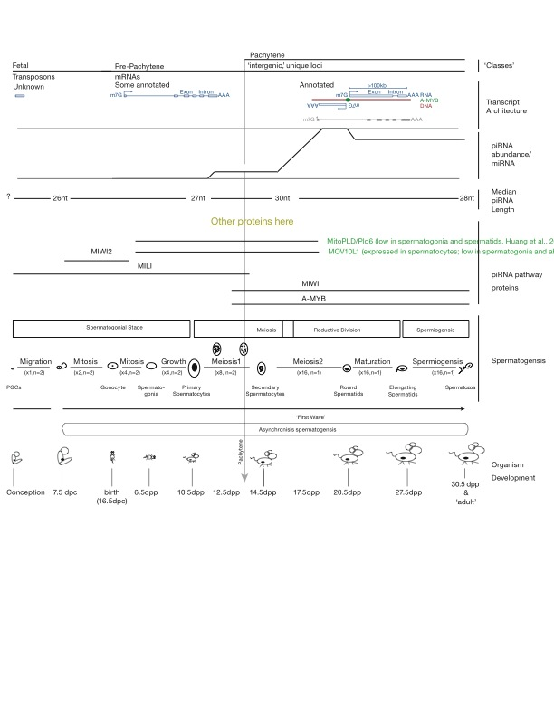

Figure ‑, Mouse piRNA dynamics across developmental time

!Description of the three classes of mammalian piRNAs (#Figure)

Mammalian piRNAs can be divided into three major classes (#Figure of my own design on piRNAs). The first, present before birth, are those of the ‘fetal piRNAs’. These piRNAs tend to be short, bind the PIWI protein MILI2 in mice, and have sequences found in transposable elements [$REF – 2008 Mol cel paper?]. The next class of piRNAs, historically but confusing grouped with the previous class, are called Pre-pachytene piRNAs. Pre-pachytene piRNAs are expressed just before birth, and continue to be expressed in functioning testes, often associated with spermotoXX and spermotXX, precursor cells to mature sperm(?), and tend to map to traditional, and annotated, protein coding genes. Finally, due to their unique sequence in the genome, the genetic origin of a millions of piRNAs belonging to the third class, the pachytene piRNAs, was immediately known. Pachytene piRNAs are extremely abundant after, not coincidently, the pachytene stage of meiosis I when (descriptor) chromosomes pair up, cross over, and rearrange their genetic material. Extremely abundant means XX fold enrichment of pachytene piRNAs compared to miRNAs, as compared to developmental timepoint just two days earlier. The genomic origins of these piRNAs, while unique in terms of sequence, are often in ‘gene deserts,’ unannotated, and devoid of intronic sequences. This ‘gene architecture’ makes the pachytene piRNA loci some of the most interesting RNA-producing regions of the mammalian genome.

!Known functions of mammalian piRNAs

Viyrekas et al discovered that many MIWI-associated piRNAs do not bind, as measured by ClIP, actually bind mRNAs directly, without a small RNA guide (Vourekas et al. 2012).

Both studies used point mutations in the catalytic tried of Miwi2, Mili,(De Fazio et al. 2011) and Miwi (Reuter et al. 2011) to remove the slicer activity. The MIWI2 and MILI study found that the mice were steile, and did not accumulate transposon-mapping piRNAs. The MIWI study found that the mice were also sterile, and demonstrated increased LINE1 atranscript accumulation. (Reuter et al. 2011; De Fazio et al. 2011). The Reuter study states that much the biological activity of MIWI depends on its slicer activity.

! Comparisons between fly and mammalian piRNA systems

The transposon-mapping nature of the fetal piRNA class made obvious comparisons to the fly piRNA system nature. In the fly system, primary piRNAs transcribed from discrete loci and fed into an amplification loop between two PIWI proteins PIWI(3) and AGO3 (‘the ping-pong’ cycle) ($REF Brenneki cell paper 2007). It is believed that PIWI proteins loaded with piRNAs bind and silence transposon messages, using the cleaved transposon transcripts, in combination with primary piRNA transcripts, as a substrates in the Ping-Pong cycle ($REF some newer review demonstrating this activity).

! Our annotation of the pachytene piRNAs and discovery of A-MYB

However, annotation of the molecular RNA precursors to these polymers–the piRNA precursor transcripts–was a simple inclusion of large chunks of chromosomal coordinates. Using 6 different types of high-throughput sequencing datasets, we have accurately defined the genetic structure of 2124 piRNA-generating loci. With these annotations, investigation into the cause of coordinated expression of pachytene piRNAs–a highly abundant and experimentally tractable class of piRNAs–, became possible. Using transcriptional start sites, a motif for the transcription factor A-MYB was clearly observed within the promoters of most of pachytene piRNA-generating loci. Additionally, gene expression analysis of mice containing a mutant form of A-MYB revealed that A-MYB also coordinates the expression of many proteins involved, or associated with, proper piRNA biogensis and function.

!Critical importance of integrating many different HTS datasets into mammalian piRNA study

piRNAs lend themselves to study using HTS

Require more datasets to work back to molecular precursors

RNA-Seq does not give precision necessary for annotation of 5prime and 3prime ends.

Cap-seq is too noisey to not have orthogonal dataset for comparison

Precision of 5prime end is critical for proper measurement of proximity to suspected transcription factor binding motifs and experimentally-determined ChIP signal

PAS-Seq challenging due to internal priming sites, difficulty of HTS platforms to read through homopolymers, and dynamic nature of 3prime end processing.

!Current status and future of transcriptome assembly

Reference most recent transcript assembly review.

Most successful methods are guided by known annotations

Unguided typically provide many discontinuous ‘contigs’

Maybe assisted by deeper RNA-Seq

Paired-end is critically important

# CHAPTER I: SeqZip methodology

#### Nature methods paper

You should tie together the fact that Dscam ALSO has Fibronectin sections!

#### Multiplex SeqZip study of AS Coordination

Can take language from your QE for an introduction

You will have to write up the results.

**Aim 3 – Investigate set of 100 human genes for coordinated distal splice events**

The ultimate goal of this proposal is to demonstrate that coordination among distant regions of AS in the same transcript is a general phenomenon. It is important to note that we are not limiting our set of chosen genes to those containing at least two *internal* sites of AS (–e.g., cassette or mutually exclusive exon events). From microarrays studies, it has been estimated that approximately 30% of all AS events involve alternative first and last exons (Bingham et al., 2008). It is known that, through alternative use of first and last exons, cells can fine-tune a transcript’s untranslated region (UTR) and control many aspects of mRNA regulation including nuclear export, localization, expression, and stability (Hughes, 2006). In support of the importance of alternative UTRs in tuning of gene expression, a recent RNA-Seq study demonstrated a high occurrence of alternative first and last exon splicing, with alternative tandem 3’ UTR usage being the most highly tissue-dependent form of AS observed (Wang et al., 2008). The current model of spatial proximity between 5’ and 3’ UTRs is suggestive of their possible interdependence. In our large-scale analysis, we plan to include genes potentially displaying interdependence between UTRs. Discovery of interdependence would lead to many questions into how specific combinations of UTRs can influence mRNA processing downstream of AS.

Our large-scale application begins with identifying a set of approximately 100 human genes that have at least two known regions of AS separated by >1500 nt of mRNA sequence. Imposing this minimum distance requirement excludes the use of other large-scale methods for efficient identification of such events. Indeed, it underscores the requirement of a large-scale technique that can maintain connectivity information in a single transcript.

**Experimental approach**

Microarrays have afforded the construction of many AS databases [reviewed in (Bingham et al., 2008)]. As mentioned, 2nd generation sequencing platforms combined with techniques such as RNA-Seq are rapidly creating extremely large datasets of their own (Wilhelm & Landry, 2009). We will use RNA-Seq datasets to assemble a set of genes with multiple regions of distant AS, similar to those shown in **Error! Reference source not found.**. Biologically interesting genes displaying all known types of AS events will be chosen. Additionally, given the highly quantitative nature of RNA-Seq data, we can select transcripts that are expressed over many orders of magnitude (Mortazavi et al., 2008).

Raw data resulting from 2nd generation sequencing efforts are deposited in NCBI’s Short Read Archive (SRA) (Barrett et al., 2007). For their study, Wang & Burge have also created a website supplying additional data ([http://genes.mit.edu/burgelab/RNA-Seq/](http://genes.mit.edu/burgelab/mrna-seq/)), where they provide a reference dataset containing all known splice junction reads as derived from current EST databases (Wang et al., 2008). The authors mapped their observed short HTS reads onto this reference dataset. Even without using RNA-Seq raw data, we can use this reference dataset to compile a set of genes where products of AS have been observed in multiple areas of a single gene. Some broad steps to transform the splice junction data into a form useful for our study would be as follows: (1) align each splice junction to a reference genome while simultaneously identifying the gene into which each read maps, (2) cluster the reads by gene, and (3) identify genes with splice junctions that are separated by >1500 nt. If we use actual RNA-Seq data, we can assume a quantitative relationship between the number of splice junction reads observed and transcript abundance. Therefore, by keeping track of the number of observed reads per junction during our analysis, we can select genetic elements expressed across a large dynamic range (Graveley, 2008).

An important consideration is if the number of genes we choose to investigate will allow us to make strong conclusions about the prevalence of coordinated splicing over a distance. If our set of 100 genes represents only a fraction of the potential total number of genes, we will increase the distance requirement between the two regions in order to compile a statistically significance subset.

After identifying our target genes, we will develop bioinformatic tools allowing efficient ligamer construction. These tools will have to (1) retrieve sequence information flanking each ligation event (although in many cases the required sequence may be provided by the reads themselves), (2) adjust the length of these sequences in order to best normalize each set of ligamers in terms of Tm, (3) provide enough difference in length of FLLP sequence to resolve using our chosen method of analysis, (4) determine and store possible outcomes of each isoform-dependent FLLP, and (5) present the data in a format facilitating convenient ligamer synthesis.

After synthesis, ligamers targeting a particular gene will be pooled at the predetermined appropriate concentration. Poly(A) samples from a treatment condition, cell-, or tissue-type of interest will be isolated. These samples will be parsed out into individual wells of a 96-well plate, and different ligamer sets will be added to individual wells. The method shown in **Error! Reference source not found.** will be followed, with required modifications for a plate-based format. Analysis of the resulting FLLPs can be carried out manually using semi-quantitative PCR, followed by denaturing PAGE or by one 454 sequencing run. After analysis, the lengths of observed FLLPs will be related back to those predicted during ligamer construction. Our primary data will represent the relative abundance of observed gene-specific isoforms for the cell- or tissue-type examined.

**Expected outcome**

We expect to observe instances of coordinated regions of AS in multiple genes. These regions will include protein-coding exons and UTRs. It is likely that coordinated regions of AS exist for some physiological reason. Perhaps inclusion of a particular exon leads to a protein domain whose function depends on another domain far away in primary sequence yet close in tertiary conformation. Another example is if a protein’s activation-dependent extracellular dimerization domain is lost concurrent with an intracellular kinase domain. This change in splicing occurs while maintaining expression of isoforms containing the extracellular ligand-binding domain, which serves as a dominant negative “sink,” preventing over-stimulation.

A general phenomenon of coordinated AS over large spans of primary sequence could greatly reduce the number of observed isoforms while simultaneously expanding our knowledge of functionally related UTRs and coding exons. Large-scale studies identify AS events in a binary fashion and, as a result, the possible number of unique isoforms becomes overwhelming. However, AS decisions in the same isoform may be interrelated. An efficient way to demonstrate this effect on a large scale may drastically reduce the number of physiologically relevant isoforms. In many instances, knowledge of these isoforms may help to draw more complete functional roles for single genes in homeostatic and developmental processes. Indeed, solving the isoform connectivity problem would open a huge area of study in the field of transcript-omics.

**Alternative approach**

Using existing techniques to assay a large set of human genes for possible coordinated AS over large distances would represent an extremely labor-intensive and expensive endeavor. Cloning inefficiencies combined with Sanger and HTS read lengths preclude these techniques from a realistic approach. However, specially designed microarrays could be employed if our technique fails. As mentioned above, microarrays have already been used to identify ~40 ‘high confidence’ genes displaying coordinated regions of AS (Fagnani et al., 2007) (partial list - **Error! Reference source not found.**). Splice junction sequence data obtained from RNA-Seq datasets compiled using the bioinformatic analysis described above would provide a promising set of probes with which to examine coordinated AS in a targeted microarray study. A microarray study would require many more controls and heavy statistical analysis in order to reliably infer connectivity information. It would also require a high rate of validation using RT-PCR analysis to prove coordination in *cis*. Although a viable alternative to demonstrate the general effect of coordinated distal regions of AS, this microarray-based approach does not represent the gain in productivity sought by the method outlined in this proposal.



Table ‑, A set of 10 genes investigated for splicing coordination using SeqZip



#### Fragmentation of in vitro transcripts

Macintosh HD:Users:royc:Dropbox:Thesis:Figures:02-Research Chapters:Chapter1-SeqZip:hiv.fragmentation.figure.ai

Figure ‑ - SeqZip quantification of fragmented in vitro transcribed RNAs

Macintosh HD:Users:royc:Dropbox:Thesis:Figures:02-Research Chapters:Chapter1-SeqZip:Trans.transcript.ratios.ai

Figure ‑, Quantification of trans-transcript effect for different [RNA]

# CHAPTER II: HIV and piRNA precursors

#### SeqZip Characterization of piRNA precursor transcripts

!Introduction

While it is believed that piRNA precursors exist as a long continuous piece of mRNA, it has not been experimentally demonstrated. The best evidence for a continuous transcript comes from genetic work performed in the Hannon lab (Brennecke et al. 2007). Here a P-element was introduced into the promoter of the *flamenco* piRNA cluster, and piRNAs many thousands of nt downstream of the promoter were missing in the mutant animals. This is suggestive of a single transcriptional source and a contiguous RNA as the precursor to piRNAs. SeqZip lends itself to measuring the ‘intactness’ of the long RNAs, as we have already shown that trans-transcript hybridization is not an issue if the RNA is kept at a low enough concentration [#FIG]. Using a list of the most highly-expressed piRNA clusters mice, ligamers were designed against cluster XXX (M1) and XXX (M11). These ligamers were meant to examine the presence of sequence in a single molecule.

Macintosh HD:Users:royc:Dropbox:Thesis:Figures:02-Research Chapters:Chapter2-HIV_and_piRNAs:example.piRNA.cluster.with.RNA-Seq.ai

Figure ‑, An example piRNA cluster

Table ‑, Just 9 clusters from 5 promoters generate >50% of 14.5 dpp (pachytene) piRNAs



Macintosh HD:Users:royc:Dropbox:Thesis:Figures:02-Research Chapters:Chapter2-HIV_and_piRNAs:rt.analysis.of.precusors.doesnt.work.ai

Figure ‑, RT-PCR can not be used to demonstrate continuous precursor transcripts



Figure ‑, SeqZip ligation products from precursor transcript is testes RNA specific



Figure ‑, Ligation product efficiency decreases with loop lengths

Macintosh HD:Users:royc:Dropbox:Thesis:Figures:02-Research Chapters:Chapter2-HIV_and_piRNAs:dst1.ai

Figure ‑, Ligation products demonstrating intact, long, *Dst* transcripts in testes RNA

!Conclusion

Unfortunately, we were never able to obtain signal representing a full-length ligation product that indicated full transcriptional length. We believe this negative signal is due to a combination of factors including 1) the low expression level of even these transcripts, and 2) the immediate and efficient fragmentation of the piRNA precursor transcripts in preparation for downstream piRNA processing. Given such a small amount of full length material, as compared to say our mRNA control of Dst1, the amount of RNA that serves as a template is extremely low. Therefor, we were unable to experimentally demonstrate the integrity of piRNA precursor transcripts using the SeqZip methodology.

#### Analysis of mammalian piRNA precursor transcripts using HTS

Macintosh HD:Users:royc:Dropbox:Thesis:Figures:02-Research Chapters:Chapter2-HIV_and_piRNAs:cluster.one.homemade.ai

Figure ‑, Unstranded RNA-Seq suggests poly(a)+ piRNA precusor transcripts

Macintosh HD:Users:royc:Dropbox:Thesis:Figures:02-Research Chapters:Chapter2-HIV_and_piRNAs:splice.junction.chalk.talk.ai

Figure ‑, piRNAs that don't map to genome do map to spliced precursor transcripts

Macintosh HD:Users:royc:Dropbox:Thesis:Figures:02-Research Chapters:Chapter2-HIV_and_piRNAs:a-myb.and.spliced.transcripts

Figure ‑, A-Myb controlled, Intergenic transcripts are spliced

Macintosh HD:Users:royc:Dropbox:Thesis:Figures:02-Research Chapters:Chapter2-HIV_and_piRNAs:precursor.transcript.features.ai

Figure ‑, Transcriptional features of piRNA precursors

Macintosh HD:Users:royc:Dropbox:Thesis:Figures:02-Research Chapters:Chapter2-HIV_and_piRNAs:cluster.transcripts.diff.tissues.pdf

Figure ‑, Precursor transcripts are only seen in testes RNA-Seq samples

! Mention the TALEN work you completed

Another interesting feature shown in #TABLE is that many of the top clusters are transcribed from a common promoter. I determined sequences appropriate for targeting and removing these promoter using the TALEN system ($REF). Future experiments in the lab will use these TALENs to remove the promoters in mice, thereby eliminating transcription from these loci, and all the piRNAs that are producted from those transcripts. Phenotypic observation of the mutants should provide valuable clues in the elusive function of pachytene piRNAs.

#### Investigating HIV viral genome integrity using SeqZip

! Base the discussion off the introduction in the HIV paper (Serquiña et al. 2013)

MOV10L1 is implicated in HIV genome stability and intactness. We sought to measure the effects of a point mutant in the ATPase domain of MOV10L1 on the ‘intactness’ of the HIV genome. The HIV genome is known to be packaged in pairs in viral particles. Proteomics studies have measured MOV10L1 and Upf1 in viral particles, implicated these proteins, which are known helicases, in the maintance and infectivity of HIV.

Macintosh HD:Users:royc:Dropbox:Thesis:Figures:02-Research Chapters:Chapter2-HIV_and_piRNAs:Pilot SeqZip on HIV Transcripts.ai

# CHAPTER III : MolCel2013

#### INTRODUCTION

P-element induced wimpy testis (PIWI)-interacting RNAs (piRNAs) can be distinguished from other animal small silencing RNAs by their longer length (typically 23–35 nt), 2′-O-methyl-modified 3′ termini, and association with PIWI proteins, a distinct subgroup of Argonaute proteins, the small RNA-guided proteins responsible for RNA interference and related pathways (Kumar and Carmichael 1998; A A Aravin and Hannon 2008; Farazi, Juranek, and Tuschl 2008; Kim, Han, and Siomi 2009; Thomson and Lin 2009; Cenik and Zamore 2011). piRNA production does not require Dicer, the double-stranded RNA endonuclease that makes microRNAs (miRNAs) and small interfering RNAs (siRNAs), and piRNAs are thought to derive from single-stranded rather than double-stranded RNA (Vagin et al. 2006; Houwing et al. 2007).

In most bilateral animals, germline piRNAs protect the genome from transposon activation, but also have other functions (Alexei A. Aravin et al. 2001; Alexei A Aravin, Hannon, and Brennecke 2007; Alexei A. Aravin et al. 2008; Vagin et al. 2004; Brennecke et al. 2007; Carmell et al. 2007; Hartig, Tomari, and Förstemann 2007; Kuramochi-Miyagawa et al. 2008; Ashe et al. 2012; Lee et al. 2012; Shirayama et al. 2012). A few days after birth, the majority of piRNAs in the mouse testis are pre-pachytene piRNAs; 25% of these piRNA species map to more than one location in the genome. A second class of piRNAs, typically derived from intergenic regions, has been reported to emerge in the mouse testis 14.5 days postpartum (dpp), when the developing spermatocytes synchronously enter the pachytene phase of meiotic prophase I. These pachytene piRNAs compose >95% of piRNAs in the adult mouse testis. Loss of genes required to make pachytene piRNAs blocks production of mature sperm (Deng and Lin 2002; A A Aravin and Hannon 2008; Reuter et al. 2011; Vourekas et al. 2012). What triggers the accumulation of pachytene piRNAs when spermatocytes enter the pachynema is unknown.

‼ Have made it here for incorporating references

In Caenorhabditis elegans, each piRNA is processed from its own short RNA polymerase II (Pol II) transcript (W. Gu et al. 2012). In contrast, insect and mouse piRNAs are thought to be processed from long RNAs transcribed from large piRNA loci. Supporting this view, a transposon inserted into the 5′ end of the flamenco piRNA cluster in flies reduces the production of flamenco piRNAs 168 kbp 3′ to the insertion, suggesting that it disrupts transcription of the entire locus (Brennecke et al. 2007)(Brennecke et al., 2007). High-throughput sequencing and chromatin immunoprecipitation (ChIP) has been used to define the genomic structure of the piRNA-producing genes of immortalized, cultured silk moth BmN4 cells (Kawaoka et al., 2013). However, for flies and mice, we do not know the structure of piRNA-producing genes, their transcripts, or the nature of the promoters that control their expression.

Instead, piRNA loci have been defined as clusters: regions of the genome with a high density of mapping piRNA sequences (Aravin et al., 2006, 2007; Girard et al., 2006; Grivna et al., 2006a; Lau et al., 2006; Brennecke et al., 2007; Ro et al., 2007). In reality, piRNA-producing loci correspond to discrete transcription units that include both intergenic loci believed to encode no protein (Brennecke et al., 2007, 2008; Vourekas et al., 2012) and protein-coding genes that also produce piRNAs (Aravin et al., 2007; Robine et al., 2009; Saito et al., 2009).

We used high-throughput sequencing data to define the genes and transcripts that produce piRNAs in the juvenile and adult mouse testis. Using these data, we identified the factor that initiates transcription of pachytene piRNA genes: A-MYB (MYBL1), a spermatocyte protein that serves as a master regulator of genes encoding proteins required for cell-cycle progression through the pachytene stage of meiosis (Trauth et al., 1994; Bolcun-Filas et al., 2011). A-MYB also initiates transcription of the genes encoding many piRNA biogenesis factors. The combined action of A-MYB at the promoters of genes producing pachytene piRNA precursor transcripts and genes encoding piRNA biogenesis proteins creates a coherent feedforward loop that triggers a >6,000-fold increase in pachytene piRNA abundance during the ∼5 days between the early and late phases of the pachytene stage of male meiosis. A-MYB also promotes its own transcription through a positive feedback loop. The A-MYB-regulated feedforward loop is evolutionarily conserved: A-MYB is bound to the promoters of both piRNA clusters and PIWIL1, TDRD1, and TDRD3 in the rooster (Gallus gallus) testis.

#### RESULTS

##### Defining piRNA-Producing Transcripts in the Mouse Testis

To define the structure of piRNA-producing loci in the testis of wild-type adult mice, we assembled the transcripts detected by three biological replicates of strand-specific, paired-end, rRNA-depleted, total RNA sequencing (RNA-seq; Figure 1A). We mapped reads to the mouse genome using TopHat (Trapnell et al., 2009) and performed de novo transcriptome assembly using Trinity (Grabherr et al., 2011) to identify unannotated exon-exon junctions. We used all mapped reads, including reads corresponding to unannotated exon-exon junctions, to perform reference-based transcript assembly (Cufflinks; Trapnell et al., 2010).

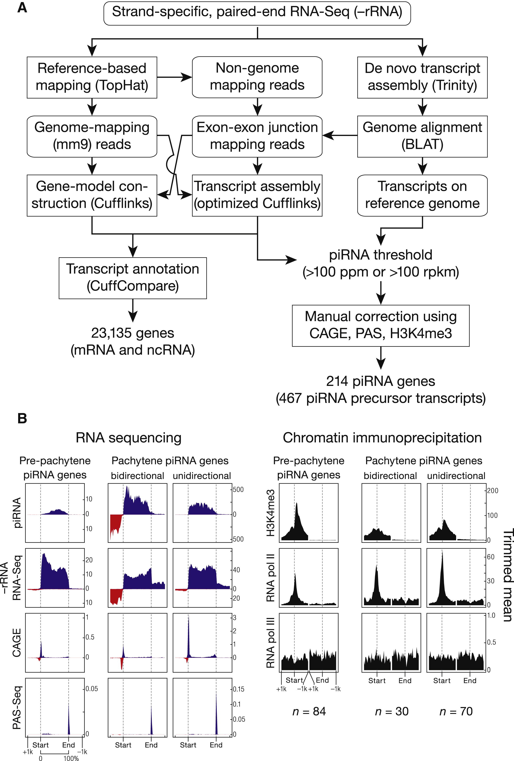

Figure ‑ piRNA Precursors are RNA Pol II Transcripts

(A) Strategy to assemble the mouse testis transcriptome. Rectangles with rounded corners, input or output data; rectangles, processes. Decisions are shown without boxing.(B) Aggregated data for piRNA-producing transcripts (5% trimmed mean). Oxidized small RNA (>23 nt) sequencing data were used to detect piRNAs; transcript abundance was measured using total RNA depleted of rRNA (RNA-seq). RNA Pol III data were from SRA001030. Dotted lines show the transcriptional start site (Start) and site of polyadenylation (End). See also Figure S1 and Table S1.

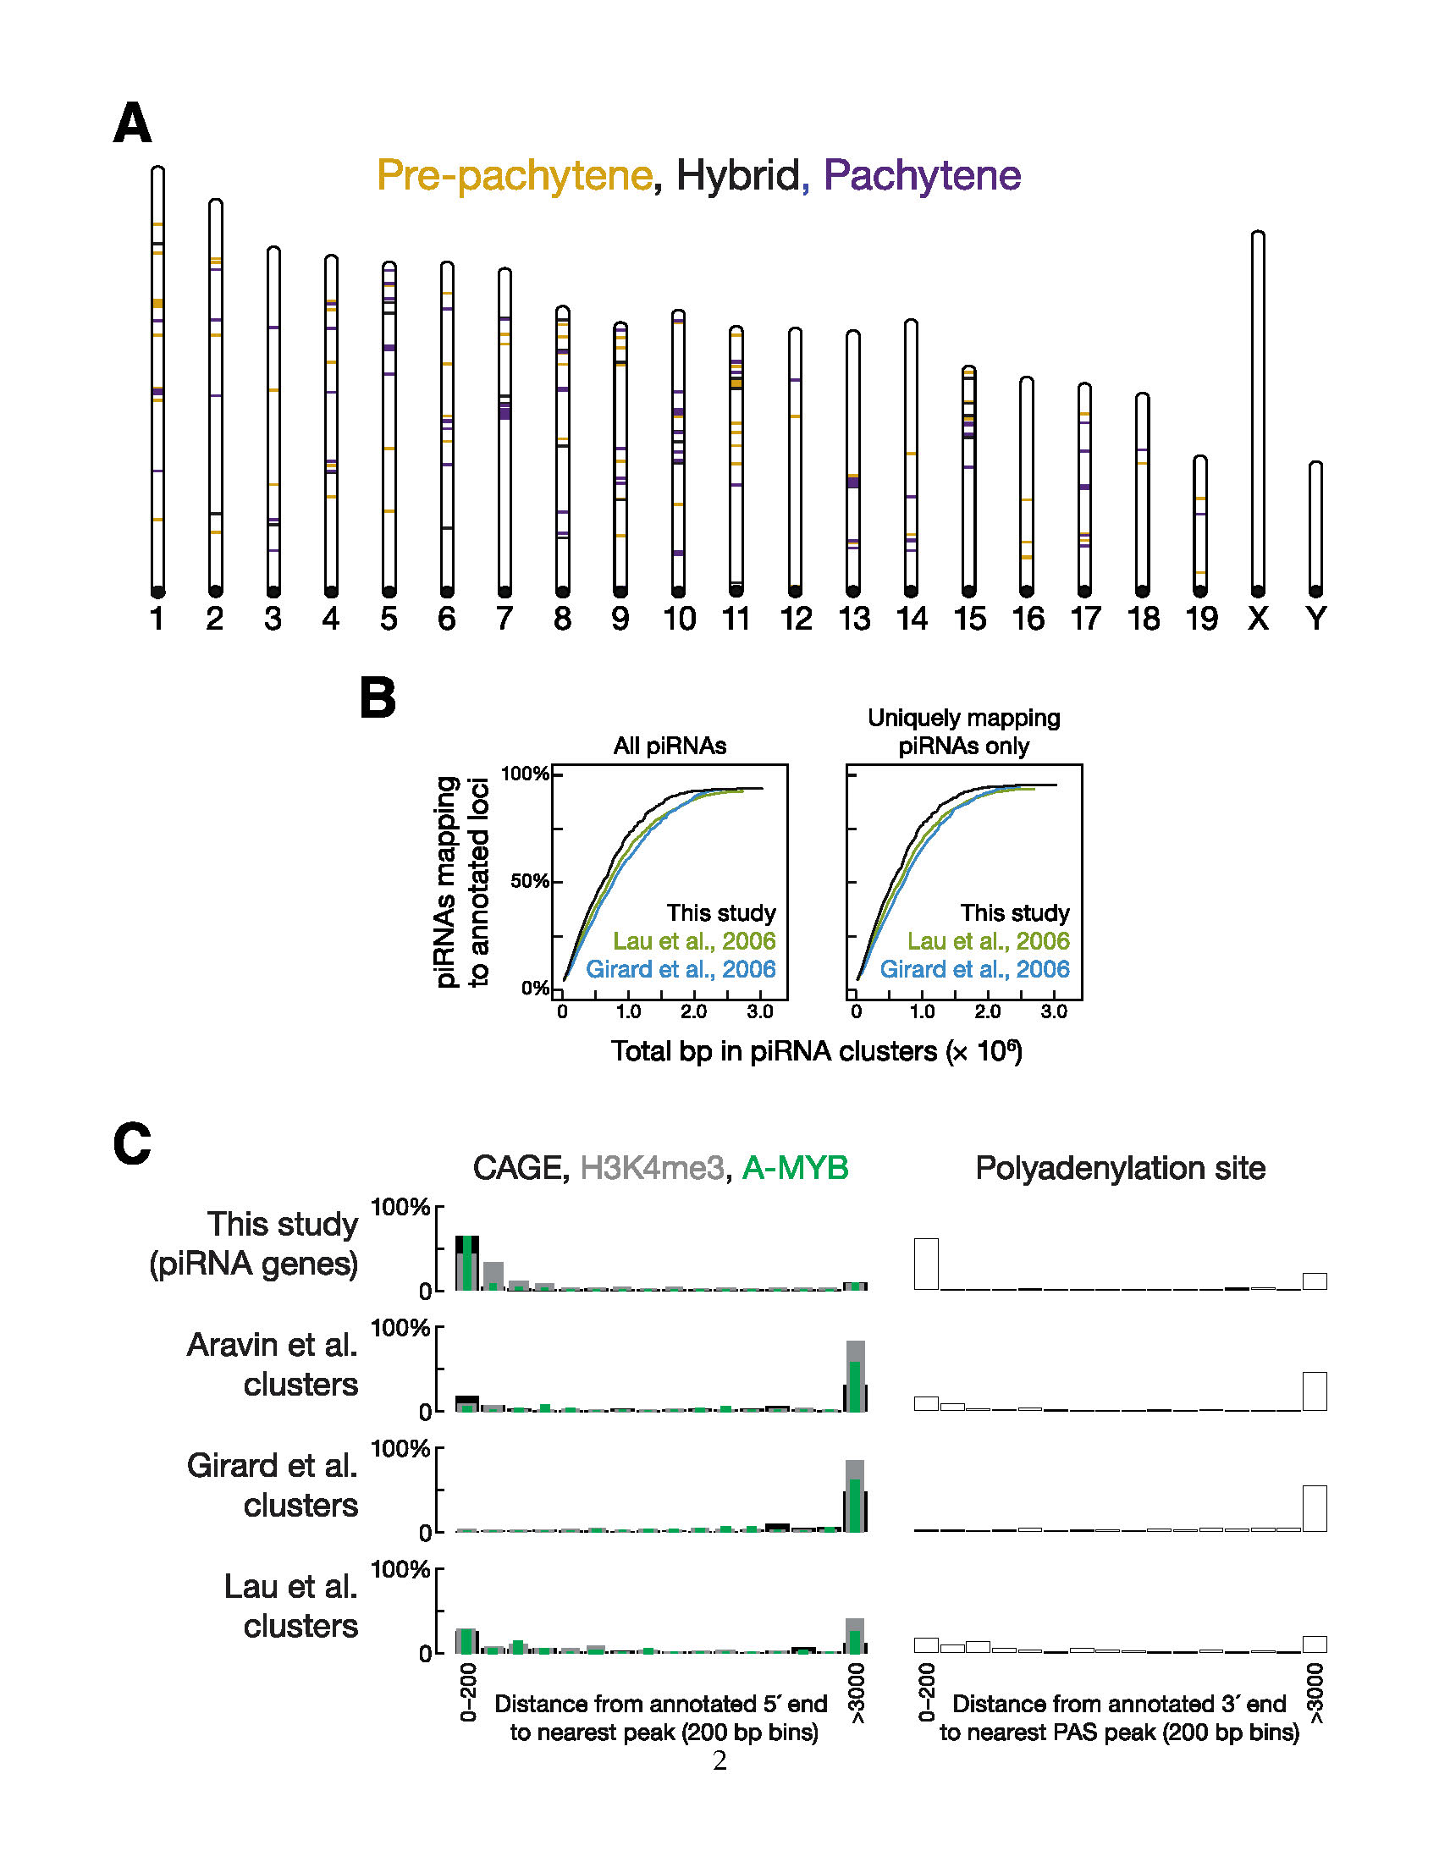

Figure‑‑. The Major piRNA-Producing Genes of the Post-Partum Mouse Testis

(A) Positions of the 214 major piRNA-producing genes on the 19 autosomes of mice. We detected no loci on the X or Y chromosomes. (B) Cumulative distributions for all piRNAs and for uniquely mapping piRNAs comparing the piRNA loci defined by our methods and by previous approaches (Girard et al., 2006; Lau et al., 2006). (C) Histogram of distances (in 200 bp bins) from the annotated 5′ or 3′ end of a piRNA gene (this study) or cluster to the nearest peak of reads from high-throughput sequencing for transcript 5′ (CAGE-seq) or 3′ (PAS-seq) ends, transcription start sites (H3K4me3) or A-MYB binding.

To identify the transcripts that produce piRNAs, we sequenced piRNAs from six developmental stages of mouse testes (10.5 dpp, 12.5 dpp, 14.5 dpp, 17.5 dpp, 20.5 dpp, and adult) and mapped them to the assembled transcripts. The first round of spermatogenesis proceeds synchronously among the tubules of the testis: mouse testes at 10.5 dpp advance no further than the zygotene stage (staging according to Nebel et al., 1961); 12.5 dpp to the early pachytene; 14.5 dpp to the middle pachytene; 17.5 to the late pachytene; and 20.5 dpp to the round spermatid stage. For each stage, we prepared two sequencing libraries: one comprising all small RNAs and one in which oxidation was used to enrich for piRNAs by virtue of their 2′-O-methyl-modified 3′ termini (Ghildiyal et al., 2008).

To qualify as a piRNA-producing transcript, an assembled RNA was required to produce either a sufficiently high piRNA abundance (>100 ppm; parts per million uniquely mapped reads) or density (>100 rpkm; reads per kilobase of transcript per million uniquely mapped reads). These criteria retained both long transcripts producing an abundance of piRNAs and short transcripts generating many piRNAs per unit of length. To refine the termini of each piRNA-producing transcript, we supplemented the RNA-seq data with high-throughput sequencing of the 5′ ends of RNAs bearing an N(5′)ppp(5′)N cap structure (cap analysis of gene expression; CAGE) and the 3′ ends of transcripts preceding the poly(A) tail (polyadenylation site sequencing; PAS-seq). The assembled piRNA-producing transcripts likely correspond to continuous RNAs in vivo because the CAGE library used to annotate transcript 5′ ends was constructed after two rounds of poly(A) selection. Thus, the RNA molecules in the library derive from complete transcripts extending from the 5′ cap to the poly(A) tail (Figure 1B). Conventional 5′ and 3′ RACE (rapid amplification of cDNA ends) analysis of piRNA-producing transcripts confirmed the ends of 16 loci (data not shown). To provide additional confirmation of the 5′ end of each piRNA-producing transcript, we also determined the locations of histone H3 bearing trimethylated lysine 4 (H3K4me3), a histone modification associated with RNA Pol II transcription start sites (Guenther et al., 2007).

##### piRNA Precursor RNAs are Canonical RNA Pol II Transcripts

The presence of 5′ caps and poly(A) tails and the binding of histone H3K4me3 to the genomic DNA immediately upstream of the transcription start site of each piRNA locus suggest that piRNA transcripts are produced by RNA pol II (Figure 1B). Moreover, using antibodies to RNA pol II but not RNA pol III, ChIP-seq showed a peak at the transcription start site as well as polymerase occupancy across the entire piRNA gene (Figure 1B; Kutter et al., 2011). We conclude that piRNA transcripts are conventional RNA pol II transcripts bearing 5′ caps and 3′ poly(A) tails.

##### A Transcript-based Set of piRNA Loci

Our transcriptome assembly yielded 467 piRNA-producing transcripts that define 214 genomic loci (Figure S1A and Table S1). Among the ∼2.2 million distinct piRNA species and ∼8.8 million piRNA reads from the adult mouse testis, the 214 genomic loci account for 95% of all piRNAs.

Previous studies defined piRNA clusters based solely on small RNA sequencing data (Girard et al., 2006; Lau et al., 2006; Aravin et al., 2007). Our approach differs in that it (1) uses RNA-seq data, whose greater read length facilitates the identification of introns, allowing us to define the architecture of piRNA precursor transcripts and (2) uses CAGE, PAS-seq, and H3K4me3 ChIP-seq data to refine the 5′ and 3′ ends of the piRNA transcripts. Consequently, the piRNA loci presented here account for more piRNAs using fewer genomic base pairs than those previously defined (Figures S1B and S1C; Lau et al., 2006; Girard et al., 2006). Our piRNA-producing loci include 41 piRNA loci that escaped previous detection (Girard et al., 2006; Lau et al., 2006; Aravin et al., 2007), 37 of which contain introns. The 41 loci account for 2% of piRNAs at 10.5 dpp and 0.36% in the adult testis.

##### Three Classes of piRNAs During Post-Natal Spermatogenesis

Mice produce three PIWI proteins: MIWI2 (PIWIL4), which binds piRNAs in perinatal testis (Carmell et al., 2007; Aravin et al., 2008); MILI (PIWIL2), which binds piRNAs at least until the round spermatid stage of spermatogenesis (Kuramochi-Miyagawa et al., 2004; Aravin et al., 2006, 2007); and MIWI (PIWILl), which is first produced during the pachytene stage of meiosis (Deng and Lin, 2002). From 10.5 to 20.5 dpp, piRNA abundance increases and longer piRNAs appear, reflecting a switch from MILI-bound piRNAs, which have a 26–27 nt modal length (Montgomery et al., 1998; Aravin et al., 2006, 2008; Robine et al., 2009), to MIWI-bound piRNAs, which have a 30 nt modal length (Figure S2A; Reuter et al., 2009; Robine et al., 2009). This switch occurs at the pachytene phase of meiosis. MILI-bound pre-pachytene piRNAs predominate before the onset of pachynema; at the pachytene and round spermatid stages, most piRNAs are MIWI-bound pachytene piRNAs.

We used hierarchical clustering to analyze the change in piRNA abundance from 10.5 to 20.5 dpp for the 214 genes defined by our data (Figures 2A and S2A and Table S2). Three types of piRNA-producing genes were identified according to when their piRNAs first accumulate and how their expression changes during spermatogenesis: 84 pre-pachytene, 100 pachytene, and 30 hybrid loci. At 10.5 dpp, the earliest time we evaluated, 84 genes dominate piRNA production (median piRNA abundance per gene = 16 rpkm; Figure 2B). Nearly all (81 out of 84) were congruent with protein-coding genes. The 84 pre-pachytene piRNA genes account for 13% of piRNAs at 10.5 dpp, but only 0.31% of piRNAs in the adult testis. Of the pre-pachytene piRNAs accounted for by the 84 loci, 15% derive from 31 piRNA-producing genes that, to our knowledge, have not previously been described.

.

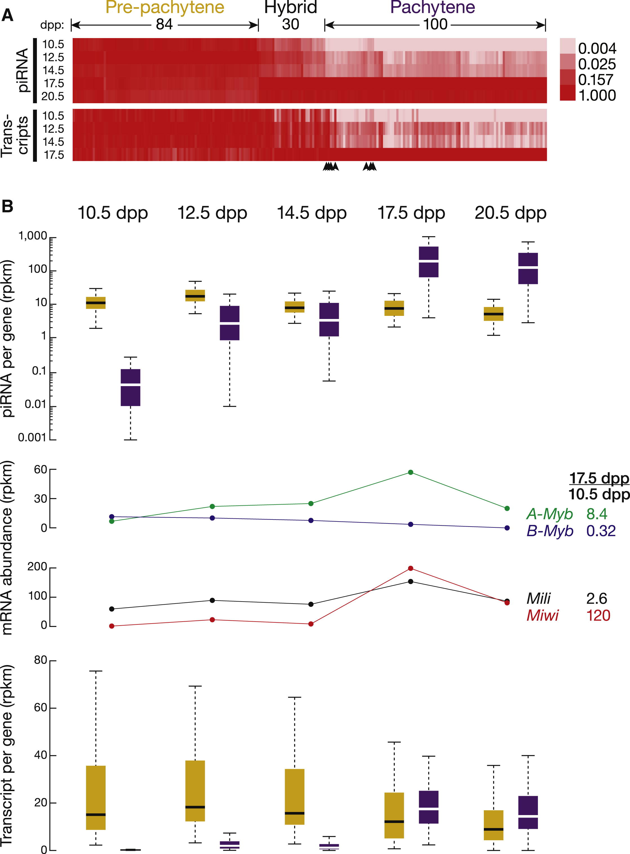

Figure ‑ Three Classes of piRNA-Generating Loci

(A) Normalized piRNA density (rpkm) for each piRNA-producing gene is shown as a heatmap across the developmental stages. Hierarchical clustering divided the genes into three classes. Arrowheads mark seven pachytene piRNA genes that were not classified as pachytene according to the change in the abundance of their precursor RNAs from 10.5 to 17.5 dpp.(B) Top: box plots present piRNA density per gene as spermatogenesis progresses (here and elsewhere, pre-pachytene in yellow and pachytene in purple). Middle: expression of A-Myb, B-Myb, Mili, and Miwi was measured by RNA-seq. Bottom: box plots present piRNA precursor expression per gene, measured by RNA-seq, from 10.5 to 20.5 dpp. See also Figure S2 and Table S2.

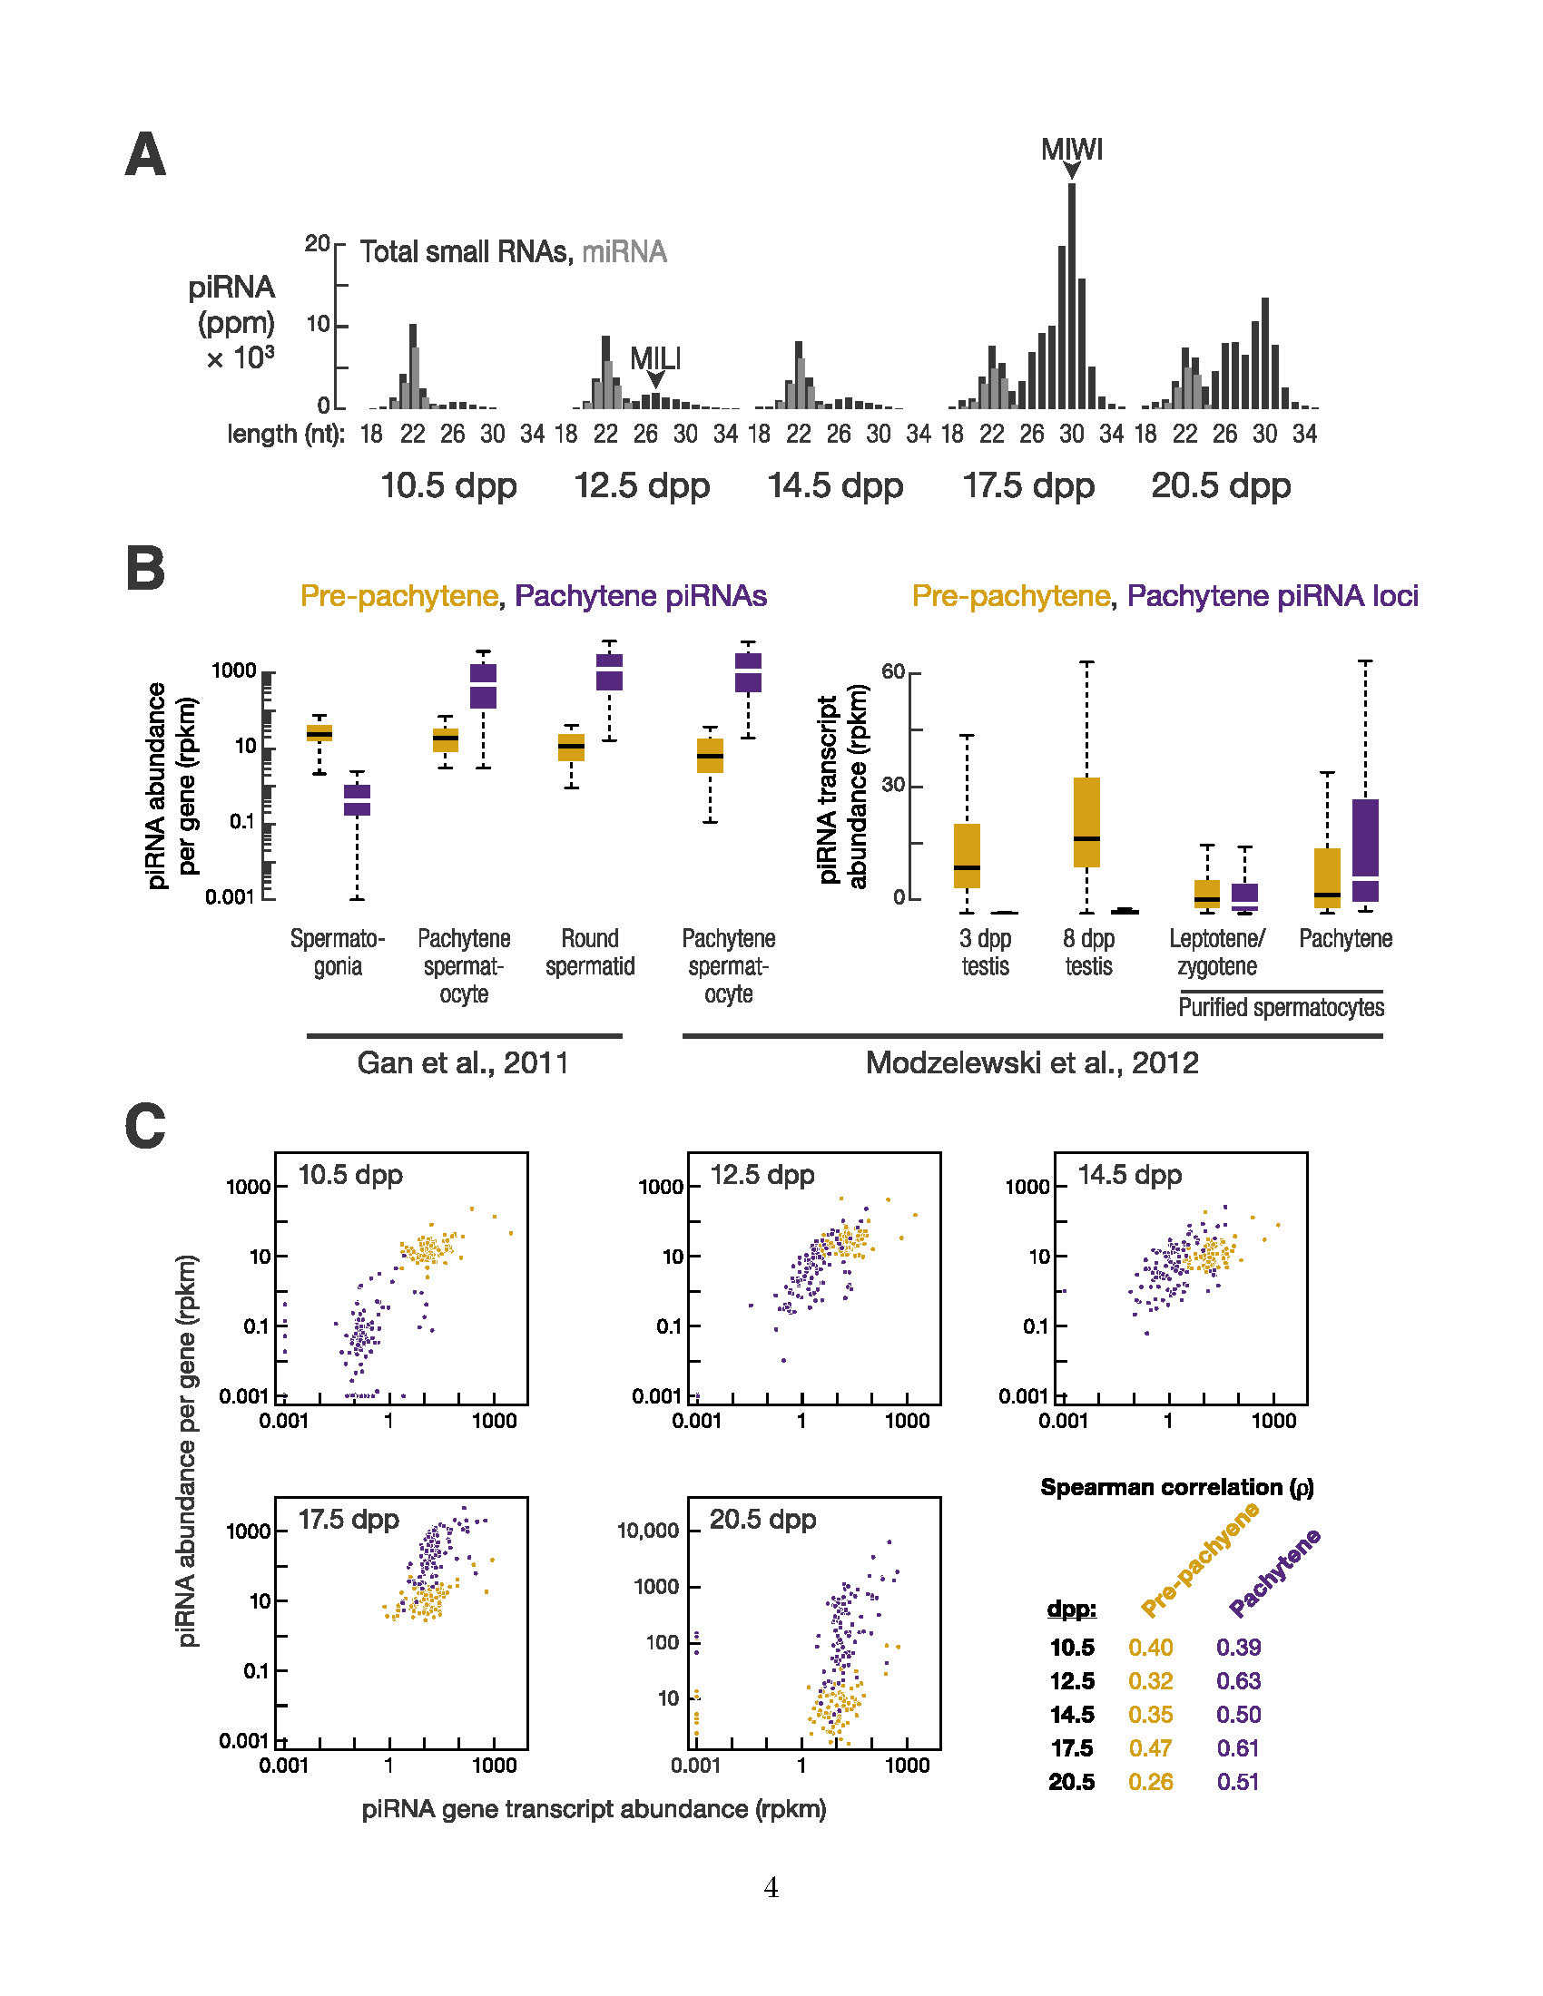

Figure ‑ Pre-pachytene piRNAs Persist in Pachytene Spermatocytes

(A) As shown previously by others using lower temporal resolution, the modal length of piRNAs increases as spermatogenesis proceeds to more advanced stages. (B) Total piRNA rpkm abundance and piRNA transcript abundance per locus by class, from purified spermatogonia, spermatocytes, round spermatids, and 3 dpp and 8 dpp testis (Gan et al., 2011; Modzelewski et al., 2012). (C) Correlation between piRNA abundance per locus and piRNA precursor transcription from 10.5 to 20.5 dpp. Throughout the Supplemental Figures, gold indicates pre-pachytene and purple indicates pachytene piRNA loci.

A parallel analysis of piRNA precursor transcription using RNA-seq (>100 nt) corroborated the classification based on piRNA abundance; of the 100 piRNA genes classified as pachytene based on the developmental expression profile of their piRNAs, 93 were grouped as pachytene according to the developmental expression profile of their transcripts. Of these 93, 89 are intergenic. All 84 piRNA genes designated pre-pachytene using piRNA data were classified as pre-pachytene according to their transcript abundance.

Despite their name, pre-pachytene piRNAs were readily detected in >90% and ∼95% pure pachytene spermatocytes, as well as round spermatids (Figure S2B; Gan et al., 2011; Modzelewski et al., 2012). Transcript abundance from the 84 pre-pachytene loci was high at 3 dpp (median abundance = 11 rpkm), higher by 8 dpp (18 rpkm), and lower in purified leptotene/zygotene spermatocytes (3.3 rpkm; Figure S2B). Yet piRNA precursor transcripts were readily detectable in purified pachytene spermatocytes at a level (4.6 rpkm) comparable to that in purified leptotene/zygotene spermatocytes (Figure S2B; Gan et al., 2011; Modzelewski et al., 2012). From 10.5 to 20.5 dpp, the steady-state level of pre-pachytene piRNA precursor transcripts remained constant (Figure 2B).

Finally, the abundance of pre-pachytene piRNA precursor transcripts was better correlated with pre-pachytene piRNA abundance at 17.5 dpp (ρ = 0.47), when pachytene spermatocytes compose a larger fraction of the testis, than at 10.5, 12.5, or 14.5 dpp (0.32 ≤ ρ ≤ 0.40; Figure S2C). Our data suggest that the pre-pachytene loci continue to be transcribed and processed into piRNAs long after spermatocytes enter the pachytene stage of meiosis. Thus, the name pre-pachytene piRNA is a misnomer that should be retained only for historical reasons.

Hierarchical clustering identified 100 pachytene genes whose piRNAs emerge at 12.5 dpp, 2 days earlier than previously reported (Girard et al., 2006). Nearly all the pachytene genes are intergenic (93 out of 100). piRNA expression from pachytene piRNA genes peaks at 17.5 dpp (Figure 2B). Overall, the median abundance of piRNAs from these 100 loci increased >6,000-fold from 10.5 to 17.5 dpp. Transcripts from pachytene genes were low at 10.5 dpp (median abundance = 0.15 rpkm) and increased 116-fold from 10.5 to 17.5 dpp. From 10.5 to 20.5 dpp, the dynamics of pachytene piRNA abundance from each piRNA gene correlated with the increase in abundance of its precursor transcripts (0.39 ≤ ρ ≤ 0.63; p value ≤ 7.3 × 10−5; Figure S2C). The 100 pachytene genes account for 92% of piRNAs in the adult testis, making it unlikely that biologically functional pachytene piRNAs originate from thousands of genomic loci (Gan et al., 2011). Figures 3 and S3 provide examples of pachytene and pre-pachytene piRNA genes defined by our data..

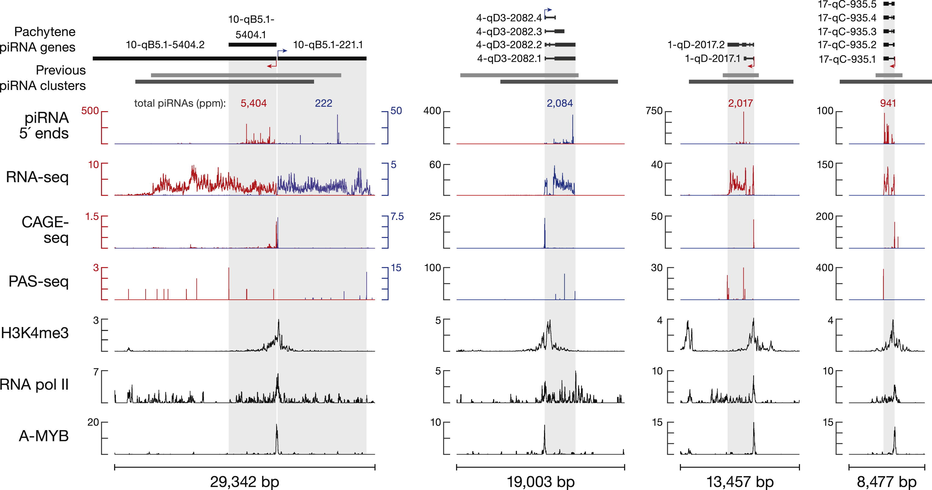

Figure ‑ Examples of Pachytene piRNA Genes

Previous cluster boundaries are from Lau et al. (2006; gray) and Girard et al. (2006; dark gray).

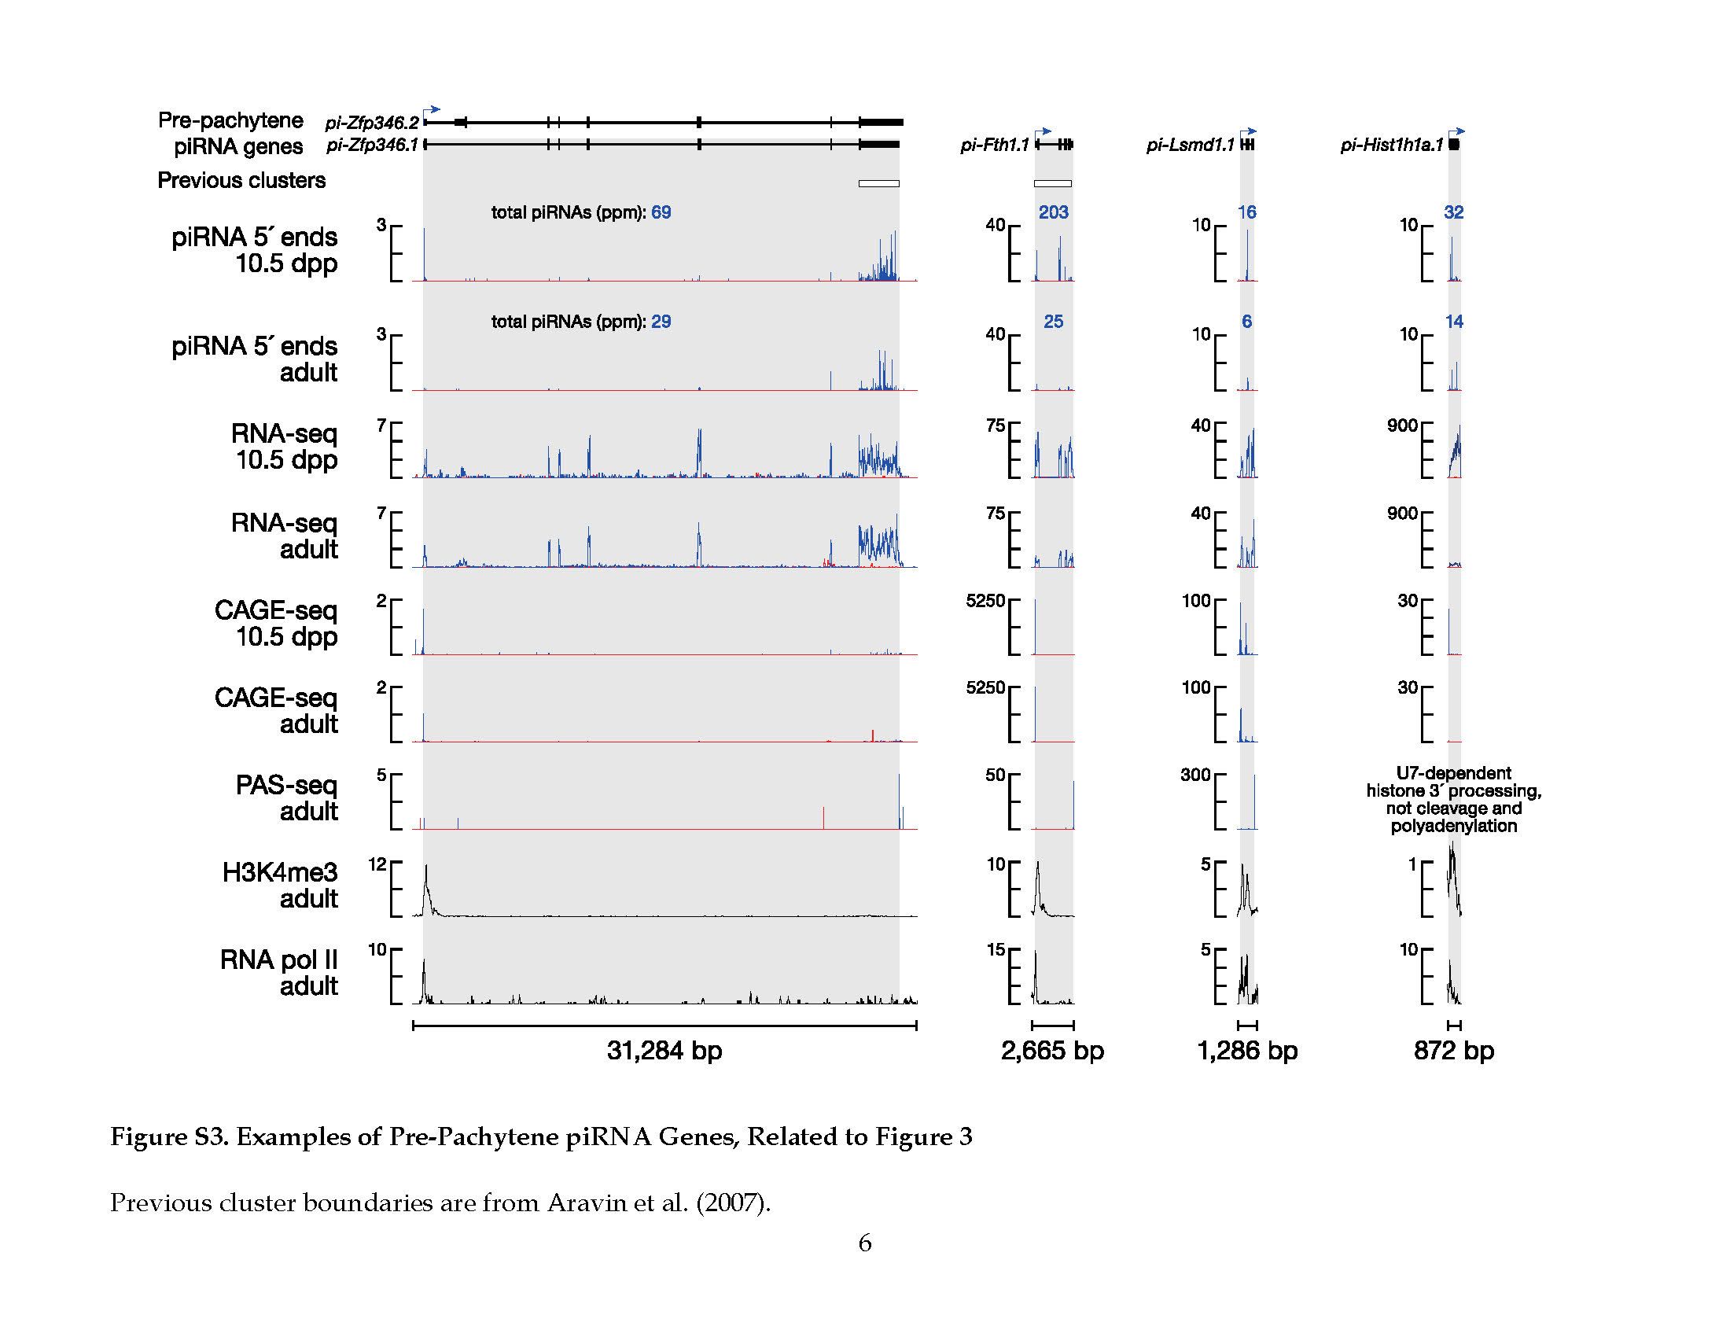

Figure ‑ Examples of Pre-Pachytene piRNA Genes

Previous cluster boundaries are from Lau et al. (2006; gray) and Girard et al. (2006; dark gray).

Hierarchical clustering detected a third class, hybrid piRNAs, which derives from 30 genes with characteristics of both pre-pachytene and pachytene piRNA loci. Like pre-pachytene, hybrid piRNAs were detected at 10.5 dpp (median abundance = 3.7 rpkm) and in purified spermatogonia (Gan et al., 2011). Like pachytene piRNAs, hybrid piRNA abundance increased during the pachytene stage of meiosis, but the increase was delayed until late (17.5 dpp) rather than early pachynema (14.5 dpp). Overall, piRNAs from hybrid genes increased >10-fold from 14.5 to 17.5 dpp. The median abundance of piRNAs from hybrid piRNA genes ranged from 90–120 rpkm in purified pachytene spermatocytes, >20-fold greater than their median abundance in spermatogonia (Gan et al., 2011; Modzelewski et al., 2012). Moreover, hybrid piRNA precursor transcripts were readily detected in purified pachytene spermatocytes (median abundance = 9.0 rpkm; Modzelewski et al., 2012).

##### A-Myb Regulates Pachytene piRNA Precursor Transcription

The coordinated increase in pachytene piRNA precursor transcripts suggests their regulation by a common transcription factor or factors. Among the 100 pachytene piRNA genes, 15 pairs (30 genes) are divergently transcribed. The 5′ ends of the piRNA precursor RNAs from each pair are close in genomic distance (median = 127 bp), suggesting that a shared promoter lies between the two transcription start sites.

We took advantage of the unique genomic organization of these 15 pairs of divergently transcribed piRNA genes to search for sequence motifs common to their promoters. The MEME algorithm (Bailey and Elkan, 1994) revealed a motif highly enriched in these bidirectional promoters (E = 8.3 × 10−12; Figure 4A). This motif matches the binding site of the Myb family of transcription factors (Figure 4A; Gupta et al., 2007; Newburger and Bulyk, 2009). The Myb motif is not restricted to bidirectional promoters; MEME identified the same motif using the promoters of all pachytene piRNA genes (E = 9.1 × 10−28; Figure 4B).

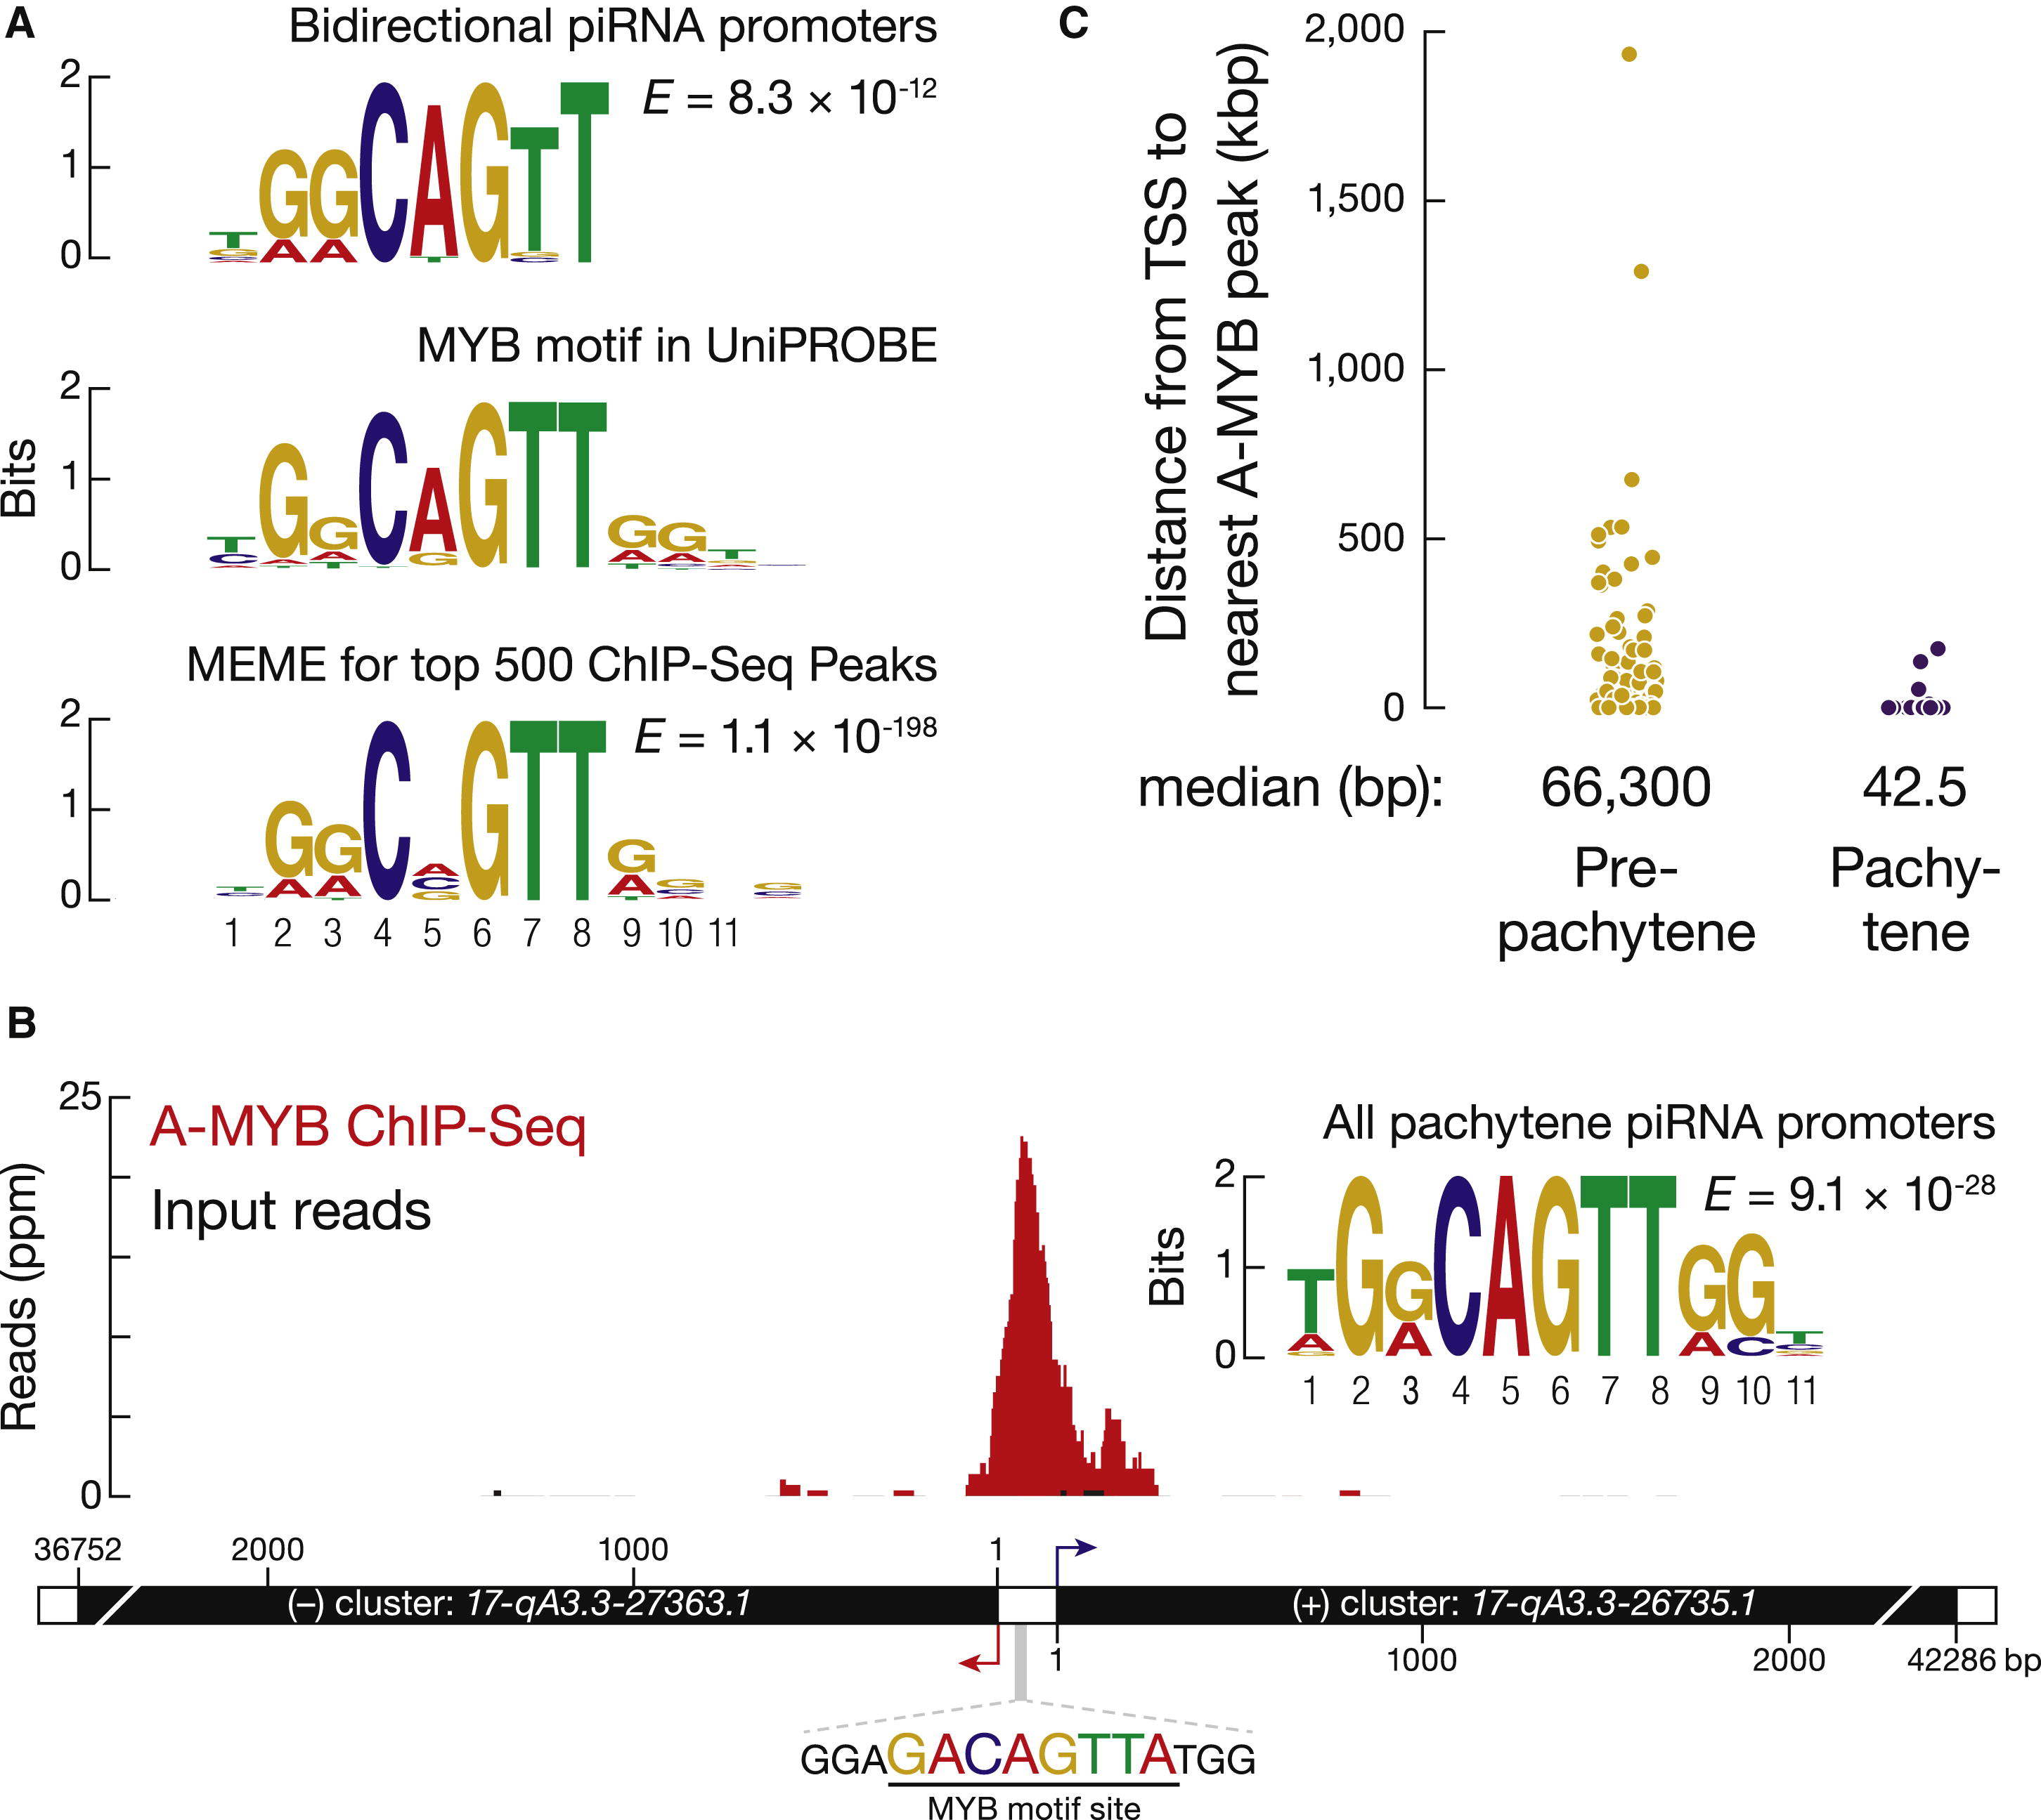

Figure ‑. A-MYB Binds the Promoters of Pachytene piRNA Genes

(A) Top: MEME identified a sequence motif in the bidirectional promoters of the 15 pairs of divergently transcribed pachytene piRNA genes. E value computed by MEME measures the statistical significance of the motif. Middle: Myb motif from the mouse UniPROBE database. Bottom: MEME-reported motif for the top 500 (by peak score) A-MYB ChIP-seq peaks from adult mouse testes.(B) A-MYB ChIP-seq data for the common promoter of the divergently transcribed pachytene piRNA genes 17-qA3.3-27363.1 and 17-qA3.3-26735.1.(C) The distance from the annotated transcription start site (TSS) of each piRNA gene to the nearest A-MYB peak. See also Figure S4.

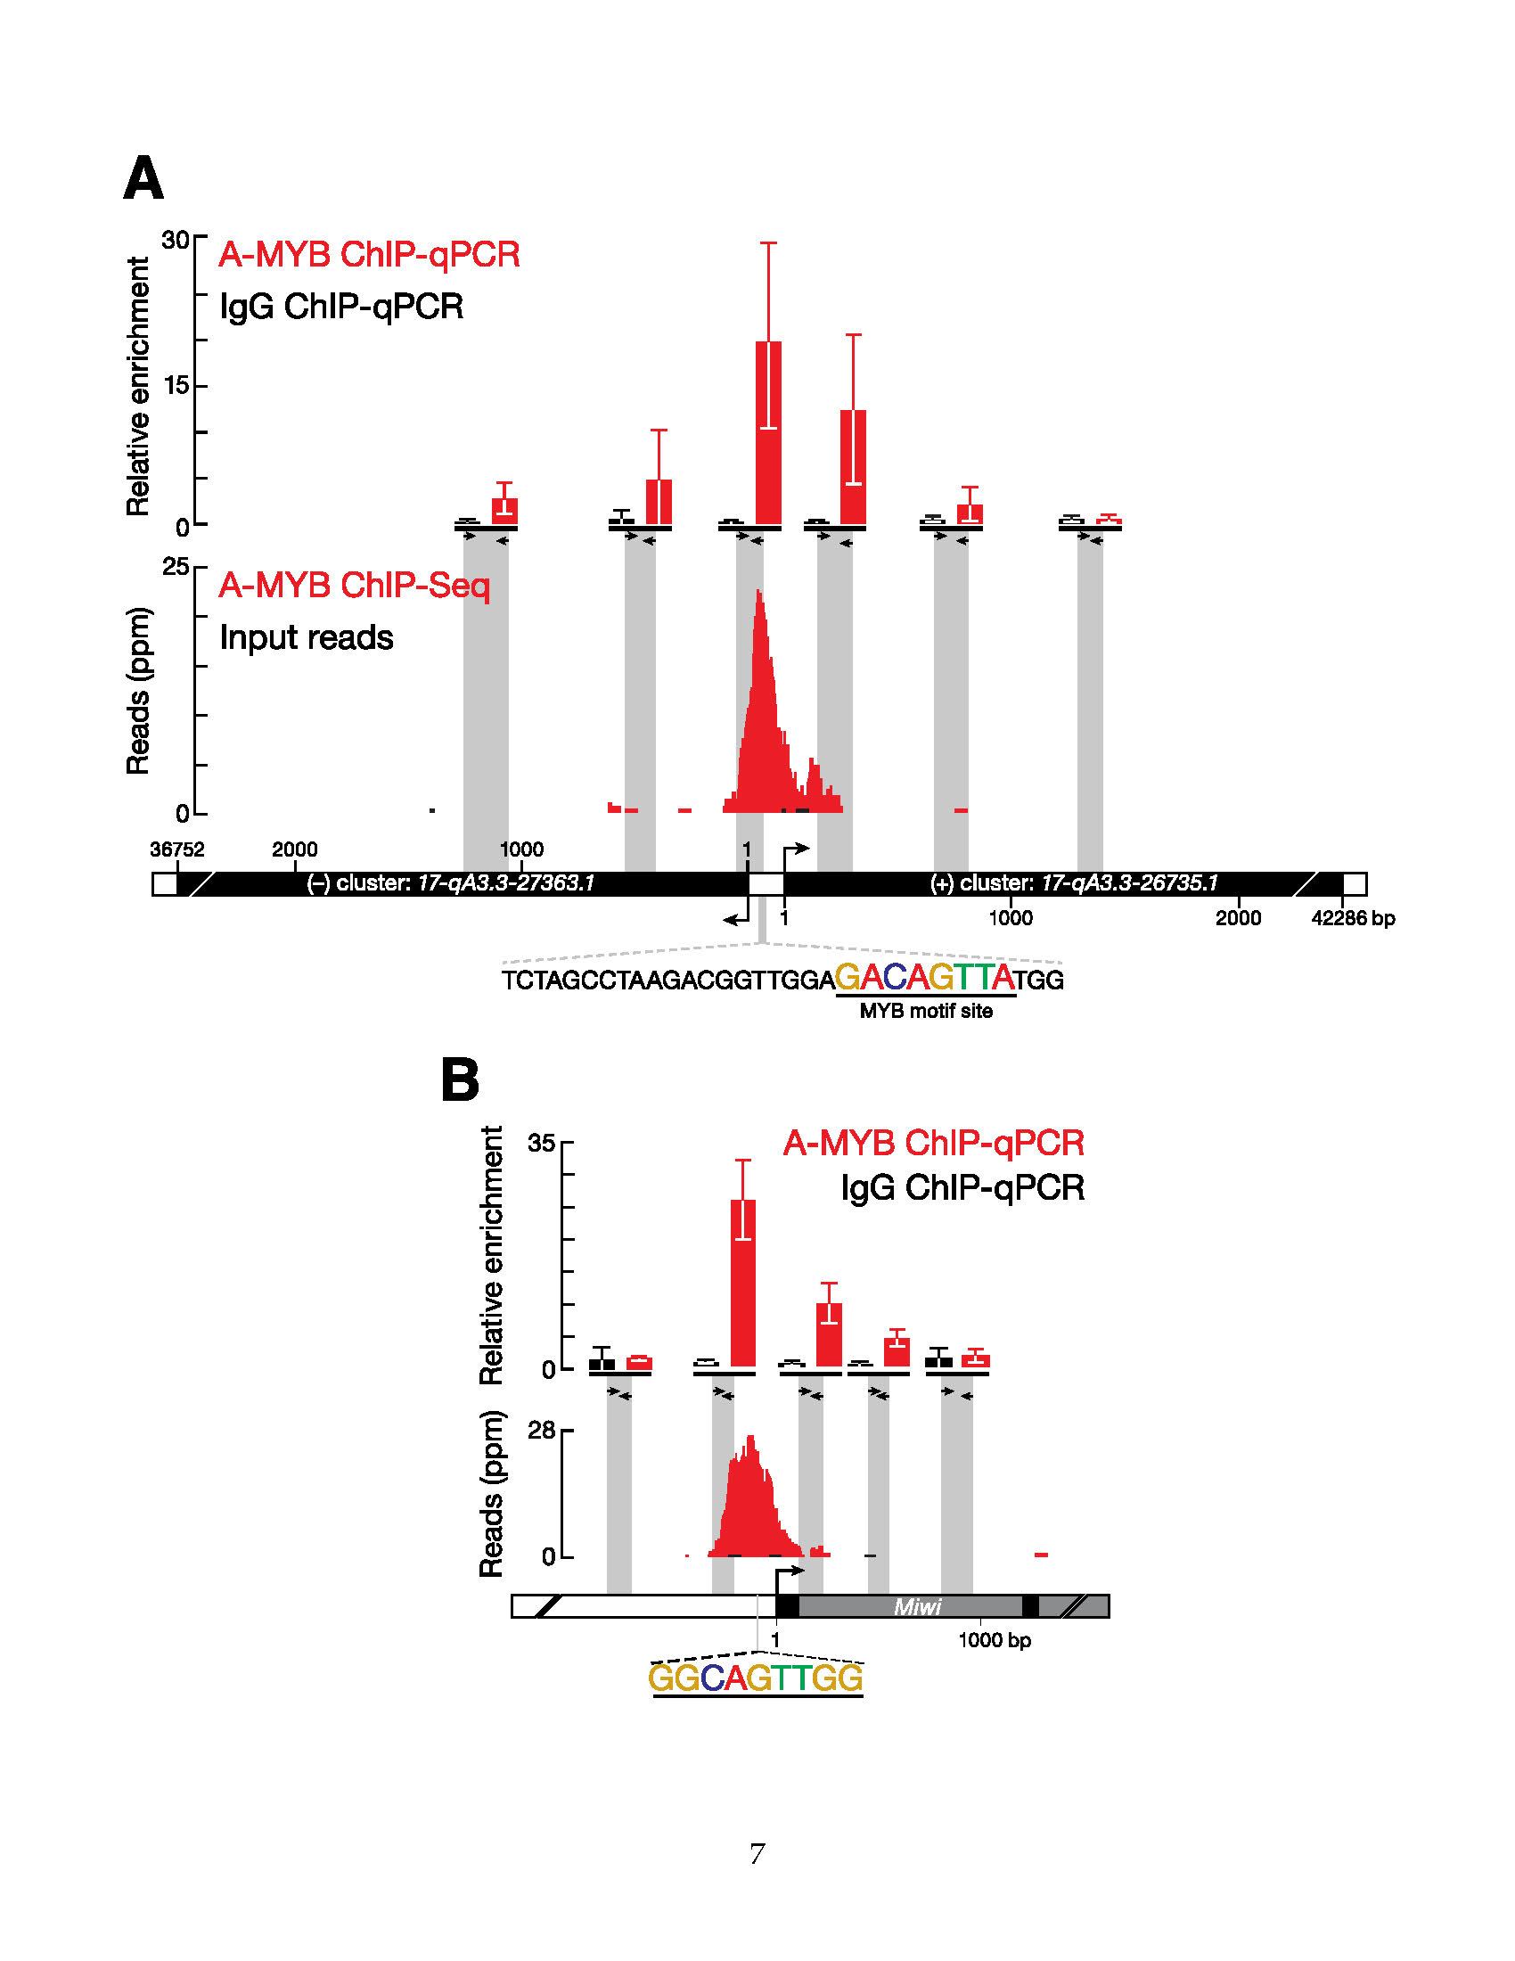

Figure ‑ ChIP-qPCR Confirms ChIP-seq Data

(A) A-MYB binds to the common promoter of divergently transcribed pachytene piRNA loci 17-qA3.3-27363.1 and 17-qA3.3-26735.1. The abundance of DNA fragments at the amplified region relative to a control region (mean ± standard deviation; n = 3) was measured by qPCR (top). The A-MYB ChIP-seq (red) and input (black) data for this pair of genes is presented as in Figure 4B. (B) ChIP-seq and qPCR were as in (A), but for the promoter region of Miwi (Piwil1). Also shown is the RefSeq gene model. Exons, black; introns, gray.

The Myb transcription factor family is conserved among eukaryotes. Like other vertebrates, mice produce three Myb proteins, A-MYB (MYBL1), B-MYB (MYBL2), and C-MYB (MYB), each with a distinct tissue distribution (Mettus et al., 1994; Trauth et al., 1994; Latham et al., 1996; Oh and Reddy, 1999). Testes produce both A- and B-MYB proteins. Multiple lines of evidence implicate A-MYB, rather than B-MYB, as a candidate for regulating pachytene piRNA transcription. First, the expression of A-Myb during spermatogenesis resembles that of pachytene piRNAs: A-Myb transcripts appear at ∼12.5 dpp and peak at 17.5 dpp (Figure 2B; Bolcun-Filas et al., 2011). The expression of A-Myb messenger RNA (mRNA) increases ∼15-fold from 8 dpp to 19 dpp, whereas B-Myb mRNA expression remains constant and low during the same time frame and into adulthood (Horvath et al., 2009). Our RNA-seq data (Figure 2B) corroborate these findings. Indeed, in our RNA-seq analysis of adult testes, A-Myb mRNA was 24-fold more abundant than B-Myb. Second, a testis-specific A-Myb point-mutant allele, Mybl1repro9, which is caused by a cytosine-to-adenine transversion that changes alanine 213 to glutamic acid, leads to meiotic arrest at the pachytene stage with subtle defects in autosome synapsis; A-Myb null mutant mice have defects in multiple tissues, including the testis and the mammary gland (Toscani et al., 1997; Bolcun-Filas et al., 2011). Third, our RNA-seq analysis of A-Myb mutant testes shows that there is no significant change in B-Myb expression in the mutant, compared to the heterozygous controls, at 14.5 or 17.5 dpp. Finally, B-MYB protein is not detectable in pachytene spermatocytes (Horvath et al., 2009).

To assess more directly the role of A-MYB in pachytene piRNA precursor transcription, we used anti-A-MYB antibody to perform ChIP followed by high-throughput sequencing of the A-MYB-bound DNA. The anti-A-MYB antibody is specific for A-MYB, and the peptide used to raise the antibody is not present in B-MYB. The model-based analysis of ChIP-seq (MACS) algorithm (Zhang et al., 2008) reported 3,815 genomic regions with significant A-MYB binding (false discovery rate, FDR < 10−25); we call these regions A-MYB peaks or peaks. Among the 500 peaks with the lowest FDR values, 394 (80%) contained at least one significant site (p < 10−4) for the MYB binding motif (Figure 4A). Figure 4B shows an example of such an A-MYB peak at the bidirectional promoter of the divergently transcribed pair of pachytene piRNA genes 17-qA3.3-27363.1 and 17-qA3.3-26735.1. A-MYB occupancy of this genomic site was confirmed by ChIP and quantitative PCR (ChIP-qPCR) (Figure S4A).

The median distance from the transcription start site to the nearest A-MYB peak was ∼43 bp for the 100 pachytene piRNA genes but >66,000 bp for the 84 pre-pachytene genes (Figure 4C). Our data suggest that during mouse spermatogenesis A-MYB binds to the promoters of both divergently and unidirectionally transcribed pachytene piRNA genes.

To test the idea that A-MYB promotes transcription of pachytene, but not pre-pachytene, piRNA genes, we used RNA-seq to measure the abundance of RNA > 100 nt long from the testes of A-Myb point-mutant (Mybl1repro9) mice and their heterozygous littermates (Figure 5). Pachytene piRNA precursor transcripts—both divergently and unidirectionally transcribed—were significantly depleted in A-Myb mutant testes compared to the heterozygotes: the median decrease was 45-fold at 14.5 dpp (q = 1.1 × 10−13) and 248-fold at 17.5 dpp (q = 3.9 × 10−23). The abundance of pre-pachytene piRNA transcripts was not significantly changed (q ≥ 0.34). The binding of A-MYB to the promoters of pachytene piRNA genes, together with the depletion of pachytene piRNA transcripts in the A-Myb mutant, further supports the view that A-MYB directly regulates transcription of pachytene piRNA genes.

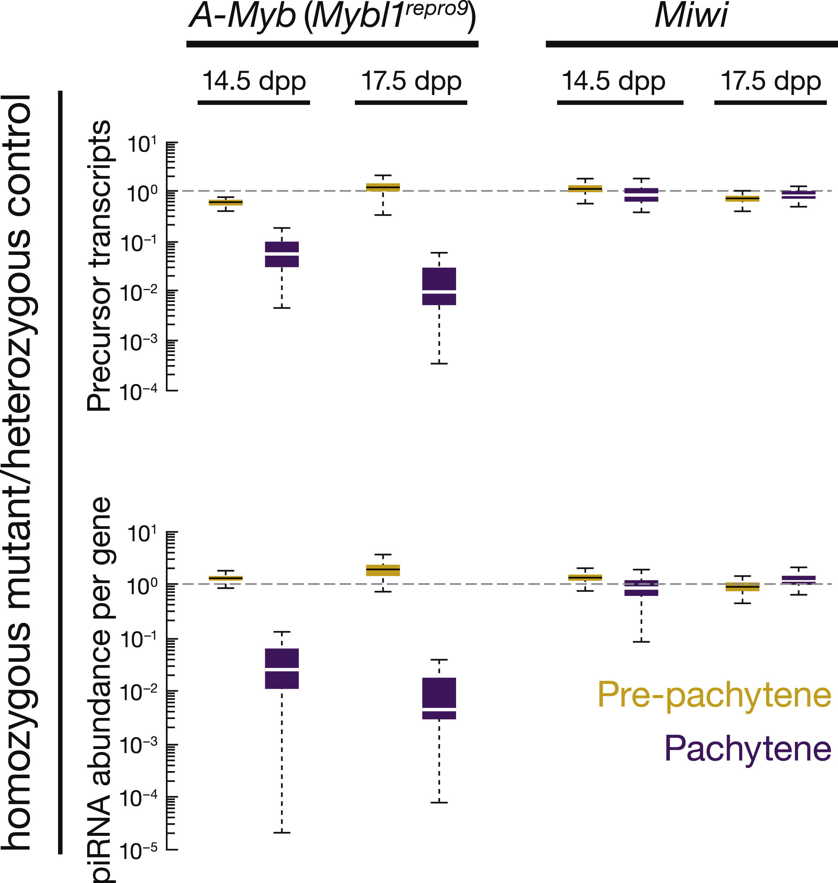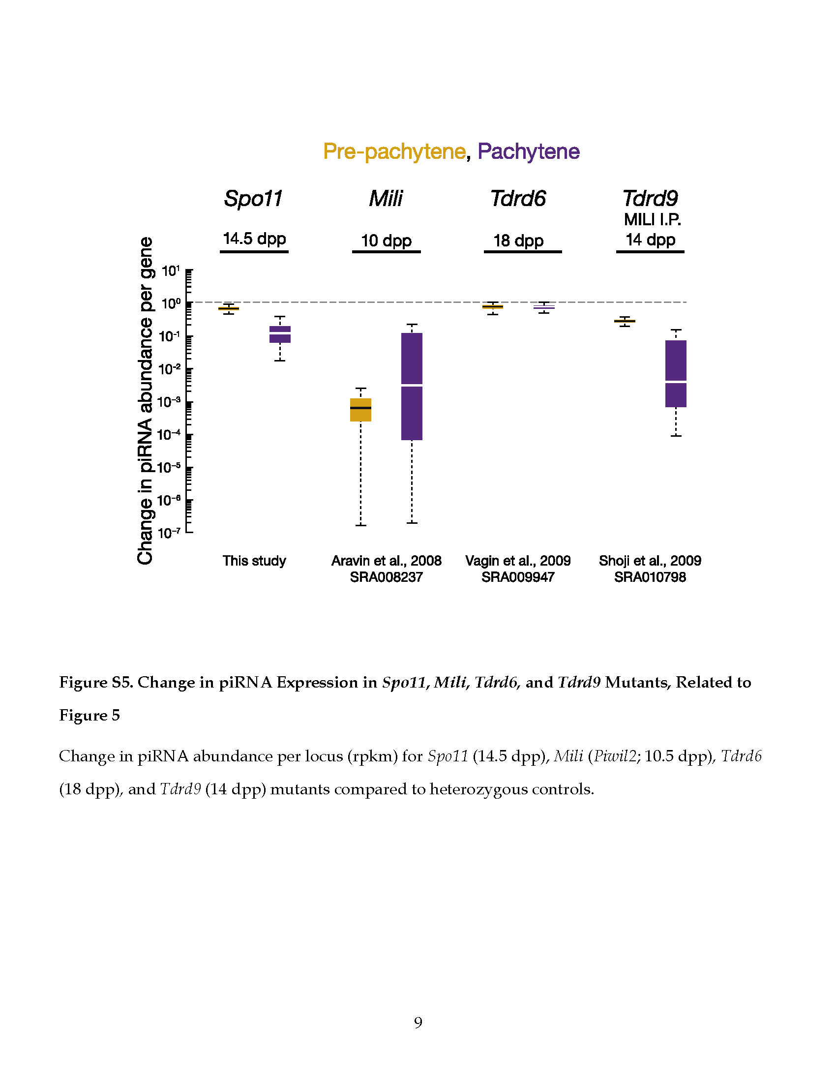

Figure ‑ Change in piRNA Expression in A-Myb, *Spo11*, *Mili, Tdrd6*, and *Tdrd9* Mutants

(Left) The change in transcript or piRNA abundance per gene in A-Myb (n = 3) and Miwi (n = 1) mutants compared to heterozygotes in testes isolated at 14.5 and 17.5 dpp. (Right) Change in piRNA abundance per locus (rpkm) for Spo11 (14.5 dpp), Mili (Piwil2; 10.5 dpp), Tdrd6 (18 dpp), and Tdrd9 (14 dpp) mutants compared to heterozygous controls.

##### A-Myb Regulates Pachytene piRNA Production

To test the consequences of the loss of piRNA precursor transcripts, we measured piRNA abundance in the A-Myb mutant. Like pachytene piRNA precursor transcription, pachytene piRNA abundance significantly decreased in mutant testes. At 14.5 dpp, median piRNA abundance per pachytene gene decreased 87-fold in A-Myb homozygous mutant testes compared to heterozygotes (p < 2.2 × 10−16; Figure 5). By 17.5 dpp, median pachytene piRNA abundance was >9,000 times lower in the A-Myb mutant than the heterozygotes (p < 2.2 × 10−16). In contrast, pre-pachytene piRNA levels were essentially unaltered. Figure 6 presents examples of the effect at 14.5 and 17.5 dpp of the A-Myb mutant on piRNA precursor transcript and mature piRNA abundance for one pre-pachytene and three pachytene piRNA genes.

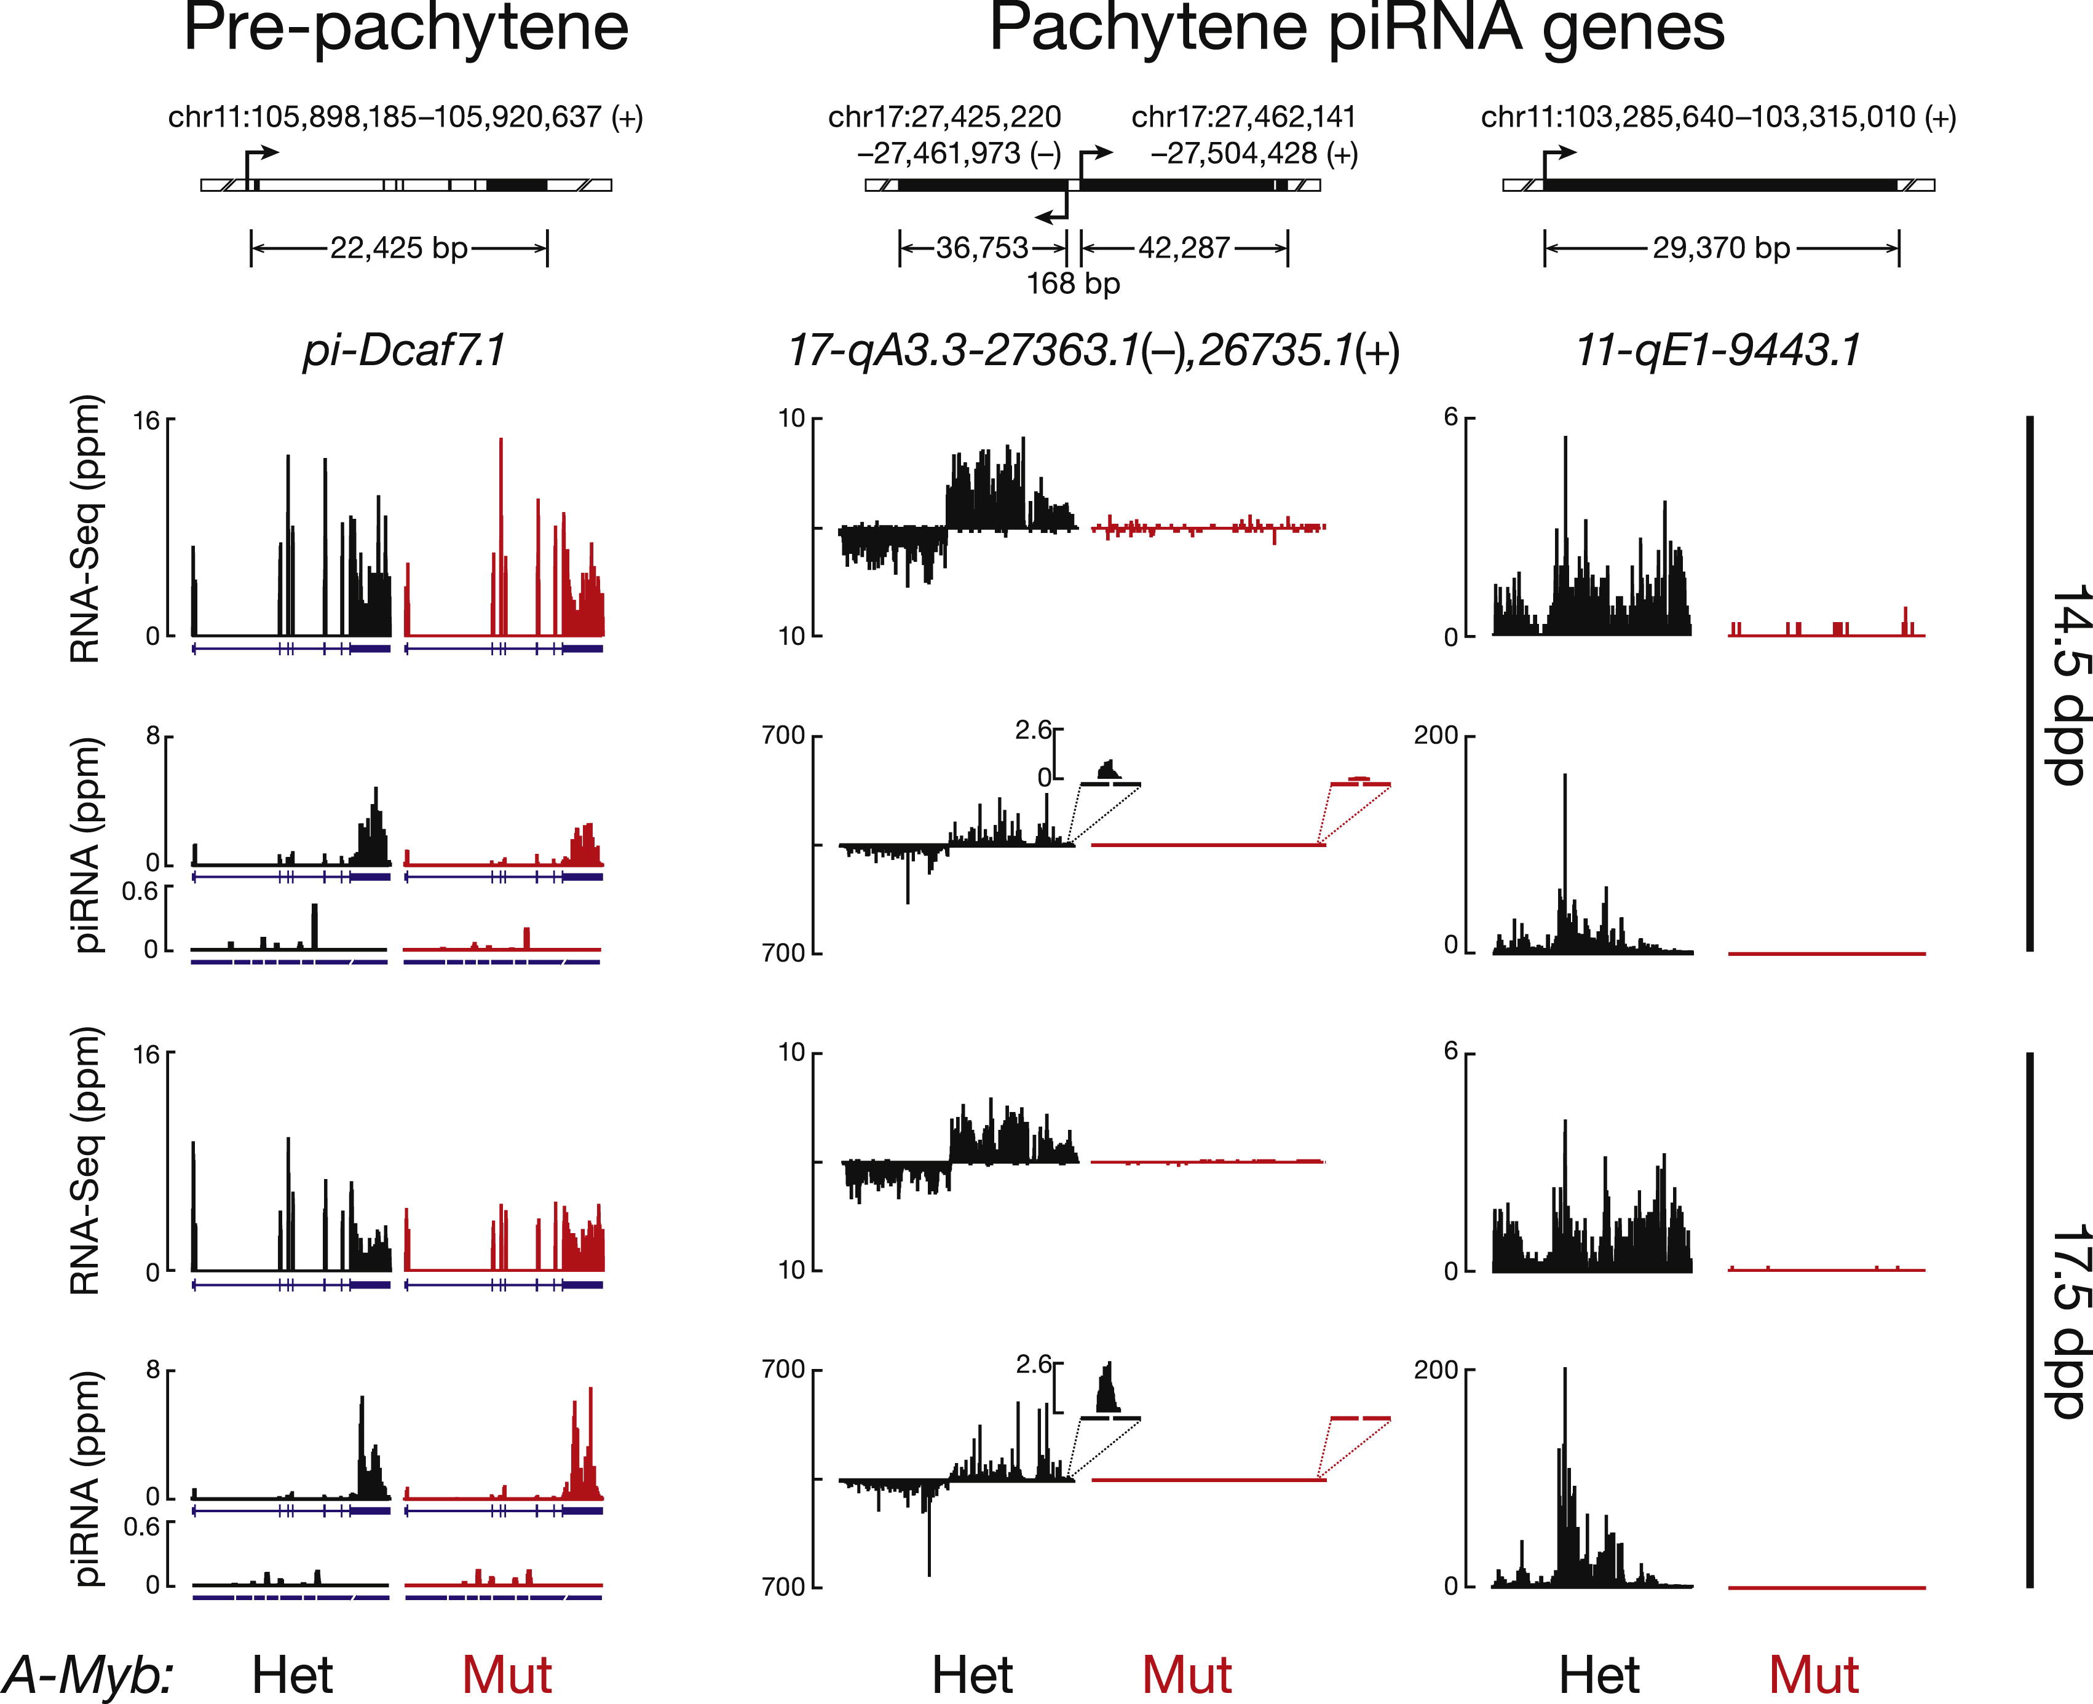

Figure ‑ Examples of the Effect of the A-Myb Mutant on piRNA Expression

Transcript (rpkm) and piRNA (ppm) abundance in heterozygous (Het) and homozygous A-Myb (Mut) point mutant testes is shown for four illustrative examples at 14.5 and 17.5 dpp. Also shown is the abundance of piRNA sequencing reads that map to the exon-exon junctions. Gene 11-qE1-9443 does not have an intron. Exons, blue boxes; splice junctions, gaps; the last exon is compressed and not to scale.

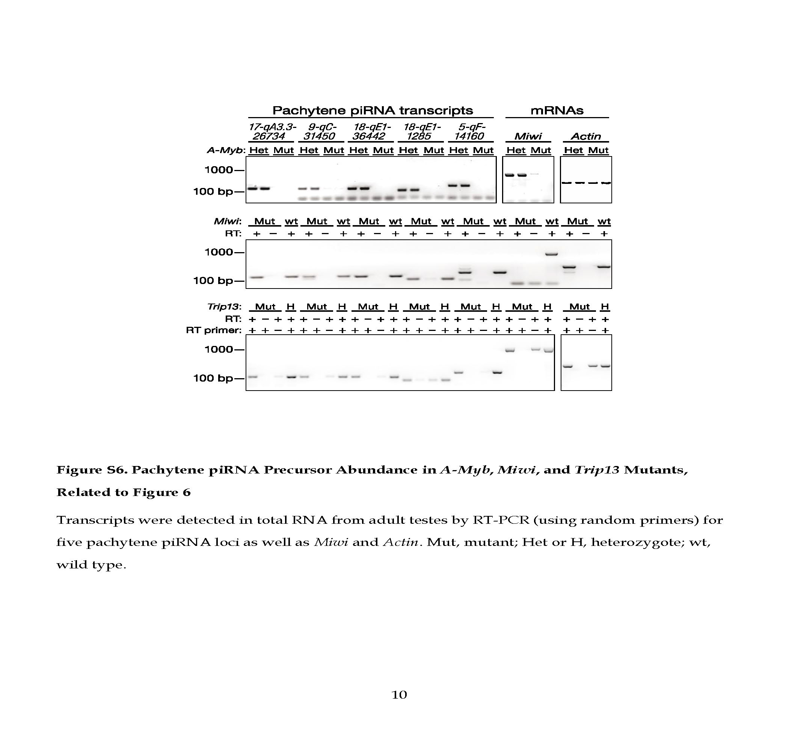

Figure ‑ Pachytene piRNA Precursor Abundance in *A-Myb*, *Miwi*, and *Trip13* mutants

Transcripts were detected in total RNA from adult testes by RT-PCR (using random primers) for five pachytene piRNA loci as well as Miwi and Actin. Mut, mutant; Het or H, heterozygote; wt, wild type.

Our data show that A-MYB binds to the promoters of pachytene piRNA genes; A-Myb, Miwi, and pachytene piRNA precursor transcription begins at 12.5 dpp; and A-Myb mutant spermatocytes reach pachynema with subtle defects in autosome synapsis (Bolcun-Filas et al., 2011). Could pachytene piRNA depletion nonetheless be an indirect consequence of the meiotic arrest caused by the A-Myb mutant? To test this possibility, we sequenced small RNAs from Spo11 mutant testes, which failed to generate double-stranded DNA breaks at the leptotene stage and display a meiotic arrest (Baudat et al., 2000; Romanienko and Camerini-Otero, 2000). The median abundance of piRNAs from pre-pachytene genes did not decrease at 14.5 dpp. By 17.5 dpp, piRNA from pachytene genes decreased just 5.9-fold in the Spo11 mutant testes compared to the heterozygotes (Figure S5). We note that A-MYB protein abundance is reduced in the Spo11 mutant (Bolcun-Filas et al., 2011).

Trip13 is required to complete the repair of double-strand DNA breaks on fully synapsed chromosomes. Trip13 mutants display a meiotic arrest similar to that in A-Myb mutant testes (Li and Schimenti, 2007): pachytene arrest with synapsed chromosomes. To further test whether the loss of pachytene piRNA precursor transcripts in A-Myb mutants reflects a general effect of meiotic arrest, we measured piRNA precursor transcript abundance in Trip13 mutant testes at 17.5 dpp. Unlike A-Myb, piRNA precursor transcripts were readily detectable in the Trip13 mutant (Figure S6). We conclude that the loss of pachytene piRNA precursor transcripts and piRNAs in A-Myb mutant testes is a direct consequence of the requirement for A-MYB to transcribe pachytene piRNA genes and not a general feature of meiotic arrest at the pachytene stage.

##### A-Myb Regulates Expression of piRNA Biogenesis Factors

The A-Myb mutant more strongly affected pachytene piRNA accumulation than it did the steady-state abundance of the corresponding piRNA precursor transcripts (Figure 5); the median decrease in pachytene piRNA abundance was 2-fold greater at 14.5 dpp and 38-fold greater at 17.5 dpp than the decrease in the steady-state abundance of pachytene precursor transcripts (Table S1). These data suggest that A-MYB exerts a layer of control on piRNA accumulation beyond its role in promoting pachytene piRNA precursor transcription.

Miwi has previously been proposed to be a direct target of A-MYB; Miwi mRNA abundance is reduced in A-MYB mutant testes, and ChIP microarray data place A-MYB on the Miwi promoter (Bolcun-Filas et al., 2011). Our RNA-seq data confirm that accumulation of Miwi mRNA requires A-MYB: Miwi mRNA decreased more than 50-fold in testes isolated from A-Myb mutant mice at 14.5 dpp compared to their heterozygous littermates (Figures 7A and S7 and Table S3). Furthermore, our ChIP data confirm that A-MYB binds the Miwi promoter in vivo (Figures 7B, S4B, and S7). Like pachytene piRNAs, Miwi transcripts first appear at 12.5 dpp (Figure 2B), and MIWI protein is first detected in testes at 14.5 dpp (Deng and Lin, 2002). Loss of MIWI arrests spermatogenesis at the round spermatid stage (Deng and Lin, 2002).

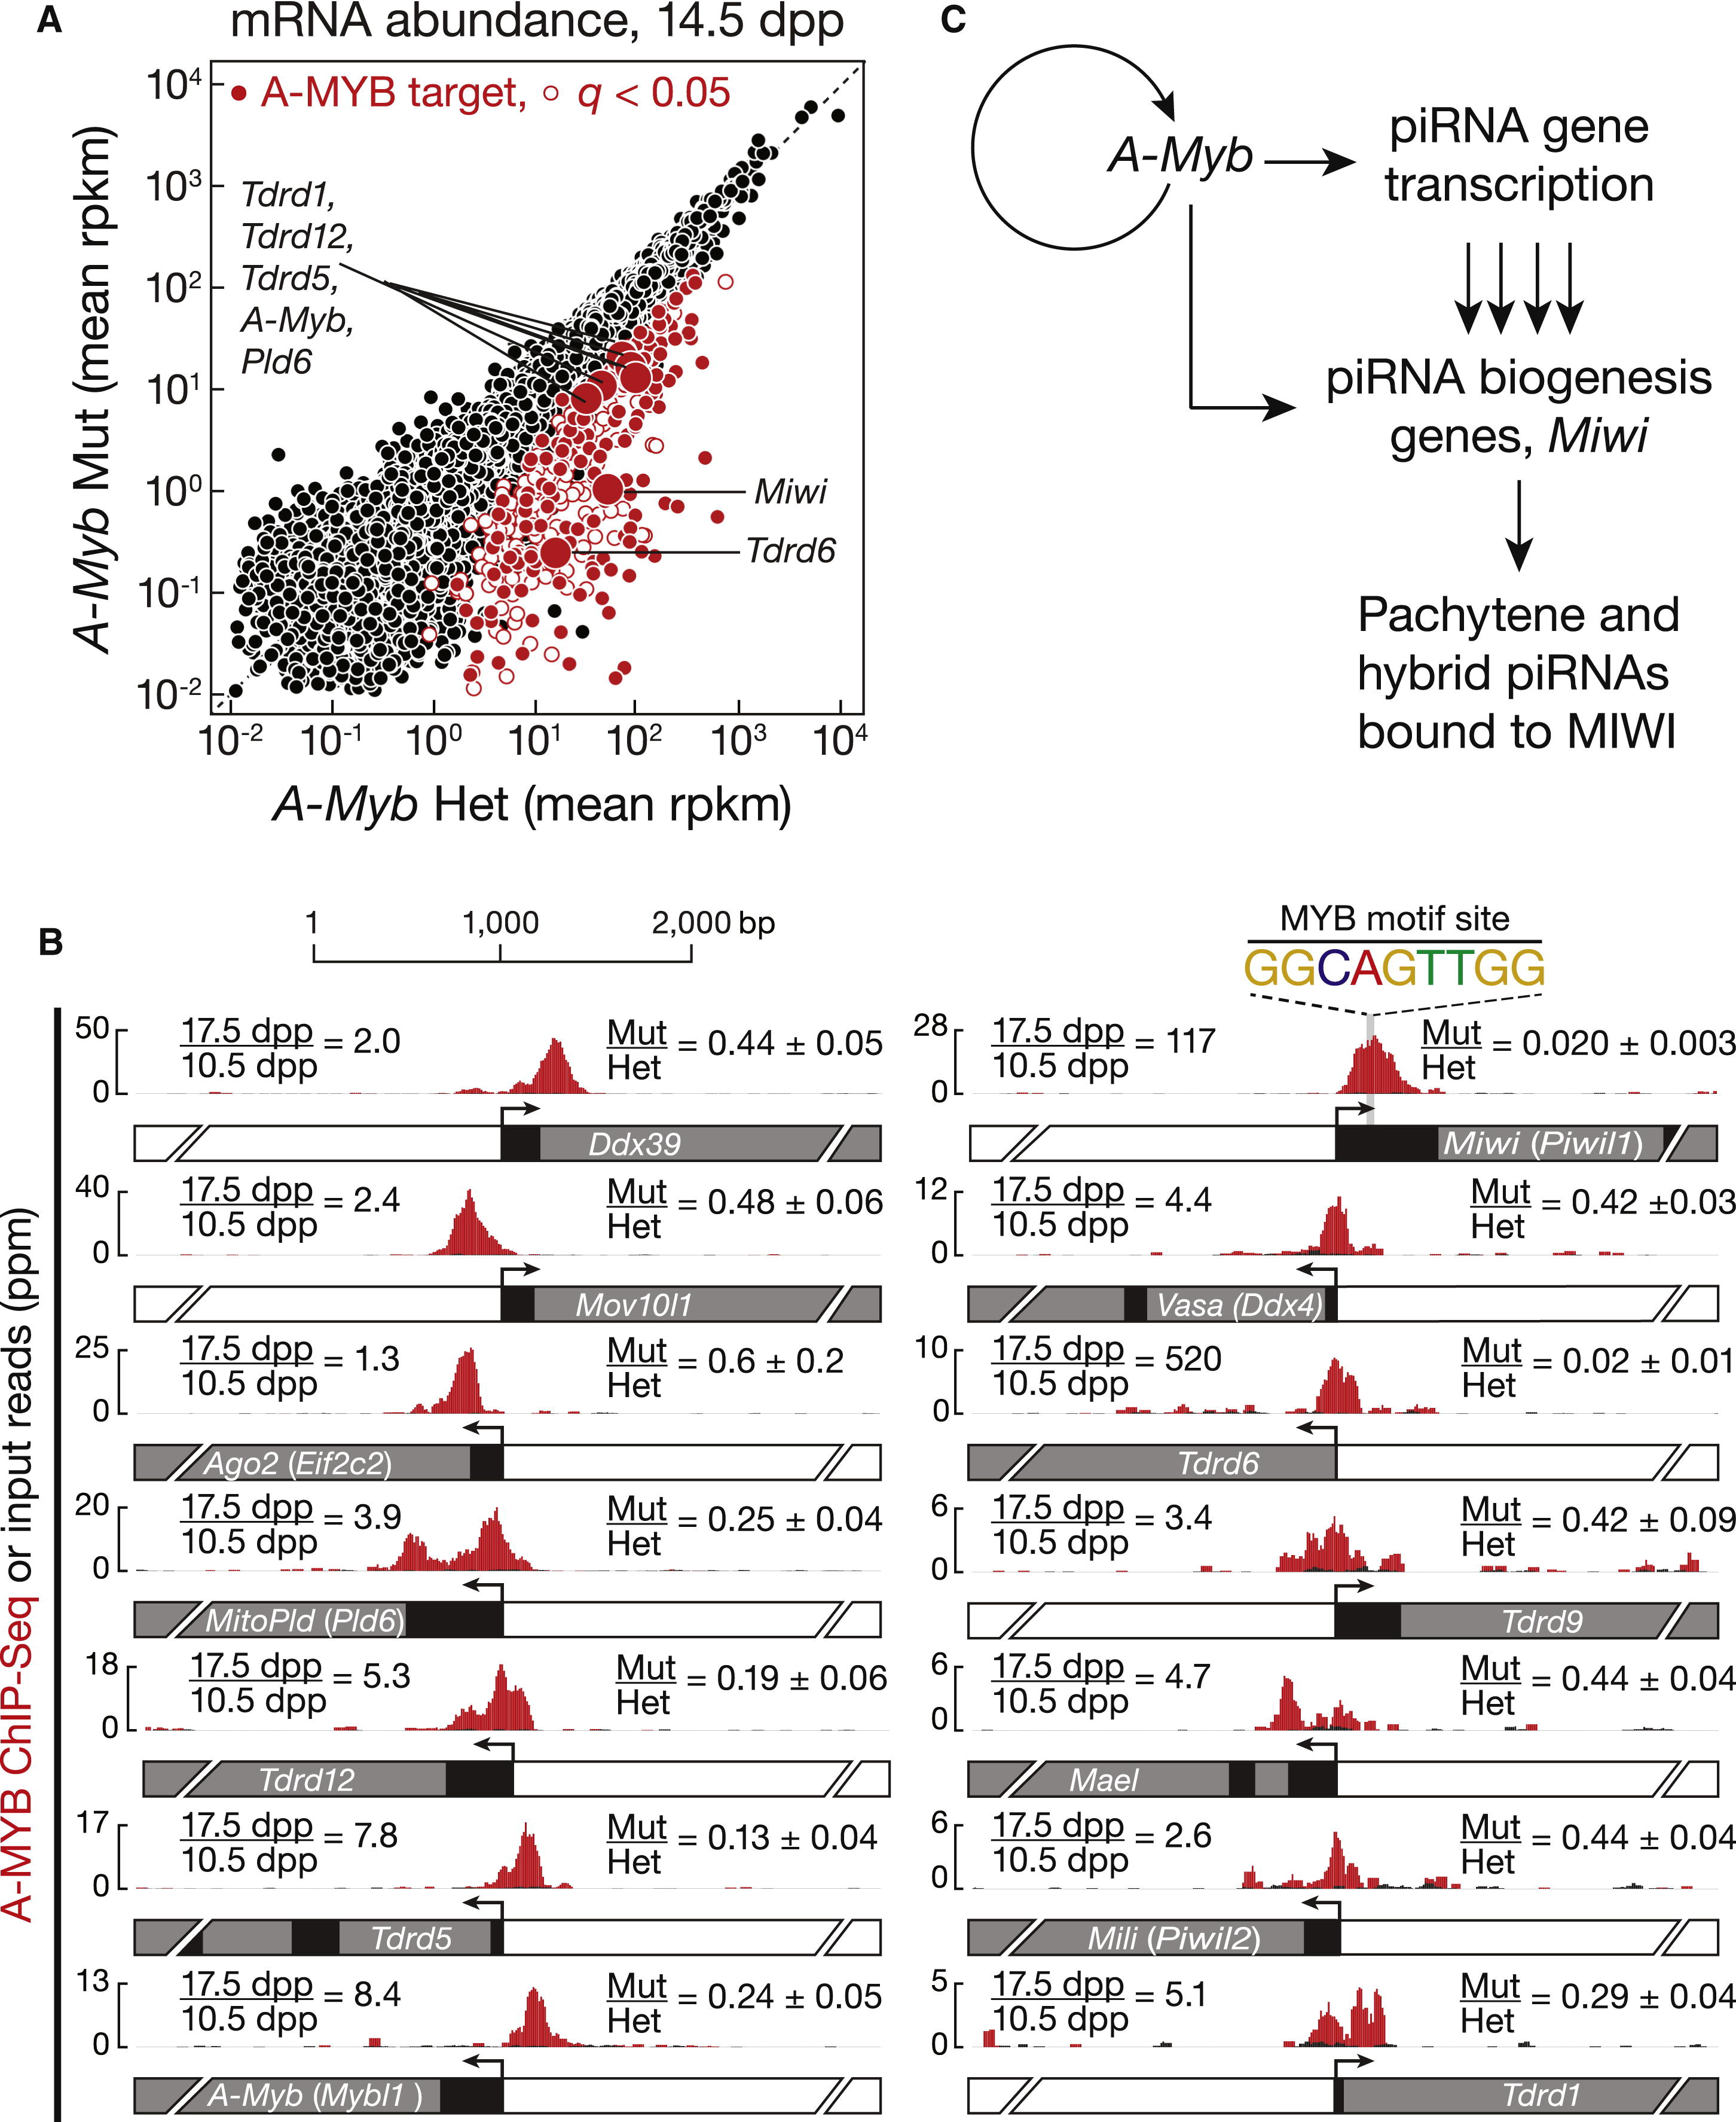

Figure ‑ A-MYB Regulates Expression of mRNAs Encoding piRNA Pathway Proteins

(A) mRNA abundance in A-Myb mutant versus heterozygous testes. The 407 genes with a significant (q < 0.05) change in steady-state mRNA levels are shown as red circles. The 203 with A-MYB peaks within 500 bp of their transcription start site are filled.(B) A-MYB ChIP-seq signal at the transcription start sites of A-Myb and genes implicated in RNA silencing pathways. For each, the figure reports the change in mRNA abundance between 17.5 and 10.5 dpp in wild-type testes and the mean change between A-Myb mutant and heterozygous testes at 14.5 dpp (mean ± SD; n = 3).(C) A model for the regulation of pachytene piRNA biogenesis by A-MYB. See also Figure S7 and Table S3.

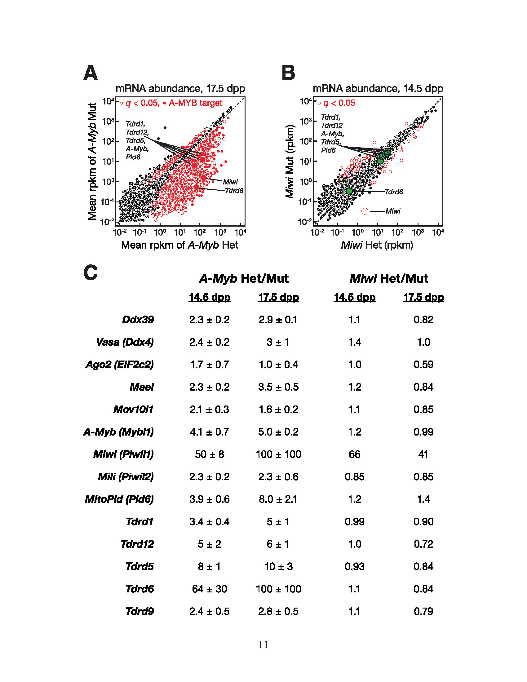

Figure ‑. A-Myb mutants, but Not Miwi Mutants, Change the Expression of RNA Silencing Pathway Genes

A) mRNA abundance in 17.5 dpp A-Myb versus heterozygous testes. The 2,853 genes with a significant (q < 0.051) change in steady-state mRNA abundance are shown as open red circles. Among them, 8721,009 genes also had A-MYB peaks within 500 bp of their transcription start sites. These “A-MYB targets” are marked with filled red circles. (B) Same as (A) but in 14.5 dpp Miwi mutant versus heterozygous testes. The genes encoding proteins implicated in RNA silencing pathways that were labeled in (A) and that showed no change in expression in Miwi mutant testes are highlighted as green filled circles. As expected, Miwi, showed a significant decrease in mRNA abundance in Miwi−/− testes. (C) The change in mRNA abundance (rpkm) in A-Myb and Miwi mutant testes versus heterozygous controls for the RNA silencing genes highlighted in (A) and (B).

A previous study reported that piRNAs fail to accumulate to wild-type levels in Miwi mutant testes (Grivna et al., 2006b). However, our data suggest that the overall change in piRNA abundance caused by loss of MIWI is quite small: RNA-seq detected no change at 14.5 dpp (change in total piRNA abundance = 1.1; n = 2) and only a modest decrease at 17.5 dpp (change in total piRNA abundance = 0.58; n = 1). piRNAs from pachytene loci decreased just 2.7-fold at 14.5 dpp (p = 0.0046) and 3.5-fold at 17.5 dpp (p = 1.8 × 10−6) in Miwi mutant testes (Figure 5). By comparison, pachytene piRNAs declined 87-fold at 14.5 dpp and 9,400-fold at 17.5 dpp in the A-Myb mutant.

Does the loss of MIWI affect piRNA precursor transcription? We measured transcript abundance and piRNA expression in Miwi null mutant testes at 14.5 and 17.5 dpp. In Miwi−/− testes, pachytene piRNA precursor transcripts were present at levels indistinguishable from Miwi heterozygotes (median change = 1.0- to 1.4-fold; q = 1; Figure 5). Thus, loss of MIWI does not explain loss of pachytene piRNA precursor transcripts in A-Myb mutant testes.

In addition to Miwi, ChIP-seq detected A-MYB bound to the promoters of 12 other RNA-silencing-pathway genes (Figure 7B and Table S3). Of these, the mRNA abundance—measured by three biologically independent RNA-seq experiments—of Ago2, Ddx39 (uap56 in flies), Mael, Mili, Mov10l1, Tdrd9, and Vasa did not change significantly at 14.5 dpp in A-Myb mutant testes compared to heterozygotes (q > 0.05); except for Ago2, all decreased significantly in the mutant at 17.5 dpp. In contrast, the abundance of the mRNAs encoding Tudor domain proteins decreased significantly in A-Myb mutant testes: Tdrd6 (64-fold decrease; q = 3.1 × 10−5) and Tdrd5 (7.5-fold decrease; q = 1.0 × 10−5). Tdrd5 is expressed in embryonic testes then decreases around birth (Yabuta et al., 2011). TDRD5 protein reappears at 12 dpp, increasing throughout the pachynema (Smith et al., 2004; Yabuta et al., 2011). Our data indicate that A-MYB activates Tdrd5 transcription at the onset of the pachytene stage of meiosis. Similarly, Tdrd6 mRNA can be detected at the middle pachytene, but not the zygotene stage, and peaks after late pachytene; TDRD6 protein can be detected at 17 dpp and continues to increase until 21 dpp (Vasileva et al., 2009). The findings that TDRD5 and TDRD6 colocalize with MIWI in pachytene spermatocytes (Hosokawa et al., 2007; Vasileva et al., 2009; Yabuta et al., 2011) and that TDRD6 binds MIWI (Chen et al., 2009; Vagin et al., 2009; Vasileva et al., 2009) suggest a role for these Tudor domain proteins in pachytene piRNA production or function. As in Miwi−/− testes, spermatogenesis arrests at the round spermatid stage in Tdrd5−/− and Tdrd6−/− mutant testes (Vasileva et al., 2009; Yabuta et al., 2011). Loss of Tdrd6 expression has little effect on piRNA levels (Figure S3; Vagin et al., 2009), perhaps because the functions of Tudor domain proteins overlap.

Other genes encoding piRNA pathway proteins whose promoters are bound by A-MYB and whose expression decreased significantly in A-Myb mutant testes include MitoPld (Pld6; 3.9-fold decrease; q = 0.0095) and Tdrd12 (5.3-fold decrease; q = 0.0046). MitoPld encodes an endoribonuclease implicated in an early step in piRNA biogenesis in mice and flies (Houwing et al., 2007; Pane et al., 2007; Haase et al., 2010; Huang et al., 2011; Watanabe et al., 2011; Ipsaro et al., 2012; Nishimasu et al., 2012). The function of Tdrd12 is not known, but its fly homologs (Yb, Brother of Yb, and Sister of Yb) are all required for piRNA production (Handler et al., 2011). Tdrd1 decreased 3.4-fold, but with q value = 0.015. Tdrd1 is first expressed in fetal prospermatogonia, then re-expressed in pachytene spermatocytes (Chuma et al., 2006). In Tdrd1 mutant testes, spermatogenesis fails, with no spermatocytes progressing past the round spermatid stage (Chuma et al., 2006). TDRD1 binds MILI and MIWI (Chen et al., 2009; Kojima et al., 2009) and colocalizes with TDRD5 and TDRD6 in the chromatoid body (Hosokawa et al., 2007).

Together, these data support the idea that at the onset of the pachytene phase of meiosis, A-MYB coordinately activates transcription of many genes encoding piRNA pathway proteins.

##### A-MYB and the Pachytene piRNA Regulatory Circuitry

A number of genes encoding known and suspected piRNA pathway proteins are bound and regulated by A-MYB (Figures 7B and S7C). Our data support a model in which A-MYB drives both the transcription of pachytene piRNA genes and the mRNAs encoding genes required for piRNA production including Miwi, MitoPld, and Tdrd9. Regulation by A-MYB of both the sources of pachytene piRNAs and the piRNA biogenesis machinery creates a coherent feedforward loop (Figure 7C). Feedforward loops amplify initiating signals to increase target gene expression. Furthermore, they function as switches that are sensitive to sustained signals; they reject transient signals (Shen-Orr et al., 2002; Osella et al., 2011).

A-MYB also bound to the A-Myb promoter (Figure 7B), and A-Myb transcripts decreased 4.2-fold in testes from an A-Myb point mutant (Mybl1repro9; Figure 7B). The A-Myb mutant fails to produce the high level of A-MYB protein observed in wild-type testes at the late pachytene stage of meiosis (Bolcun-Filas et al., 2011). Instead, A-MYB protein never becomes more abundant than the level achieved in wild-type testes by the beginning of the pachytene stage. While the lower level of A-MYB in the A-Myb mutant may reflect instability of the mutant protein, a simpler explanation is that mutant A-MYB cannot activate A-Myb transcription.

##### Feed-Forward Regulation of piRNA Production is Evolutionarily Conserved

Is A-MYB-mediated, feedforward control a general feature of regulation of piRNA production among vertebrates? To test whether A-MYB control of piRNA precursor transcription is evolutionarily conserved, we used high-throughput sequencing to identify piRNAs in adult rooster testes. Birds and mammals diverged 330 million years ago (Benton and Donoghue, 2007). After removing the sequences of identifiable miRNAs (Burnside et al., 2008) and annotated noncoding RNAs, total small RNA from the adult rooster testis showed peaks at both 23 and 25 nt (Figure 8A). When the RNA was oxidized before being prepared for sequencing, only a single 25 nt peak remained, consistent with the 25 nt small RNAs corresponding to piRNAs containing 2′-O-methyl-modified 3′ termini. These longer, oxidation-resistant species typically began with uracil (62% of species and 65% of reads; Figure 8B), and we detected a significant Ping-Pong amplification signature (Z score = 31; Figure 8C). We conclude that the oxidation-resistant, 24–30 nt long small RNAs correspond to rooster piRNAs. Like piRNAs generally, rooster piRNAs are diverse, with 5,742,529 species present among 81,121,893 genome-mapping reads. Like mouse pachytene piRNAs, 70% of piRNAs from adult rooster testes mapped to unannotated intergenic regions, 19% mapped to transposons, and 14% mapped to protein-coding genes. Of the piRNAs that map to protein-coding genes, >95% derive from introns. Forty-two percent of piRNA species mapped uniquely to the Gallus gallus genome.

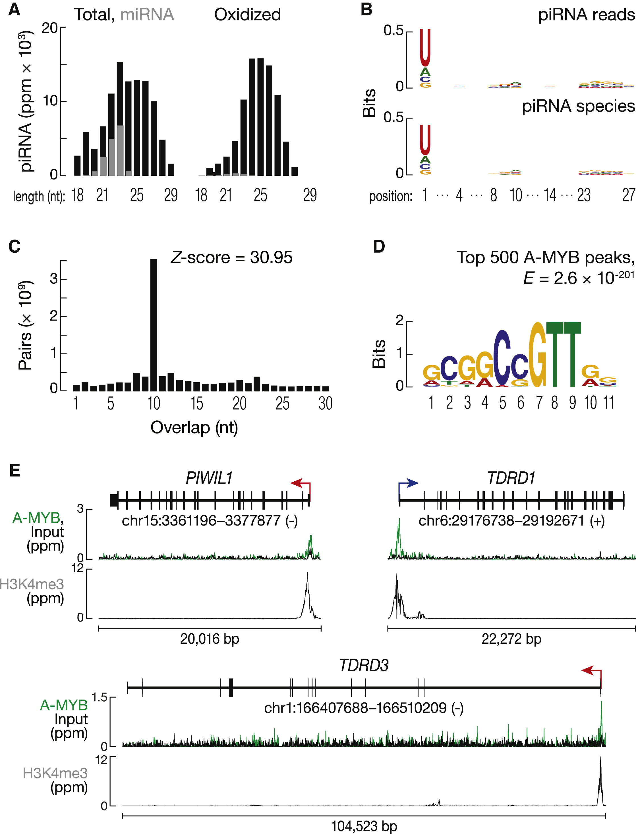

Figure ‑ Feed-Forward Regulation of piRNA Biogenesis by A-MYB is Conserved in Rooster

(A) Length distributions of total rooster testis small RNAs (black) and miRNAs (gray).(B) Sequence logo showing the nucleotide composition of piRNA reads and species.(C) The 5′-5′ overlap between piRNAs from opposite strands was analyzed to determine if rooster piRNAs display Ping-Pong amplification. The number of pairs of piRNA reads at each position is reported. Z score indicates that a significant 10 nt overlap (Ping-Pong) was detected. Z score > 1.96 corresponds to p value < 0.05.(D) MEME-reported motif of the top 500 (by peak score) A-MYB ChIP-seq peaks from adult rooster testes.(E) A-MYB, H3K4me3, and input ChIP-seq signals at the transcription start sites of rooster PIWIL1, TDRD1, and TDRD3. See also Figure S8.

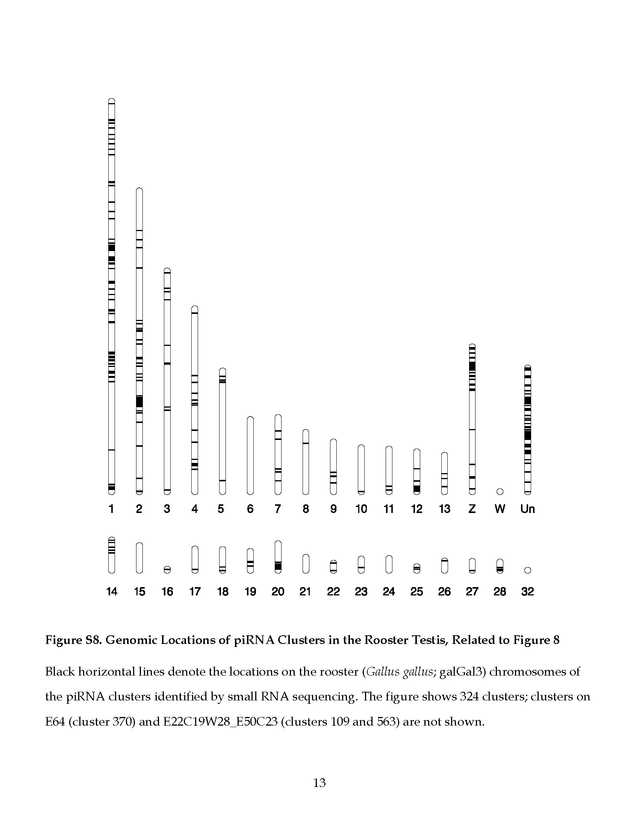

Figure ‑. Genomic Locations of piRNA Clusters in the Rooster (*Gallus gallus)* Testis.

Black horizontal lines denote the locations on the Gallus gallus (galGal3) chromosomes of the piRNA clusters identified by small RNA sequencing. The figure shows 324 clusters; clusters on E64 (cluster 370) and E22C19W28\_E50C23 (clusters 109 and 563) are not shown.

Using 24–30 nt piRNAs from oxidized libraries, we identified 327 rooster piRNA clusters (Figure S8). These account for 76% of all uniquely mapping piRNAs. Of the 327 clusters, 25 overlapped with protein-coding genes. To begin to identify the transcription start sites for the rooster piRNA clusters, we analyzed adult rooster testes by H3K4me3 ChIP-seq. More than 81% (268 out of 327) of the clusters contained a readily detectable H3K4me3 peak within 1 kbp of the piRNA cluster. In contrast, the median distance from a cluster to the nearest transcription start site of an annotated gene was 73 kbp, suggesting that the H3K4me3 peaks reflect the start sites for rooster piRNA precursor transcripts.

Next, we asked where in the genome A-MYB bound in adult rooster testes. A-MYB ChIP-seq identified 5,509 significant peaks (FDR < 10−25). MEME analysis of the top 500 peaks with the lowest FDR values identified a motif (E = 2.6 × 10−201; Figure 8D) similar to that found in the mouse (Figure 4A). A-MYB is the only one of the three chicken MYB genes expressed in adult testis (X.Z.L. and P.D.Z., unpublished data), supporting the view that these peaks correspond to A-MYB binding. The core sequence motif associated with A-MYB binding in mouse differs at one position (CAGTT) from that in rooster (C C/G GTT). This difference between mammalian and chicken MYB proteins has been noted previously (Weston, 1992; Deng et al., 1996).

To determine whether chicken A-MYB might regulate transcription of some piRNA clusters in the testis, we compared the A-MYB peak nearest to each piRNA cluster with the nearest H3K4me3 peak. Of the 327 rooster piRNA clusters, at least 104 were occupied by A-MYB at their promoters, as defined by an overlapping H3K4me3 peak. These 104 clusters account for 31% of uniquely mapping rooster piRNAs.

The chicken genome encodes at least two PIWI proteins: PIWIL1 and PIWIL2. Remarkably, the promoter of Gallus gallus PIWIL1, the homolog of mouse Miwi, contained a prominent A-MYB peak (Figure 8E). TDRD1 and TDRD3 also showed A-MYB peaks (Figure 8E). Thus, as in mice, Gallus gallus A-MYB controls the transcription of both piRNA clusters and genes encoding piRNA pathway proteins. We conclude that A-MYB-mediated feedforward regulation of piRNA production was likely present in the last common ancestor of birds and mammals.

In mice, we found no piRNA-producing genes on the sex chromosomes (Figure S1A), perhaps because mouse sex chromosomes are silenced during the pachytene stage (Li et al., 2009b). Birds use a ZW rather than an XY mechanism for sex determination, so roosters are homogametic (ZZ), allowing the sex chromosomes to remain transcriptionally active in males (Namekawa and Lee, 2009; Schoenmakers et al., 2009). Indeed, we find that 39 of the 327 rooster piRNA clusters are on the Z chromosome, accounting for 12% of uniquely mapping piRNAs (Figure S8). Of the 39 Z chromosome clusters, 18 had an A-MYB peak at their promoter.

#### DISCUSSION

The data presented here provide strong support for the view that piRNAs in mammals begin as long, single-stranded precursors generated by testis-specific, RNA Pol II transcription of individual piRNA genes (see also Vourekas et al., 2012). Transcription by RNA Pol II affords piRNA genes the same rich set of transcriptional controls available to regulate mRNA expression. Our data establish that developmentally regulated transcription of piRNA genes determines when specific classes of piRNAs emerge during spermatogenesis.

During mouse spermatogenesis, transcription of pachytene piRNA genes begins at the onset of the pachytene stage of meiosis; pachytene piRNAs accumulate subsequently. The presence of the MYB binding motif near the transcription start sites of pachytene piRNA genes, the physical binding of A-MYB to those genes, and the loss of pachytene piRNA precursor transcripts and piRNAs in testes from A-Myb mutant mice all argue that A-MYB regulates pachytene piRNA production.

A-MYB also drives increased expression of piRNA pathway genes. Among these, Miwi expression shows the greatest dependence on A-MYB, but A-MYB also drives transcription of genes encoding other proteins in the piRNA pathway, including MitoPld, Mael, and five genes encoding Tudor domain proteins. For example, A-MYB increases expression of Tdrd6 more than 500-fold. Loss of A-MYB function more strongly depletes pachytene piRNAs than loss of MIWI, in part because pachytene piRNAs can still be loaded into MILI in Miwi mutant testes, although MILI-loaded pachytene piRNAs do not suffice to produce functional sperm. In the A-Myb mutant, expression of mRNAs encoding multiple piRNA pathway proteins decreases. We speculate that in wild-type male mice, the increased expression of these mRNAs at the onset of the pachytene stage of meiosis ensures that sufficient piRNA-precursor-processing and MIWI-loading factors are available to cope with the large increase in pachytene piRNA precursor transcription.

We propose that induction of A-MYB during the early pachytene stage of spermatogenesis initiates a feedforward loop that ensures the precisely timed production of these piRNAs. Coherent feedforward loops show delayed kinetics in order to reject background stimuli (Mangan and Alon, 2003). Indeed, we observed a delay from the early to middle pachytene in the accumulation of pachytene piRNAs, despite the continued increase in A-Myb expression (Figure 2A). Pachytene piRNA levels increase 75-fold (median for the 100 genes) from 10.5 to 12.5 dpp, coincident with increased expression of A-Myb. However, from 12.5 to 14.5 dpp, pachytene piRNAs increase only 1.2-fold. Pachytene piRNAs subsequently resume their accumulation, increasing 65-fold from 14.5 to 17.5 dpp. We believe this delay is a consequence of a feedforward loop that ensures the production of pachytene piRNAs only at the pachytene stage of spermatogenesis. Regulation by a feedforward loop also predicts a rapid shutdown of pachytene piRNA pathways at round spermatid stage VIII, when A-MYB protein levels decrease (Horvath et al., 2009). Supporting this idea, the abundance of MIWI decreases sharply by the elongated spermatid stage of spermatogenesis (Deng and Lin, 2002). Testing this proposal is a clear challenge for the future.

In fruit flies and zebrafish (Brennecke et al., 2007; Houwing et al., 2007), most piRNAs map to repetitive regions, whereas in mammals, uniquely mapping intergenic piRNAs predominate in the adult testis. The discovery that 70% of rooster piRNA reads map to intergenic regions suggests that the expansion of intergenic piRNAs controlled by A-MYB feedforward regulation arose before the divergence of birds and mammals. In the future, detailed analysis of piRNA production across avian spermatogenesis should provide insight into the evolutionary origins and functions of pachytene piRNAs, a class of piRNAs thus far only detected in mammals.

In summary, we have shown that mouse piRNA genes are coregulated transcriptionally, establishing that A-MYB coordinately regulates the biogenesis of an entire piRNA class, the pachytene piRNAs. The discovery that a loss-of-function A-Myb mutant, Mybl1repro9, disrupts piRNA precursor transcription in vertebrates provides a tool to understand the transformation of long, single-stranded piRNA precursors into mature piRNAs and to explore the functions and targets of the pachytene piRNAs.

#### EXPERIMENTAL PROCEDURES

##### Mice

Mybl1repro9, Spo11tm1Sky, and Piwil1tm1Hf mice were maintained and used according to the guidelines of the Institutional Animal Care and Use Committee of the University of Massachusetts Medical School and genotyped as described (Baudat et al., 2000; Deng and Lin, 2002; Bolcun-Filas et al., 2011).

##### Sequencing

Small (Ghildiyal et al., 2008; Seitz et al., 2008) and long RNA-seq (Zhang et al., 2012) and analysis (Li et al., 2009a) were as described. Reads that did not map to mouse genome mm9 were mapped to piRNA precursor transcripts to obtain splice junction mapping small RNAs. Total small RNA libraries from different developmental stages and from mutants were normalized to the sum of all miRNA hairpin mapping reads. Oxidized samples were calibrated to the corresponding total small RNA library via the abundance of shared, uniquely mapped piRNA species. piRNA expression data were grouped with Cluster 3.0. Differential gene expression was analyzed with DESeq R (Anders and Huber, 2010); ChIP-seq reads were aligned to the genome using Bowtie version 0.12.7 (Langmead et al., 2009), and peaks were identified using MACS (Zhang et al., 2008).

##### Acknowledgments

We thank K. Chase and K. Schimenti for help collecting tissues; C. Tipping for help with mouse husbandry; P. Johnson and B. Keagle for providing rooster testes; G. Farley for technical assistance; H. Lin for reagents; Xi Chen, Xiaotu Ma, Oliver Rando, and Benjamin Carone for advice on ChIP; and members of our laboratories for critical comments on the manuscript. X.Z.L. was supported by the Lalor Foundation and the Jane Coffin Childs Memorial Fund for Medical Research.

##### Accession Numbers

The Gene Expression Omnibus (GEO) accession number for the RNA-seq, ChIP-seq, and small RNA data reported in this paper is [GSE44690](http://www.ncbi.nlm.nih.gov/geo/query/acc.cgi?acc=GSE44690).

##### Animals

Mice were maintained and used according to the guidelines of the Institutional Animal Care and Use Committee of the University of Massachusetts Medical School. C57BL/6J (Jackson Labs, Bar Harbor, ME, USA; stock number 664); *Mybl1repro9* in a mixed 129X1/SvJ × C57BL/6J background; *Spo11tm1Sky* in a C57BL/6J background; and *Piwil1tm1Hf* in a mixed 129X1/SvJ × C57BL/6J background (“*Miwi*”) mice were genotyped as described (Baudat et al., 2000; Deng and Lin, 2002; Deng and Lin, 2002; Bolcun-Filas et al., 2011). Rooster testes from White Leghorn of the Cornell Special C strain, about 15 months old, were used for small RNA analysis; and testes from the Brown Leghorn strain, about one year old, were used for ChIP analysis.

##### RNA Sequencing

Small RNA libraries were constructed and sequenced as described (Ghildiyal et al., 2008; Seitz et al., 2008) except that 18–35 nt RNA was isolated and 2S rRNA depletion omitted. Sequencing was performed using either a Genome Analyzer GAII (36 or 76 nt reads) or HiSeq 2000 (50 nt) instrument (Illumina, San Diego, CA, USA). We analyzed published small RNA libraries from purified mouse spermatogonia (SRR069809), spermatocytes (SRR069810, GSE39652), or spermatids (SRR069811; Gan et al., 2011; Modzelewski et al., 2012); from Mili mutant or heterozygous testes at 10 dpp (SRX003089 and SRX003088; Aravin et al., 2008); from Tdrd6 mutant or heterozygous testes at 18 dpp (SRX012165 and SRX012166; Vagin et al., 2009); and MILI IP samples from *Tdrd9* mutant or heterozygous testes at 14 dpp (SRX015795, SRX015796, SRX015797, and SRX015798; Shoji et al., 2009).

Strand-specific RNA-seq libraries (Zhang et al., 2012) using Ribo-Zero Gold (Epicentre Biotechnologies, Madison, WI, USA) were sequenced using the paired-end protocol on a HiSeq 2000.

##### Small RNA Analysis

Small RNA sequence analysis was as described (Li et al., 2009) using mouse genome release mm9 and chicken genome release galGal3. Non-coding RNA annotations comprised data from ncRNAscan, the known tRNAs from UCSC, and 18S, 28S and 5.8S rRNAs. miRNA hairpin and mature miRNA annotation was from miRBase Release 19. Mouse and chicken transposons were annotated using Repeat Masker from UCSC. Reads that did not map to the mouse genome (mm9) were mapped to piRNA precursor transcripts to obtain splice junction-mapping small RNAs. Total small RNA libraries from different developmental stages and from mutants were normalized to the sum of all miRNA hairpin-mapping reads. Oxidized samples were calibrated to the corresponding total small RNA library via the abundance of shared, uniquely mapped piRNA species. Table S1 reports the statistics for high-throughput sequencing. For oxidized (i.e., piRNA-enriched) samples, uniquely mapping small RNAs >23 nt were mapped to each assembled piRNA precursor transcript and reported as reads per kilobase pair per million reads mapped to the genome (rpkm) using a pseudo count of 0.001.

##### RNA-seq Analysis

RNA-seq reads were aligned to the genome (NCBI 37/mm9) using TopHat 2.0.4 (Trapnell et al., 2009). Reads were mapped uniquely using the ‘-g 1’ switch. We assembled the mouse testes transcriptome (see below). For genes with multiple isoforms, the transcript with the highest average rpkm value among the three replicates of adult testes was selected for further analysis. Fragments with both reads mapped within a transcript, or to piRNA precursor transcripts, were counted using BEDTools (Quinlan and Hall, 2010). The sum of the reads aligning to the top quartile of expressed transcripts per library was used to calibrate the samples. The number of reads per transcript was normalized by length, divided by the library-specific calibration factor, and reported as rpkm with a pseudo count of 0.001. Table S1 presents the statistics for the RNA-seq data. Sequences mapping to five genes (Table S1) that overlapped with or were embedded within a piRNA gene were excluded when calculating piRNA precursor transcript abundance.

##### PAS-seq Library Construction and Analysis

PAS-seq libraries (Table S1) were prepared essentially as described (Shepard et al., 2011) and sequenced using a HiSeq 2000 (100 nt read length). We first removed adaptors and performed quality control using Flexbar 2.2 (http://sourceforge.net/projects/theflexibleadap) with the parameters “-at 3 -ao 10 --min-readlength 30 --max-uncalled 70 --phred-pre-trim 10.” For reads beginning with GGG including (NGG, NNG or GNG) and ending with three or more adenosines, we removed the first three nucleotides and mapped the remaining sequence with and without the tailing adenosines to the mouse genome using TopHat 2.0.4. We retained only those reads that could be mapped to the genome without the trailing adenosine residues. Genome-mapping reads containing trailing adenosines were regarded as potentially originating from internal priming and thus discarded. The 3′ end of the mapped, retained read was reported as the site of cleavage and polyadenylation.

##### CAGE Library Construction and Analysis

CAGE (cap analysis of gene expression; Table S1) was as described (Yang et al., 2011) and sequenced using a HiSeq 2000 (100 nt reads). After removing adaptor sequences and checking read quality using Flexbar 2.2 with the parameters of “-at 3 -ao 10 --min-readlength 20 --max-uncalled 70 --phred-pre-trim 10”, we retained only reads beginning with NG or GG (the last two nucleotides on the 5′ adaptor). We then removed the first two nucleotides and mapped the sequences to the mouse genome using TopHat 2.0.4. All unique 5′ ends of the mapped positions were considered as CAGE-tag starting sites and grouped into tag clusters using a distance-based method in which the maximal distance between two neighboring tags was required to be <20 bp. The peak position of a tag cluster was then reported as the transcription start site.

##### Transcriptome Assembly and Annotation

De novo transcriptome assembly from three biological replicates of strand-specific RNA-seq data from adult testes was performed using Trinity (r2012-06-08) with default parameters (Grabherr et al., 2011).The assembled RNA sequences were aligned to the mouse genome (mm9) with BLAT (Kent, 2002), and the alignments with more than 95% of sequence length mapped and fewer than 1% mismatches retained.

We extracted novel junctions from Trinity (i.e., reads with [0-9]+M[0-9]+N[0-9]+M pattern in the CIGAR string of SAM output), and re-mapped all RNA-seq reads to these junctions, rescuing 1,402,444 reads in three replicates. Rescued reads were combined with TopHat alignments (supplied with "–max-multihits 100" to assembly through repetitive regions) and used as input for reference-based assembly.

We used Cufflinks v2.0.2 (Trapnell et al., 2010) with parameters of “-u -j 0.2 --min-frags-per-transfrag 40” to assemble transcripts. To join small transcript fragments caused by insufficient read coverage or embedded repetitive elements, two different gap-joining distance cutoffs were used for the assembly of genes (“--overlap-radius 100”) and piRNA loci (“--overlap-radius 250”). We used Cuffcompare v2.0.2 (Trapnell et al., 2010) to annotate the 49,840 Cufflinks-assembled transcripts using parameters optimized for genic conditions (“--overlap-radius 100”).

##### piRNA Precursor Transcript Annotation

We combined transcripts from the two Cufflink assemblies with those from the Trinity assembly, producing 136,069 unique transcripts. Those transcripts with 100 ppm or 100 rpkm unique mapping piRNAs at any time point (10.5, 12.5, 14.5, 17.5, 20.5 dpp and adult oxidized small RNA from testis) were selected for manual annotation.

To refine the termini of the piRNA-producing transcripts, we supplemented the RNA-seq data with high-throughput sequencing of 5′ ends of RNAs bearing (5′)ppp(5′) cap structures (CAGE) and of the 3′ ends of transcripts flanking the poly(A) tail (PAS-seq). To provide independent confirmation of the 5′ ends of each piRNA-producing transcript, we used chromatin immunoprecipitation (ChIP-seq) of RNA polymerase II (pol II) and histone H3 bearing trimethylated lysine-4 (H3K4me3). Refinement of transcriptional starts required both a CAGE and a H3K4me3 peak to support the 5′ end of the transcript. When no H3K4me3 peak corroborated alternative transcription start sites proposed by the CAGE data, the alternative transcripts were merged with the fully substantiated transcript.

##### piRNA Gene Nomenclature

When piRNA-producing genes overlap an annotated protein coding gene, we refer to them using the name of the overlapping gene preceded by ‘pi-‘; when they do not, their names refer to their genomic location followed by a number indicating the piRNA abundance in ppm at 6 weeks post-partum. The last digit of a piRNA gene name specifies the rank order of expression among isoforms, determined by the highest abundance of transcripts (rpkm) observed for that gene among the six developmental stages of testis.

##### Grouping piRNA Precursor Transcripts

For the most abundant transcript in each locus, the abundance (rpkm) of piRNAs at each stage was expressed as a fraction of the maximum abundance reached during the developmental time course. These data were then analyzed by hierarchical clustering according to Euclidean distance and complete linkage using Cluster 3.0. Clustering results were visualized using Java Tree View 1.1.3.

##### Analysis of Differential Gene Expression

We determined differential gene expression using DESeq R (Anders and Huber, 2010). For each annotated mRNA, reads from each library were aligned to the most abundant assembled transcript. Transcripts with *q* < 0.05 were considered to be differentially expressed. Table S3 lists the genes that were differentially expressed in *A-Myb* at 14.5 dpp. Three biologically independent replicates were used for *A-Myb* homozygotes and heterozygotes at 14.5 and at 17.5 dpp.

##### Motif Discovery

For divergently transcribed piRNA gene pairs, the promoter region was defined as the region between the transcription start sites defined by CAGE peaks. Sequence motifs in these putative promoter regions were detected ab initio using MEME (Bailey and Elkan, 1994; Bailey et al., 2009) in TCM mod (any number of repetitions per sequence) and compared to existing JASPAR and TRANSFAC libraries via TOMTOM (Gupta et al., 2007). FIMO was used to detect motif sites within the putative promoters (default p < 10-4; Grant et al., 2011).

##### Chromatin Immunoprecipitation (ChIP)

ChIP was performed as described (Chen et al., 2008) except that testes were macerated on ice and then fixed with 1.5% (w/v) formaldehyde for 20 min. Samples were then further crushed using 20 strokes with a ‘B’ pestle in a Dounce homogenizer (Kimble-Chase, Vineland, NJ, USA). Chromatin was sheared by sonication and immunoprecipitated using anti-A-MYB (HPA008791; Sigma, St. Louis, MO, USA) or anti-H3K4me3 (ab8580; Abcam, Cambridge, MA, USA) antibody; immunoglobulin G (IgG; Sigma, item 2729) served as a control. ChIP-quantitative PCR (qPCR) was performed using the CFX96 Real-Time PCR Detection System with SsoFast EvaGreen Supermix (Bio-Rad, Hercules, CA, USA). Data were analyzed using DART-PCR (Peirson et al., 2003). Relative ChIP enrichment values were normalized to *MyoD1*, a gene not expressed in testes. Table S1 lists ChIP-*q*PCR primers. ChIP-seq libraries for anti-A-MYB and control input DNA were prepared following the Illumina ChIP-seq protocol and sequenced on a HiSeq 2000 (50 nt reads).

##### ChIP-seq Analysis

ChIP-seq reads were aligned to the genome using Bowtie version 0.12.7 (Langmead et al., 2009). Reads were mapped uniquely using the ‘-M 1 --best --strata’ switches and one mismatch was allowed (-v 1). ChIP peaks were identified using MACS version 1.4.1 (Zhang et al., 2008) using default arguments, input as control, and a cutoff *p*-value = 10-25 was used. BEDTools was used to assign peaks to the nearest 5′ end of genes. Table S1 reports sequencing statistics for ChIP-seq.

##### RT-PCR

Total RNA was treated with Turbo DNase (Ambion, Austin, TX, USA), and then reverse transcribed using SuperScript III (Invitrogen, Eugene,OR, USA) with random primers (Promega, Madison, WI, USA). The resulting cDNA was analyzed by conventional PCR. Table S1 lists the primers used in Figure S6.

##### Ping-Pong Analysis

Ping-Pong amplification was analyzed by the 5′–5′ overlap between piRNA pairs from opposite genomic strands (Li et al., 2009). Overlap scores for each overlapping pair were the product of the number of reads of each of the piRNAs from opposite strands. The overall score for each overlap extend (1–30) was the sum of all such products for all chromosomes. Heterogeneity at the 3′ ends of small RNAs was neglected. *Z*-score for 10 bp overlap was calculated using the scores of overlaps from 1–9 and 11–30 as background.

##### Rooster piRNA Cluster Detection

We developed a dynamic programming algorithm to identify the genomic regions with the highest piRNA density. We used oxidized small RNA reads (>23 nt) to detect clusters. We used the conservative assumption that piRNA clusters compose at most 2% of the chicken genome. We first split the genome into 1 kbp non-overlapping windows and computed piRNA abundance for each window. The mean of the top 2% of windows was used as the penalty score for the dynamic programming algorithm. The algorithm computes the cumulative piRNA abundance score as a function of the window index along each chromosome. The score at a window is the sum of the score in the previous window and the piRNA abundance in the current window, minus the penalty score; if the resulting score was negative it was reset to 0. The maximal score points to the largest piRNA cluster. We extracted the largest piRNA cluster, recomputed the scores at the corresponding windows, and searched for the next cluster. The process continued until the scores for all windows were zero. The boundaries of each cluster were further refined by including those base pairs for which piRNA abundance exceeded the mean piRNA abundance of the top 2% windows. We considered only those clusters with abundance >10 ppm for uniquely mapping piRNAs. In Figure 8E, gene models were corrected using data from our unpublished adult rooster testis RNA-seq data.

# Perspective

### General Discussion

Things to remember about this section:

1. Multiple people have stated that this can be highly speculative
2. This is my chance to show that I am a scientist
3. If I were to die tomorrow, what would be the experiments to conduct

#### Technology development and basic research

* Most high cited pnas papers are methodology papers [www.pnas.org/reports/most-cited](http://www.pnas.org/reports/most-cited)

### Future SeqZip applications

### Future mammalian piRNA questions

Interaction w/ ribosomes?

How does cell partition prepachytene transcripts to mRNA or piRNA use?

Unanswered questions/issues of the resources paper?

### HTS and 'big data' meet bench scientists

* Talk about my path during PhD
* Mention BG’s paper New Insights from Existing Sequence Data: Generating Breakthroughs without a Pipette AM Plocik, BR Graveley Molecular cell 49 (4), 605-617
* Discuss importance of BigData and being able to analyze in parallel, looking for genome wide changes

### High resolution transcriptome analysis

* Implications for discrination past one's DNA as it is the actual PRODUCT of the DNA and the actual biology (or at least closer to the functional biology) that is going on inside of every person

#### Full length analysis of RNAs

#### Long Range RNA interactions

* Discuss long range RNA secondary structure and implecations of regulating alternative splicing (See Li, S., & Breaker, R. R. (2013). Eukaryotic TPP riboswitch regulation of alternative splicing involving long-distance base pairing. Nucleic acids research, 41(5), 3022–31. doi:10.1093/nar/gkt057) and Reg of AS by long RANGE SS folder in Mendeley

#### Signal and noise separation

# Back Matter

## Appendices

### Methods

### Oligo Database

## Bibliography

Aravin, A A, and G J Hannon. 2008. “Small RNA Silencing Pathways in Germ and Stem Cells.” *Cold Spring Harbor Symposia on Quantitative Biology* 73: 283–290.

Aravin, Alexei A, Gregory J Hannon, and Julius Brennecke. 2007. “The Piwi-piRNA Pathway Provides an Adaptive Defense in the Transposon Arms Race.” *Science* 318 (5851) (November): 761–764. doi:10.1126/science.1146484. http://www.sciencemag.org/content/318/5851/761.

Aravin, Alexei A., Natalia M. Naumova, Alexei V. Tulin, Vasilii V. Vagin, Yakov M. Rozovsky, and Vladimir A. Gvozdev. 2001. “Double-stranded RNA-mediated Silencing of Genomic Tandem Repeats and Transposable Elements in the D. Melanogaster Germline.” *Current Biology* 11 (13) (July): 1017–1027. doi:16/S0960-9822(01)00299-8. http://www.sciencedirect.com/science/article/pii/S0960982201002998.

Aravin, Alexei A., Ravi Sachidanandam, Deborah Bourc’his, Christopher Schaefer, Dubravka Pezic, Katalin Fejes Toth, Timothy Bestor, and Gregory J. Hannon. 2008. “A piRNA Pathway Primed by Individual Transposons Is Linked to De Novo DNA Methylation in Mice.” *Molecular Cell* 31 (6) (September): 785–799. doi:10.1016/j.molcel.2008.09.003. http://www.sciencedirect.com/science/article/pii/S1097276508006199.

Ashe, Alyson, Alexandra Sapetschnig, Eva-Maria Weick, Jacinth Mitchell, Marloes P Bagijn, Amy C Cording, Anna-Lisa Doebley, et al. 2012. “piRNAs Can Trigger a Multigenerational Epigenetic Memory in the Germline of C. Elegans.” *Cell* 150 (1) (July 6): 88–99. doi:10.1016/j.cell.2012.06.018. http://www.pubmedcentral.nih.gov/articlerender.fcgi?artid=3464430&tool=pmcentrez&rendertype=abstract.

Barash, Yoseph, John A. Calarco, Weijun Gao, Qun Pan, Xinchen Wang, Ofer Shai, Benjamin J. Blencowe, and Brendan J. Frey. 2010. “Deciphering the Splicing Code.” *Nature* 465 (7294) (May): 53–59. doi:10.1038/nature09000. http://www.nature.com/doifinder/10.1038/nature09000.

Barbosa-Morais, Nuno L., Manuel Irimia, Qun Pan, Hui Y. Xiong, Serge Gueroussov, Leo J. Lee, Valentina Slobodeniuc, et al. 2012. “The Evolutionary Landscape of Alternative Splicing in Vertebrate Species.” *Science (New York, N.Y.)* 338 (6114) (December 21): 1587–93. doi:10.1126/science.1230612. http://www.ncbi.nlm.nih.gov/pubmed/23258890.

Barrett, Tanya, Stephen E Wilhite, Pierre Ledoux, Carlos Evangelista, Irene F Kim, Maxim Tomashevsky, Kimberly a Marshall, et al. 2013. “NCBI GEO: Archive for Functional Genomics Data Sets--update.” *Nucleic Acids Research* 41 (Database issue) (January): D991–5. doi:10.1093/nar/gks1193. http://www.pubmedcentral.nih.gov/articlerender.fcgi?artid=3531084&tool=pmcentrez&rendertype=abstract.

Bell, G I, R L Pictet, W J Rutter, B Cordell, E Tischer, and H M Goodman. 1980. “Sequence of the Human Insulin Gene.” *Nature* 284: 26–32.

Benson, Dennis a, Ilene Karsch-Mizrachi, David J Lipman, James Ostell, and Eric W Sayers. 2011. “GenBank.” *Nucleic Acids Research* 39 (Database issue) (January): D32–7. doi:10.1093/nar/gkq1079. http://www.pubmedcentral.nih.gov/articlerender.fcgi?artid=3013681&tool=pmcentrez&rendertype=abstract.

Blencowe, Benjamin J, Sidrah Ahmad, and Leo J Lee. 2009. “Current-generation High-throughput Sequencing: Deepening Insights into Mammalian Transcriptomes.” *Genes & Development* 23 (12) (June 15): 1379–86. doi:10.1101/gad.1788009. http://www.ncbi.nlm.nih.gov/pubmed/19528315.

Brennecke, Julius, Alexei A Aravin, Alexander Stark, Monica Dus, Manolis Kellis, Ravi Sachidanandam, and Gregory J Hannon. 2007. “Discrete Small RNA-generating Loci as Master Regulators of Transposon Activity in Drosophila.” *Cell* 128 (6) (March): 1089–1103. doi:10.1016/j.cell.2007.01.043. http://www.ncbi.nlm.nih.gov/pubmed/17346786.

Brenner, S, M Johnson, J Bridgham, G Golda, D H Lloyd, D Johnson, S Luo, et al. 2000. “Gene Expression Analysis by Massively Parallel Signature Sequencing (MPSS) on Microbead Arrays.” *Nature Biotechnology* 18 (6) (June): 630–4. doi:10.1038/76469. http://www.ncbi.nlm.nih.gov/pubmed/10835600.

Calarco, John A, Arneet L Saltzman, Joanna Y Ip, and Benjamin J Blencowe. 2007. “Technologies for the Global Discovery and Analysis of Alternative Splicing.” In *Advances in Experimental Medicine and Biology*, 623:64–84. http://www.ncbi.nlm.nih.gov/pubmed/18380341.

Calarco, John A, Yi Xing, Mario Cáceres, Joseph P Calarco, Xinshu Xiao, Qun Pan, Christopher Lee, Todd M Preuss, and Benjamin J Blencowe. 2007. “Global Analysis of Alternative Splicing Differences Between Humans and Chimpanzees.” *Genes & Development* 21 (22) (November): 2963–75. doi:10.1101/gad.1606907. http://www.ncbi.nlm.nih.gov/pubmed/17978102.

Carmell, Michelle A., Angélique Girard, Henk J.G. van de Kant, Deborah Bourc’his, Timothy H. Bestor, Dirk G. de Rooij, and Gregory J. Hannon. 2007. “MIWI2 Is Essential for Spermatogenesis and Repression of Transposons in the Mouse Male Germline.” *Developmental Cell* 12 (4) (April): 503–514. doi:10.1016/j.devcel.2007.03.001. http://www.sciencedirect.com/science/article/B6WW3-4NCCF20-1/2/320872bb9eea35c7846e92ae5dd3080d.

Cenik, Elif Sarinay, and Phillip D Zamore. 2011. “Argonaute Proteins.” *Current Biology : CB* 21 (12) (June 21): R446–9. doi:10.1016/j.cub.2011.05.020. http://www.ncbi.nlm.nih.gov/pubmed/21683893.

Consortium, International Human Genome Sequencing. 2005. “Finishing the Euchromatic Sequence of the Human Genome.” *Nature* 50 (2) (February): 162–8. http://www.ncbi.nlm.nih.gov/pubmed/15704464.

Core, Leighton J, Joshua J Waterfall, and John T Lis. 2008. “Nascent RNA Sequencing Reveals Widespread Pausing and Divergent Initiation at Human Promoters.” *Science* 322: 1845–1848.

De Fazio, Serena, Nenad Bartonicek, Monica Di Giacomo, Cei Abreu-Goodger, Aditya Sankar, Charlotta Funaya, Claude Antony, Pedro N. Moreira, Anton J. Enright, and Donal O/’Carroll. 2011. “The Endonuclease Activity of Mili Fuels piRNA Amplification That Silences LINE1 Elements.” *Nature* advance on (October). doi:10.1038/nature10547. http://dx.doi.org/10.1038/nature10547.

Deng, Wei, and Haifan Lin. 2002. “Miwi, a Murine Homolog of Piwi, Encodes a Cytoplasmic Protein Essential for Spermatogenesis.” *Developmental Cell* 2 (6) (June): 819–830. doi:16/S1534-5807(02)00165-X. http://www.sciencedirect.com/science/article/pii/S153458070200165X.

Djebali, Sarah, Carrie a Davis, Angelika Merkel, Alex Dobin, Timo Lassmann, Ali Mortazavi, Andrea Tanzer, et al. 2012. “Landscape of Transcription in Human Cells.” *Nature* 489 (7414) (September 6): 101–8. doi:10.1038/nature11233. http://www.ncbi.nlm.nih.gov/pubmed/22955620.

Djebali, Sarah, Philipp Kapranov, Sylvain Foissac, Julien Lagarde, Alexandre Reymond, Catherine Ucla, Carine Wyss, et al. 2008. “Efficient Targeted Transcript Discovery via Array-based Normalization of RACE Libraries.” *Nat Meth* 5 (7) (July): 629–635. doi:10.1038/nmeth.1216. http://dx.doi.org/10.1038/nmeth.1216.

Emerick, Mark, Giovanni Parmigiani, and William Agnew. 2007. “Multivariate Analysis and Visualization of Splicing Correlations in Single-Gene Transcriptomes.” *BMC Bioinformatics* 8 (1): 16. doi:10.1186/1471-2105-8-16. http://www.biomedcentral.com/1471-2105/8/16.

Fagnani, Matthew, Yoseph Barash, Joanna Y Ip, Christine Misquitta, Qun Pan, Arneet L Saltzman, Ofer Shai, et al. 2007. “Functional Coordination of Alternative Splicing in the Mammalian Central Nervous System.” *Genome Biology* 8 (6): R108. doi:10.1186/gb-2007-8-6-r108. http://genomebiology.com/content/8/6/R108.

Farazi, Thalia a, Stefan a Juranek, and Thomas Tuschl. 2008. “The Growing Catalog of Small RNAs and Their Association with Distinct Argonaute/Piwi Family Members.” *Development (Cambridge, England)* 135 (7) (April): 1201–14. doi:10.1242/dev.005629. http://www.ncbi.nlm.nih.gov/pubmed/18287206.

Fededa, Juan P., Ezequiel Petrillo, Mikhail S. Gelfand, Alexei D. Neverov, Sebastián Kadener, Guadalupe Nogués, Federico Pelisch, Francisco E. Baralle, Andrés F. Muro, and Alberto R. Kornblihtt. 2005. “A Polar Mechanism Coordinates Different Regions of Alternative Splicing Within a Single Gene.” *Molecular Cell* 19 (3) (August): 393–404. doi:10.1016/j.molcel.2005.06.035. http://www.sciencedirect.com/science?\_ob=GatewayURL&\_origin=CELLPRESS&\_urlversion=4&\_method=citationSearch&\_version=1&\_src=FPDF&\_piikey=S1097276505014425&md5=6792ea574f8eda1316388b24d0e2d655.

Ghildiyal, Megha, Hervé Seitz, Michael D Horwich, Chengjian Li, Tingting Du, Soohyun Lee, Jia Xu, et al. 2008. “Endogenous siRNAs Derived from Transposons and mRNAs in Drosophila Somatic Cells.” *Science* 320 (5879) (May): 1077–1081. doi:10.1126/science.1157396. http://www.sciencemag.org/content/320/5879/1077.

Ghosh, Shubhendu, and Allan Jacobson. 2010. “RNA Decay Modulates Gene Expression and Controls Its Fidelity.” *WIREs RNA* 1: 351–361. doi:10.1002/wrna.25.

Gilbert, W. 1978. “Why Genes in Pieces?” *Nature* 271 (5645) (February): 501. http://www.ncbi.nlm.nih.gov/pubmed/622185.

Graveley, B R. 2000. “Sorting Out the Complexity of SR Protein Functions.” *RNA (New York, N.Y.)* 6 (9) (September): 1197–211. http://www.ncbi.nlm.nih.gov/pubmed/10999598.

Gu, Aihua, Guixiang Ji, Xiangguo Shi, Yan Long, Yankai Xia, Ling Song, Shoulin Wang, and Xinru Wang. 2010. “Genetic Variants in Piwi-Interacting RNA Pathway Genes Confer Susceptibility to Spermatogenic Failure in a Chinese Population.” *Human Reproduction* 25 (12) (December): 2955–2961. doi:10.1093/humrep/deq274. http://www.ncbi.nlm.nih.gov/pubmed/20940137.

Gu, Weifeng, Heng-Chi Lee, Daniel Chaves, Elaine M Youngman, Gregory J Pazour, Darryl Conte, and Craig C Mello. 2012. “CapSeq and CIP-TAP Identify Pol II Start Sites and Reveal Capped Small RNAs as C. Elegans piRNA Precursors.” *Cell* 151 (7) (December 21): 1488–500. doi:10.1016/j.cell.2012.11.023. http://www.pubmedcentral.nih.gov/articlerender.fcgi?artid=3581324&tool=pmcentrez&rendertype=abstract.

Hafner, Markus, Markus Landthaler, Lukas Burger, Mohsen Khorshid, Jean Hausser, Philipp Berninger, Andrea Rothballer, et al. 2010. “Transcriptome-wide Identification of RNA-Binding Protein and MicroRNA Target Sites by PAR-CLIP.” *Cell* 141 (1) (April): 129–141. doi:10.1016/j.cell.2010.03.009. http://www.sciencedirect.com/science/article/B6WSN-4YRY58X-H/2/506aed3f8c6aebed3d3b0918ed7e8ec1.

Hartig, Julia Verena, Yukihide Tomari, and Klaus Förstemann. 2007. “piRNAs--the Ancient Hunters of Genome Invaders.” *Genes & Development* 21 (14) (July 15): 1707–13. doi:10.1101/gad.1567007. http://www.ncbi.nlm.nih.gov/pubmed/17639076.

House, Amy E, and Kristen W Lynch. 2008. “Regulation of Alternative Splicing: More Than Just the ABCs.” *The Journal of Biological Chemistry* 283 (3) (January): 1217–21. doi:10.1074/jbc.R700031200. http://www.ncbi.nlm.nih.gov/pubmed/18024429.

Houwing, Saskia, Leonie M. Kamminga, Eugene Berezikov, Daniela Cronembold, Angélique Girard, Hans van den Elst, Dmitri V. Filippov, et al. 2007. “A Role for Piwi and piRNAs in Germ Cell Maintenance and Transposon Silencing in Zebrafish.” *Cell* 129 (1) (April): 69–82. doi:10.1016/j.cell.2007.03.026. http://www.sciencedirect.com/science/article/pii/S0092867407003923.

Ingolia, Nicholas T, Sina Ghaemmaghami, John R S Newman, and Jonathan S Weissman. 2009. “Genome-wide Analysis in Vivo of Translation with Nucleotide Resolution Using Ribosome Profiling.” *Science* 324: 218–223.

Ingolia, Nicholas T, Liana F Lareau, and Jonathan S Weissman. 2011. “Ribosome Profiling of Mouse Embryonic Stem Cells Reveals the Complexity and Dynamics of Mammalian Proteomes.” *Cell* 147 (4) (November 11): 789–802. doi:10.1016/j.cell.2011.10.002. http://www.pubmedcentral.nih.gov/articlerender.fcgi?artid=3225288&tool=pmcentrez&rendertype=abstract.

Jin, Yui, Hitoshi Suzuki, Shingo Maegawa, Hitoshi Endo, Sumio Sugano, Katsuyuki Hashimoto, Kunio Yasuda, and Kunio Inoue. 2003. “A Vertebrate RNA-binding Protein Fox-1 Regulates Tissue-specific Splicing via the Pentanucleotide GCAUG.” *The EMBO Journal* 22 (4) (February): 905–12. doi:10.1093/emboj/cdg089. http://www.ncbi.nlm.nih.gov/pubmed/12574126.

Johnson, Jason M, John Castle, Philip Garrett-Engele, Zhengyan Kan, Patrick M Loerch, Christopher D Armour, Ralph Santos, Eric E Schadt, Roland Stoughton, and Daniel D Shoemaker. 2003. “Genome-Wide Survey of Human Alternative Pre-mRNA Splicing with Exon Junction Microarrays.” *Science* 302 (5653): 2141–2144. http://www.sciencemag.org/cgi/content/abstract/302/5653/2141.

Kennard, E. H. 1927. “Zur Quantenmechanik Einfacher Bewegungstypen.” *Zeitschrift F�r Physik* 44 (4-5) (April): 326–352. doi:10.1007/BF01391200. http://link.springer.com/10.1007/BF01391200.

Kim, V Narry, Jinju Han, and Mikiko C Siomi. 2009. “Biogenesis of Small RNAs in Animals.” *Nature Reviews. Molecular Cell Biology* 10 (2) (February): 126–39. doi:10.1038/nrm2632. http://www.ncbi.nlm.nih.gov/pubmed/19165215.

Kumar, M, and G G Carmichael. 1998. “Antisense RNA: Function and Fate of Duplex RNA in Cells of Higher Eukaryotes.” *Microbiology and Molecular Biology Reviews : MMBR* 62 (4) (December): 1415–34. http://www.pubmedcentral.nih.gov/articlerender.fcgi?artid=98951&tool=pmcentrez&rendertype=abstract.

Kuramochi-Miyagawa, Satomi, Toshiaki Watanabe, Kengo Gotoh, Yasushi Totoki, Atsushi Toyoda, Masahito Ikawa, Noriko Asada, et al. 2008. “DNA Methylation of Retrotransposon Genes Is Regulated by Piwi Family Members MILI and MIWI2 in Murine Fetal Testes.” *Genes & Development* 22 (7) (April): 908–917. doi:10.1101/gad.1640708. http://genesdev.cshlp.org/content/22/7/908.

Ladd, Andrea N, and Thomas A Cooper. 2002. “Finding Signals That Regulate Alternative Splicing in the Post-genomic Era.” *Genome Biology* 3 (11) (October): reviews0008. http://www.ncbi.nlm.nih.gov/pubmed/12429065.

Lander, E S, L M Linton, B Birren, C Nusbaum, M C Zody, J Baldwin, K Devon, et al. 2001. “Initial Sequencing and Analysis of the Human Genome.” *Nature* 409 (6822) (February 15): 860–921. doi:10.1038/35057062. http://www.ncbi.nlm.nih.gov/pubmed/11237011.

Lander, Eric S. 2011. “Initial Impact of the Sequencing of the Human Genome.” *Nature* 470 (7333) (February 10): 187–97. doi:10.1038/nature09792. http://www.ncbi.nlm.nih.gov/pubmed/21307931.

Lee, Heng-Chi, Weifeng Gu, Masaki Shirayama, Elaine Youngman, Darryl Conte, and Craig C Mello. 2012. “C. Elegans piRNAs Mediate the Genome-wide Surveillance of Germline Transcripts.” *Cell* 150 (1) (July 6): 78–87. doi:10.1016/j.cell.2012.06.016. http://www.pubmedcentral.nih.gov/articlerender.fcgi?artid=3410639&tool=pmcentrez&rendertype=abstract.

Li, M, I X Wang, Y Li, A Bruzel, A L Richards, J M Toung, and V G Cheung. 2011. “Widespread RNA and DNA Sequence Differences in the Human Transcriptome.” *Science* 333: 53–8. doi:10.1126/science.1207018.

Licatalosi, Donny D., Aldo Mele, John J. Fak, Jernej Ule, Melis Kayikci, Sung Wook Chi, Tyson A. Clark, et al. 2008. “HITS-CLIP Yields Genome-wide Insights into Brain Alternative RNA Processing.” *Nature* 456 (7221) (November): 464–469. doi:10.1038/nature07488. http://dx.doi.org/10.1038/nature07488.

Lister, Ryan, Ronan C O’Malley, Julian Tonti-Filippini, Brian D Gregory, Charles C Berry, A Harvey Millar, and Joseph R Ecker. 2008. “Highly Integrated Single-base Resolution Maps of the Epigenome in Arabidopsis.” *Cell* 133 (3) (May): 523–36. doi:10.1016/j.cell.2008.03.029. http://www.ncbi.nlm.nih.gov/pubmed/18423832.

Long, Jennifer C, and Javier F Caceres. 2009. “The SR Protein Family of Splicing Factors: Master Regulators of Gene Expression.” *The Biochemical Journal* 417 (1): 15–27. http://www.ncbi.nlm.nih.gov/pubmed/19061484.

Marioni, John C, Christopher E Mason, Shrikant M Mane, Matthew Stephens, and Yoav Gilad. 2008. “RNA-seq: An Assessment of Technical Reproducibility and Comparison with Gene Expression Arrays.” *Genome Research* 18 (9) (September): 1509–17. doi:10.1101/gr.079558.108. http://www.ncbi.nlm.nih.gov/pubmed/18550803.

Martinez-Contreras, Rebeca, Philippe Cloutier, Lulzim Shkreta, Jean-François Fisette, Timothée Revil, and Benoit Chabot. 2007. “hnRNP Proteins and Splicing Control.” *Advances in Experimental Medicine and Biology* 623: 123–147.

Maxam, A M, and W Gilbert. 1977. “A New Method for Sequencing DNA.” *Proceedings of the National Academy of Sciences* 24 (2) (January): 99–103. http://www.ncbi.nlm.nih.gov/pubmed/1422074.

Merkin, Jason, Caitlin Russell, Ping Chen, and Christopher B. Burge. 2012. “Evolutionary Dynamics of Gene and Isoform Regulation in Mammalian Tissues.” *Science* 338 (6114) (December 20): 1593–1599. doi:10.1126/science.1228186. http://www.sciencemag.org/cgi/doi/10.1126/science.1228186.

Modrek, Barmak, and Christopher Lee. 2002. “A Genomic View of Alternative Splicing.” *Nature Genetics* 30 (1) (January): 13–9. doi:10.1038/ng0102-13. http://www.ncbi.nlm.nih.gov/pubmed/11753382.

Mortazavi, Ali, Brian A Williams, Kenneth McCue, Lorian Schaeffer, and Barbara Wold. 2008. “Mapping and Quantifying Mammalian Transcriptomes by RNA-Seq.” *Nat Meth* 5 (7) (July): 621–628. doi:10.1038/NMETH.1226. http://www.ncbi.nlm.nih.gov/pubmed/18516045.

Mutz, Kai-Oliver, Alexandra Heilkenbrinker, Maren Lönne, Johanna-Gabriela Walter, and Frank Stahl. 2013. “Transcriptome Analysis Using Next-generation Sequencing.” *Current Opinion in Biotechnology* 24 (1) (February): 22–30. doi:10.1016/j.copbio.2012.09.004. http://www.ncbi.nlm.nih.gov/pubmed/23020966.

Nagalakshmi, Ugrappa, Zhong Wang, Karl Waern, Chong Shou, Debasish Raha, Mark Gerstein, and Michael Snyder. 2008. “The Transcriptional Landscape of the Yeast Genome Defined by RNA Sequencing.” *Science (New York, N.Y.)* 320 (5881) (June): 1344–9. doi:10.1126/science.1158441. http://www.ncbi.nlm.nih.gov/pubmed/18451266.

Nakano, Michihiko, Jun Komatsu, Shun-ichi Matsuura, Kazunori Takashima, Shinji Katsura, and Akira Mizuno. 2003. “Single-molecule PCR Using Water-in-oil Emulsion.” *Journal of Biotechnology* 102 (2) (April 24): 117–124. doi:http://dx.doi.org/10.1016/S0168-1656(03)00023-3. http://www.sciencedirect.com/science/article/pii/S0168165603000233.

Pan, Qun, Arneet L Saltzman, Yoon Ki Kim, Christine Misquitta, Ofer Shai, Lynne E Maquat, Brendan J Frey, and Benjamin J Blencowe. 2006. “Quantitative Microarray Profiling Provides Evidence Against Widespread Coupling of Alternative Splicing with Nonsense-mediated mRNA Decay to Control Gene Expression.” *Genes & Development* 20 (2): 153–158. http://genesdev.cshlp.org/content/20/2/153.abstract.

R.Staden. 1979. “A Strategy of DNA Sequencing Employing Computer Programs.” *Nucleic Acids Research* 6 (7): 2601–2610. http://www.ncbi.nlm.nih.gov/pmc/articles/PMC327874/.

Reuter, Michael, Philipp Berninger, Shinichiro Chuma, Hardik Shah, Mihoko Hosokawa, Charlotta Funaya, Claude Antony, Ravi Sachidanandam, and Ramesh S. Pillai. 2011. “Miwi Catalysis Is Required for piRNA Amplification-independent LINE1 Transposon Silencing.” *Nature* advance on (November). doi:10.1038/nature10672. http://dx.doi.org/10.1038/nature10672.

Riley, Kasandra J, and Joan A Steitz. 2013. “Minireview The ‘“ Observer Effect ”’ in Genome-wide Surveys of Protein-RNA Interactions Minireview”: 2011–2014.

Roach, Jared C, Cecilie Boysen, I K A I Wang, and Leroy Hood. 1995. “Pairwise End Sequencing: a Unified Approach to Genomic Mapping and Sequencing.” *Genomics* 26: 345–353.

Ronaghi, M, M Uhlén, and P Nyrén. 1998. “A Sequencing Method Based on Real-time Pyrophosphate.” *Science* 281: 363, 365.

Salehi-Ashtiani, Kourosh, Xinping Yang, Adnan Derti, Weidong Tian, Tong Hao, Chenwei Lin, Kathryn Makowski, et al. 2008. “Isoform Discovery by Targeted Cloning, ‘Deep-well’ Pooling and Parallel Sequencing.” *Nature Methods* 5 (7) (July): 597–600. doi:10.1038/nmeth.1224. http://www.ncbi.nlm.nih.gov/pubmed/18552854.

Sanger, F, and A R Coulson. 1975. “A Rapid Method for Determining Sequences in DNA by Primed Synthesis with DNA Polymerase.” *Journal of Molecular Biology* 94: 441–448.

Sanger, F, A R Coulson, T Friedmann, G M Air, B G Barrell, N L Brown, J C Fiddes, C A Hutchison, P M Slocombe, and M Smith. 1978. “The Nucleotide Sequence of Bacteriophage phiX174.” *Journal of Molecular Biology* 125: 225–246.

Sanger, F, S Nicklen, and A R Coulson. 1977. “DNA Sequencing with Chain-terminating Inhibitors.” *Proceedings of the National Academy of Sciences of the United States of America* 74: 5463–5467.

Schwarzbauer, J E, J W Tamkun, I R Lemischka, and R O Hynes. 1983. “Three Different Fibronectin mRNAs Arise by Alternative Splicing Within the Coding Region.” *Cell* 35 (2 Pt 1) (December): 421–31. http://www.ncbi.nlm.nih.gov/pubmed/6317187.

Serquiña, Anna Kristina P, Suman R Das, Elena Popova, Ogooluwa A Ojelabi, Christian K Roy, and Heinrich G Göttlinger. 2013. “UPF1 Is Crucial for the Infectivity of Human Immunodeficiency Virus Type 1 Progeny Virions.” *Journal of Virology* (June 19): JVI.00925–13–. doi:10.1128/JVI.00925-13. http://jvi.asm.org/content/early/2013/06/13/JVI.00925-13.abstract.

Shalek, Alex K, Rahul Satija, Xian Adiconis, Rona S Gertner, Jellert T Gaublomme, Raktima Raychowdhury, Schragi Schwartz, et al. 2013. “Single-cell Transcriptomics Reveals Bimodality in Expression and Splicing in Immune Cells.” *Nature* (May 19): 1–5. doi:10.1038/nature12172. http://www.ncbi.nlm.nih.gov/pubmed/23685454.

Shapiro, Ehud, Tamir Biezuner, and Sten Linnarsson. 2013. “Single-cell Sequencing-based Technologies Will Revolutionize Whole-organism Science.” *Nature Reviews. Genetics* 14 (9) (July 30): 618–630. doi:10.1038/nrg3542. http://www.ncbi.nlm.nih.gov/pubmed/23897237.

Sharp, P A. 1994. “Split Genes and RNA Splicing.” *Cell* 77 (6) (June): 805–15. http://www.ncbi.nlm.nih.gov/pubmed/7516265.

Shendure, Jay. 2008. “The Beginning of the End for Microarrays?” *Nat Meth* 5 (7) (July): 585–587. doi:10.1038/nmeth0708-585. http://dx.doi.org/10.1038/nmeth0708-585.

Shendure, Jay, and Erez Lieberman Aiden. 2012. “The Expanding Scope of DNA Sequencing.” *Nature Biotechnology* 30 (11): 1084–1094. doi:10.1038/nbt.2421. http://www.nature.com/nbt/journal/v30/n11/full/nbt.2421.html.

Shendure, Jay, Robi D Mitra, Chris Varma, and George M Church. 2004. “Advanced Sequencing Technologies: Methods and Goals.” *Nature Reviews. Genetics* 5 (5) (May): 335–44. doi:10.1038/nrg1325. http://www.ncbi.nlm.nih.gov/pubmed/15143316.

Shendure, Jay, Gregory J. Porreca, Nikos B. Reppas, Xiaoxia Lin, John P. McCutcheon, Abraham M. Rosenbaum, Michael D. Wang, Kun Zhang, Robi D. Mitra, and George M. Church. 2005. “Accurate Multiplex Polony Sequencing of an Evolved Bacterial Genome.” *Science* 309 (5741) (September): 1728–1732. doi:10.1126/science.1117389. http://www.sciencemag.org.ezproxy.umassmed.edu/cgi/content/abstract/309/5741/1728.

Shepard, Peter J., Eun-A Choi, Jente Lu, Lisa A. Flanagan, Klemens J. Hertel, and Yongsheng Shi. 2011. “Complex and Dynamic Landscape of RNA Polyadenylation Revealed by PAS-Seq.” *RNA* 17 (4) (April): 761 –772. doi:10.1261/rna.2581711. http://rnajournal.cshlp.org/content/17/4/761.abstract.

Shiraki, Toshiyuki, Shinji Kondo, Shintaro Katayama, Kazunori Waki, Takeya Kasukawa, Hideya Kawaji, Rimantas Kodzius, et al. 2003. “Cap Analysis Gene Expression for High-throughput Analysis of Transcriptional Starting Point and Identification of Promoter Usage.” *Proceedings of the National Academy of Sciences of the United States of America* 100: 15776–15781.

Shirayama, Masaki, Meetu Seth, Heng-Chi Lee, Weifeng Gu, Takao Ishidate, Darryl Conte, and Craig C. Mello. 2012. “piRNAs Initiate an Epigenetic Memory of Nonself RNA in the C. Elegans Germline.” *Cell*. doi:10.1016/j.cell.2012.06.015. http://www.cell.com/abstract/S0092-8674(12)00764-7.

Southern, E M. 2001. “DNA Microarrays. History and Overview.” *Methods in Molecular Biology (Clifton, N.J.)* 170: 1–15. doi:10.1385/1-59259-234-1:1. http://www.ncbi.nlm.nih.gov/pubmed/11357674.

Sultan, Marc, Marcel H. Schulz, Hugues Richard, Alon Magen, Andreas Klingenhoff, Matthias Scherf, Martin Seifert, et al. 2008. “A Global View of Gene Activity and Alternative Splicing by Deep Sequencing of the Human Transcriptome.” *Science* 321 (5891) (August): 956–960. doi:10.1126/science.1160342. http://www.sciencemag.org/cgi/content/abstract/321/5891/956.

Tazi, Jamal, Nadia Bakkour, and Stefan Stamm. 2009. “Alternative Splicing and Disease.” *Biochimica Et Biophysica Acta* 1792 (1) (January): 14–26. doi:10.1016/j.bbadis.2008.09.017. http://www.ncbi.nlm.nih.gov/pubmed/18992329.

Thomson, Travis, and Haifan Lin. 2009. “The Biogenesis and Function of PIWI Proteins and piRNAs: Progress and Prospect.” *Annual Review of Cell and Developmental Biology* 25 (January): 355–76. doi:10.1146/annurev.cellbio.24.110707.175327. http://www.pubmedcentral.nih.gov/articlerender.fcgi?artid=2780330&tool=pmcentrez&rendertype=abstract.

Trapnell, Cole, Brian A Williams, Geo Pertea, Ali Mortazavi, Gordon Kwan, Marijke J van Baren, Steven L Salzberg, Barbara J Wold, and Lior Pachter. 2010. “Transcript Assembly and Quantification by RNA-Seq Reveals Unannotated Transcripts and Isoform Switching During Cell Differentiation.” *Nat Biotech* 28 (5) (May): 511–515. doi:10.1038/nbt.1621. http://dx.doi.org/10.1038/nbt.1621.

Ule, Jernej, Kirk Jensen, Aldo Mele, and Robert B. Darnell. 2005. “CLIP: A Method for Identifying protein-RNA Interaction Sites in Living Cells.” *Methods* 37 (4) (December): 376–386. doi:10.1016/j.ymeth.2005.07.018. http://www.sciencedirect.com/science/article/B6WN5-4HN9Y57-D/2/1718faa3c3c5bd5bcc6f6959e0316231.

Vagin, Vasily V, Mikhail S Klenov, Anastasia D Stolyarenko, and Roman N Kotelnikov. 2004. “The RNA Interference Proteins and Vasa Locus Are Involved in the Silencing of Retrotransposons in the Female Germline of Drosophila Melanogaster.” *RNA Biology* (June): 54–58.

Vagin, Vasily V., Alla Sigova, Chengjian Li, Hervé Seitz, Vladimir Gvozdev, and Phillip D. Zamore. 2006. “A Distinct Small RNA Pathway Silences Selfish Genetic Elements in the Germline.” *Science* 313 (5785) (July): 320 –324. doi:10.1126/science.1129333. http://www.sciencemag.org/content/313/5785/320.abstract.

Velculescu, V E, L Zhang, B Vogelstein, and K W Kinzler. 1995. “Serial Analysis of Gene Expression.” *Science (New York, N.Y.)* 270 (5235) (October 20): 484–7. http://www.ncbi.nlm.nih.gov/pubmed/7570003.

Venter, J C, M D Adams, E W Myers, P W Li, R J Mural, G G Sutton, H O Smith, et al. 2001. “The Sequence of the Human Genome.” *Science (New York, N.Y.)* 291 (5507) (February 16): 1304–51. doi:10.1126/science.1058040. http://www.ncbi.nlm.nih.gov/pubmed/11181995.

Venter, J. Craig. 2008. *A Life Decoded: My Genome: My Life*. Penguin (Non-Classics). http://www.amazon.com/Life-Decoded-My-Genome/dp/B002HREL9K.

Vourekas, Anastassios, Qi Zheng, Panagiotis Alexiou, Manolis Maragkakis, Yohei Kirino, Brian D. Gregory, and Zissimos Mourelatos. 2012. “Mili and Miwi Target RNA Repertoire Reveals piRNA Biogenesis and Function of Miwi in Spermiogenesis.” *Nature Structural & Molecular Biology* 19 (8): 773–781. doi:10.1038/nsmb.2347. http://www.nature.com/nsmb/journal/v19/n8/full/nsmb.2347.html.

Wang, Eric T, Rickard Sandberg, Shujun Luo, Irina Khrebtukova, Lu Zhang, Christine Mayr, Stephen F Kingsmore, Gary P Schroth, and Christopher B Burge. 2008. “Alternative Isoform Regulation in Human Tissue Transcriptomes.” *Nature* 456 (7221) (November): 470–6. doi:10.1038/nature07509. http://www.nature.com/nature/journal/v456/n7221/pdf/nature07509.pdf.

Wang, Zefeng, and Christopher B Burge. 2008. “Splicing Regulation: From a Parts List of Regulatory Elements to an Integrated Splicing Code.” *RNA (New York, N.Y.)* 14 (5) (May): 802–13. doi:10.1261/rna.876308. http://www.ncbi.nlm.nih.gov/pubmed/18369186.

Watson, James D., and FHC Crick. 1953. “Molecular Structure of Nucleic Acids.” *Nature* 4356 (171): 737–738. http://www.nature.com/physics/looking-back/crick/.

Watson, James D., Alexander Gann, and Jan Witkowski. 2012. *The Annotated and Illustrated Double Helix*. Simon & Schuster. http://www.amazon.com/The-Annotated-Illustrated-Double-Helix/dp/1476715491.

White, Eric S, and Andrés F Muro. 2011. “Fibronectin Splice Variants: Understanding Their Multiple Roles in Health and Disease Using Engineered Mouse Models.” *IUBMB Life* 63 (7) (July): 538–46. doi:10.1002/iub.493. http://www.ncbi.nlm.nih.gov/pubmed/21698758.

Wills, Quin F, Kenneth J Livak, Alex J Tipping, Tariq Enver, Andrew J Goldson, Darren W Sexton, and Chris Holmes. 2013. “Single-cell Gene Expression Analysis Reveals Genetic Associations Masked in Whole-tissue Experiments.” *Nature Biotechnology* 31 (8) (July 21): 748–752. doi:10.1038/nbt.2642. http://www.ncbi.nlm.nih.gov/pubmed/23873083.

Zhu, Jun, Jay Shendure, Robi D Mitra, and George M Church. 2003. “Single Molecule Profiling of Alternative pre-mRNA Splicing.” *Science (New York, N.Y.)* 301 (5634) (August): 836–8. doi:10.1126/science.1085792. http://www.ncbi.nlm.nih.gov/pubmed/12907803.